 | AGREEMENT  ON THE INTERNATIONAL CARRIAGE OF PERISHABLE FOODSTUFFS AND ON THE SPECIAL EQUIPMENT TO BE USED FOR SUCH CARRIAGE (ATP)  ("Off. Herald of RS - Treaties", No. 5/2023)

Annex 1
DEFINITIONS OF AND STANDARDS FOR SPECIAL EQUIPMENT ¹ FOR THE CARRIAGE OF PERISHABLE FOODSTUFFS
1. Insulated equipment. Equipment of which the body² is built with rigid* insulating walls, doors, floor and roof, by which heat exchanges between the inside and outside of the body can be so limited that the overall coefficient of heat transfer (K coefficient) is such that the equipment is assignable to one or other of the following two categories:
I_{N} = Normally insulated equipment specified by: - a K coefficient equal to or less than 0.70 W/m²ºC;
I_{R} = Heavily insulated equipment specified by: - a K coefficient equal to or less than 0.40 W/m²ºC
and by side-walls with a thickness of at least 45 mm for transport equipment of a width greater than 2.50 m.
The definition of the K coefficient and a description of the method to be used in measuring it are given in appendix 2 to this annex.
2. Refrigerated equipment. Insulated equipment which, using a source of cold (natural ice, with or without the addition of salt; eutectic plates; dry ice, with or without sublimation control; liquefied gases, with or without evaporation control, etc.) other than a mechanical or "absorption" unit, is capable, with a mean outside temperature of +30 ºC, of lowering the temperature inside the empty body to, and thereafter maintaining it:
At +7 ºC maximum in the case of class A;
At -10 ºC maximum in the case of class B;
At -20 ºC maximum in the case of class C; and
At 0 ºC maximum in the case of class D.
If such equipment includes one or more compartments, receptacles or tanks for the refrigerant, the said compartments, receptacles or tanks shall:
- be capable of being filled or refilled from the outside; and
- have a capacity in conformity with the provisions of annex l, appendix 2, paragraph 3.1.3.
The K coefficient of refrigerated equipment of classes B and C shall in every case be equal to or less than 0.40 W/m²ºC.
3. Mechanically refrigerated equipment. Insulated equipment either fitted with its own refrigerating appliance, or served jointly with other units of transport equipment by such an appliance (fitted with either a mechanical compressor, or an "absorption" device, etc.). The appliance shall be capable, with a mean outside temperature of +30 ºC, of lowering the temperature Ti inside the empty body to, and thereafter maintaining it continuously in the following manner at:
In the case of classes A, B and C, any desired practically constant inside temperature Ti in conformity with the standards defined below for the three classes:
Class A. Mechanically refrigerated equipment fitted with a refrigerating appliance such that Ti may be chosen between +12 ºC and 0 ºC inclusive;
Class B. Mechanically refrigerated equipment fitted with a refrigerating appliance such that Ti may be chosen between +12 ºC and -10 ºC inclusive;
Class C. Mechanically refrigerated equipment fitted with a refrigerating appliance such that Ti may be chosen between +12 ºC and -20 ºC inclusive.
In the case of classes D, E and F a fixed practically constant inside temperature Ti in conformity with the standards defined below for the three classes:
Class D. Mechanically refrigerated equipment fitted with a refrigerating appliance such that Ti is equal to or less than 0 ºC;
Class E. Mechanically refrigerated equipment fitted with a refrigerating appliance such that Ti is equal to or less than -10 ºC;
Class F. Mechanically refrigerated equipment fitted with a refrigerating appliance such that Ti is equal to or less than -20 ºC. The K coefficient of equipment of classes B, C, E and F shall in every case be equal to or less than 0.40 W/m²ºC.
4. Heated equipment. Insulated equipment, which is capable of raising the inside temperature of the empty body to, and thereafter maintaining it for not less than 12 hours without renewal of supply at, a practically constant value of not less than +12 ºC when the mean outside temperature, is as indicated below:
- -10 ºC in the case of class A heated equipment;
- -20 ºC in the case of class B heated equipment;
- -30 ºC in the case of class C heated equipment;
- -40 ºC in the case of class D heated equipment.
Heat producing appliances shall have a capacity in conformity with the provisions of annex 1, appendix 2, paragraphs 3.3.1 to 3.3.5.
The K coefficient of equipment of classes B, C and D shall in every case be equal to or less than 0.40 W/m²ºC.
5. Mechanically refrigerated and heated equipment. Insulated equipment either fitted with its own refrigerating appliance, or served jointly with other units of transport equipment by such an appliance (fitted with either a mechanical compressor, or an ‘absorption’ device, etc.), and heating (fitted with electric heaters, etc.) or refrigerating-heating units capable both of lowering the temperature Ti inside the empty body and thereafter maintaining it continuously, and of raising the temperature and thereafter maintaining it for not less than 12 hours without renewal of supply at a practically constant value, as indicated below.
Class A: Ti may be chosen between +12 ºC and 0 ºC inclusive at a mean outside temperature between
-10 ºC and +30 ºC.
Class B: Ti may be chosen between +12 ºC and 0 ºC inclusive at a mean outside temperature between
-20 ºC and +30 ºC.
Class C: Ti may be chosen between +12 ºC and 0 ºC inclusive at a mean outside temperature between
-30 ºC and +30 ºC.
Class D: Ti may be chosen between +12 ºC and 0 ºC inclusive at a mean outside temperature between
-40 ºC and +30 ºC.
Class E: Ti may be chosen between +12 ºC and -10 ºC inclusive at a mean outside temperature between
-10 ºC and +30 ºC.
Class F: Ti may be chosen between +12 ºC and -10 ºC inclusive at a mean outside temperature between
-20 ºC and +30 ºC.
Class G: Ti may be chosen between +12 ºC and -10 ºC inclusive at a mean outside temperature between
-30 ºC and +30 ºC.
Class H: Ti may be chosen between +12 ºC and -10 ºC inclusive at a mean outside temperature between
-40 ºC and +30 ºC.
Class I: Ti may be chosen between +12 ºC and -20 ºC inclusive at a mean outside temperature between
-10 ºC and +30 ºC.
Class J: Ti may be chosen between +12 ºC and -20 ºC inclusive at a mean outside temperature between
-20 ºC and +30 ºC.
Class K: Ti may be chosen between +12 ºC and -20 ºC inclusive at a mean outside temperature between
-30 ºC and +30 ºC.
Class L: Ti may be chosen between +12 ºC and -20 ºC inclusive at a mean outside temperature between
-40 ºC and +30 ºC.
The K coefficient of equipment of classes B, C, D, E, F, G, H, I, J, K and L shall in every case be equal to or less than 0.40 W/m²ºC.
Heat producing or refrigerating-heating appliances when in heating mode shall have a capacity in conformity with the provisions of annex 1, appendix 2, paragraphs 3.4.1 to 3.4.5.
6. Transitional measures
6.1 Insulated bodies with non-rigid walls which first came into service before the amendment of paragraph 1 of annex 1 entered into force on 6 January 2018 may continue to be used for the carriage of perishable foodstuffs of the appropriate classification until the validity of the certificate of compliance expires. The validity of the certificate shall not be extended.
7. Definitions
Equipment means an assembly of parts forming an insulated body and its supportive structure needed for carriage on road and rail. Thermal appliances may be part of the assembly.
Heating appliance means a thermal appliance that generates thermal energy to increase (heat) the temperature inside.
Mechanically heated and refrigerated appliance means a mechanical refrigerating appliance that is able to decrease (cool) or increase (heat) the temperature inside the equipment that is tested to certify both the capacity to cool and to heat.
Mechanically refrigerating appliance means a thermal appliance that generates thermal energy to decrease (cool) the temperature inside the equipment by a mechanical drive system.
Refrigerating appliance means a thermal appliance that generates thermal energy to decrease (cool) the temperature inside the equipment by melting, evaporation or sublimation of for example natural ice, brine (eutectic) liquefied gas or dry ice.
Thermal appliance means a device to generate thermal energy, to decrease (cool) or increase (heat) the temperature inside the equipment.
--------
¹Wagons, lorries, trailers, semi-trailers, containers and other similar equipment.
²In the case of tank equipment, the term "body" means under this definition, the tank itself.
* Rigid in this case refers to non-flexible continuous or non-continuous surfaces, for example full solid walls or roller-shutter doors.
Annex 1, Appendix 1
PROVISIONS RELATING TO THE CHECKING OF INSULATED, REFRIGERATED, MECHANICALLY REFRIGERATED, HEATED OR MECHANICALLY REFRIGERATED AND HEATED EQUIPMENT FOR COMPLIANCE WITH THE STANDARDS
1. Checks for conformity with the standards prescribed in this annex shall be made:
a) before equipment enters into service;
b) periodically, at least once every six years; and
c) whenever required by the competent authority.
Except in the cases provided for in appendix 2, sections 5 and 6, to this annex, the checks shall be made at a testing station designated or approved by the competent authority of the country in which the equipment is registered or recorded, unless, in the case of the check referred to in (a) above, a check has already been made on the equipment itself or on its prototype in a testing station designated or approved by the competent authority of the country in which the equipment was manufactured.
2. The methods and procedures to be used in checking for compliance with the standards are described in appendix 2 to this annex.
3. A certificate of compliance with the standards shall be issued by the competent authority of the country in which the equipment is to be registered or recorded. This certificate shall conform to the model reproduced in appendix 3 to this annex.
The certificate of compliance shall be carried on the equipment during carriage and be produced whenever so required by the control authorities. However, if a certification plate of compliance, as reproduced in appendix 3 to this annex, is fixed to the equipment, the certification plate of compliance shall be recognized as equivalent to a certificate of compliance. A certification plate of compliance may be fixed to the equipment only when a valid certificate of compliance is available. Certification plates of compliance shall be removed as soon as the equipment ceases to conform to the standards laid down in this annex.
In the case of equipment transferred to another country, which is a Contracting Party to ATP, it shall be accompanied by the following documents so that the competent authority of the country in which the equipment is to be registered or recorded can issue a certificate of compliance:
a) in all cases, the test report of the equipment itself or, in the case of serially produced equipment, of the reference equipment;
b) in all cases, the certificate of compliance issued by the competent authority of the country of manufacture or, for equipment in service, the competent authority of the country of registration. This certificate will be treated as a provisional certificate if necessary with a maximum validity of six months. For Multi Temperature, Multi Compartment equipment also the declaration of conformity (see 7.3.6 of annex I, appendix 2) shall be provided;
c) in the case of serially produced equipment, the technical specification of the equipment to be certified as issued by the manufacturer of the equipment or his duly accredited representative (this specification shall cover the same items as the descriptive pages concerning the equipment which appear in the test report and shall be drawn up in at least one of the official languages). For Multi Temperature, Multi Compartment equipment also a calculation sheet (see 7.3.6 of annex I, appendix 2) based on the iterative method shall be provided.
In the case of equipment transferred after it has been in use, the equipment may be subject to a visual inspection to confirm its identity before the competent authority of the country, in which it is to be registered or recorded, issues a certificate of compliance.
For a batch of identical serially produced insulated equipment (containers) having an internal volume of less than 2 m³, a certificate of compliance for the batch may be issued by the competent authority. In such cases the identification numbers of all the insulated equipment, or the first and the last identification numbers of the series, shall be indicated on the certificate of compliance instead of the serial number of each individual unit. In that case, the insulated equipment listed in that certificate shall be fitted with a certification plate of compliance as described in Annex 1, Appendix 3 B issued by the competent authority.
In the case of transfer of this insulated equipment (containers) to another country which is a Contracting Party to this Agreement in order to be registered or recorded there, the competent authority of the country of the new registration or recording may provide an individual certificate of compliance based on the original certificate of compliance established for the whole batch.
4. Distinguishing marks and particulars shall be affixed to the equipment in conformity with the provisions of appendix 4 to this annex. They shall be removed as soon as the equipment ceases to conform to the standards laid down in this annex.
5. The insulated bodies of ‘insulated’, ‘refrigerated’, ‘mechanically refrigerated’, ‘heated’ or ‘mechanically refrigerated and heated’ transport equipment and their thermal appliances shall each bear a durable manufacturer’s plate firmly affixed by the manufacturer in a conspicuous and readily accessible position on a part not subject to replacement in use. It shall be able to be checked easily and without the use of tools. For insulated bodies, the manufacturer’s plate shall be on the outside of the body. The manufacturer’s plate shall show clearly and indelibly at least the following particulars³:
Country of manufacture or letters used in international road traffic; Name of manufacturer or company;
Model (figures and/or letters);
Serial number;
Month and year of manufacture.
6. a) New equipment of a specific type serially produced may be approved by testing one unit of that type. If the unit tested meets the class specification, the resulting test report shall be regarded as a Type Approval Certificate. This certificate shall expire at the end of a period of six years beginning from the date of completion of the test.
The date of expiry of test reports shall be stated in months and years.
b) The competent authority shall take steps to verify that production of other units is in conformity with the approved type. For this purpose it may check by testing sample units drawn at random from the production series.
c) A unit shall not be regarded as being of the same type as the unit tested unless it satisfies the following minimum conditions:
(i) If it is insulated equipment, in which case the reference equipment may be insulated, refrigerated, mechanically refrigerated, heated or mechanically refrigerated and heated equipment,
the construction shall be comparable and, in particular, the insulating material and the method of insulation shall be identical;
the thickness of the insulating material shall be not less than that of the reference equipment;
the interior fittings shall be identical or simplified;
the number of doors and the number of hatches or other openings shall be the same or less; and
the inside surface area of the body shall not be as much as 20% greater or smaller;
minor and limited modifications of added or exchanged interior and exterior fittings may be permitted:⁴
- if the equivalent volume of accumulated insulation material of all such modifications is less than 1/100th of the total volume of the insulating material in the insulated unit;
- if the K coefficient of the tested reference equipment, corrected by a calculation of the added thermal losses, is less than or equal to the K coefficient limit of the category of the equipment; and
- if such modifications of interior fittings are carried out using the same technique, particularly as concerns glued fittings.
All modifications shall be done by or be approved by the manufacturer of the insulated equipment.
(ii) If it is refrigerated equipment, in which case the reference equipment shall be refrigerated equipment,
the conditions set out under (i) above shall be satisfied;
inside circulating fans shall be comparable;
the source of cold shall be identical; and
the reserve of cold per unit of inside surface area shall be greater or equal;
(iii) If it is mechanically refrigerated equipment, in which case the reference equipment shall be either:
a) mechanically refrigerated equipment;
- the conditions set out in (i) above shall be satisfied; and
- the effective refrigerating capacity of the mechanical refrigeration appliance per unit of inside surface area, under the same temperature conditions, shall be greater or equal; or
b) insulated equipment which is complete in every detail but minus its mechanical refrigeration unit which will be fitted at a later date.
The resulting aperture will be filled, during the measurement of the K coefficient, with close fitting panels of the same overall thickness and type of insulation as is fitted to the front wall. In which case:
- the conditions set out in (i) above shall be satisfied; and
- the effective refrigerating capacity of the mechanical refrigeration unit fitted to insulated reference equipment shall be as defined in annex 1, appendix 2, paragraph 3.2.6.
(iv) If it is heated equipment, in which case the reference equipment may be insulated or heated equipment,
- the conditions set out under (i) above shall be satisfied;
- the source of heat shall be identical; and
- the capacity of the heating appliance per unit of inside surface area shall be greater or equal.
(v) If it is mechanically refrigerated and heated equipment, in which case the reference equipment shall be:
a) mechanically refrigerated and heated equipment,
- the conditions set out under (i) above shall be satisfied; and
- the effective refrigerating capacity of the mechanical refrigeration or mechanical refrigeration-heating appliance per unit of inside surface area, under the same temperature conditions, shall be greater or equal;
- the source of heat shall be identical; and
- the capacity of the heating appliance per unit of inside surface area shall be greater or equal; or
b) insulated equipment which is complete in every detail but minus its mechanical refrigeration, heating or mechanical refrigeration-heating appliance, which will be fitted at a later date.
The resulting aperture will be filled, during the measurement of the K coefficient, with close fitting panels of the same overall thickness and type of insulation as are fitted to the front wall, in which case:
- the conditions set out under (i) above shall be satisfied; and
- the effective refrigerating capacity of the mechanical refrigeration or mechanical refrigeration-heating unit fitted to insulated reference equipment shall be as defined in annex 1, appendix 2, paragraph 3.4.7;
- the source of heat shall be identical; and
- the capacity of the heating appliance per unit of inside surface area shall be greater or equal.
d) If, in the course of the six-year period, the production series exceeds 100 units, the competent authority shall determine the percentage of units to be tested.
--------
3 These requirements shall apply to new plates only. A transitional period of three months shall be granted from the date of entry into force of this requirement.
4 The present provisions regarding minor and limited modifications apply to equipment manufactured after the date of their entry into force (30 September 2015).
Annex 1, Appendix 2
METHODS AND PROCEDURES FOR MEASURING AND CHECKING THE INSULATING CAPACITY AND THE EFFICIENCY OF THE COOLING OR HEATING APPLIANCES OF SPECIAL EQUIPMENT FOR THE CARRIAGE OF PERISHABLE FOODSTUFFS
1. DEFINITIONS AND GENERAL PRINCIPLES
1.1 K coefficient. The overall heat transfer coefficient (K coefficient) of the special equipment is defined by the following formula:
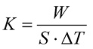
where W is either the heating power or the cooling capacity, as the case may be, required to maintain a constant absolute temperature difference ∆T between the mean inside temperature Ti and the mean outside temperature Te, during continuous operation, when the mean outside temperature Te is constant for a body of mean surface area S.
1.2 The mean surface area S of the body is the geometric mean of the inside surface area Si and the outside surface area Se of the body.
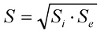
In determining the two surface areas Si and Se, structural peculiarities and surface irregularities of the body, such as chamfers, wheel-arches and similar features, shall be taken into account and shall be noted under the appropriate heading in test reports; however, if the body is covered with corrugated sheet metal the area considered shall be that of the plane surface occupied, not that of the developed corrugated surface.
For calculating the mean surface area of the body of a panel van, the test station appointed by the competent authority shall select from one of the following three methods.
Method A. The manufacturer shall provide drawings and calculations of the inside and outside surfaces.
The surface areas Se and Si are determined taking into consideration the projected surface areas of specific design features of the irregularities of its surface such as curves, corrugations, wheel boxes, etc.
Method B. The manufacturer shall provide drawings and the test station appointed by the competent authority shall use the calculations according to the schemes⁵ and formulae below.
Si = (((WI × LI) + (HI × LI) + (HI × WI)) × 2)
Se = (((WE × LE) + (HE × LE) + (HE × WE)) × 2)
Where:
WI is the Y axis of the internal surface area LI is the X axis of the internal surface area
HI is the Z axis of the internal surface area WE is the Y axis of the external surface area LE is the X axis of the external surface area
HE is the Z axis of the external surface area
Using the most appropriate formula for the Y axis of the internal surface area
WI = (WIa x a + WIb x (b + c/2) + WIc x c/2) / (a + b + c)
WI = (WIa × a/2 + WIb (a/2 + b/2) + WIc (b/2)) / (a + b)
WI = (WIa × a + WIb × b + (WIb + WIc)/2 × c) / (a + b + c)
Where:
WIa is the internal width at the floor or between the wheel arches
WIb is the internal width at the height of the vertical edge from the floor or above the wheel arches.
WIc is the internal width along the roof
a is the height of the vertical edge from the floor
b is either the height between the bottom of the vertical edge and the roof or between the top of the wheel arch and the top of the vertical edge from the floor.
c is the height between the roof and point b
Along with the two formulae for the X and Z axes of the internal surface:
LI = ((LIa x a) + (LIb + LIc) / 2 x b + (LIc x c)) / (a + b + c)
Where:
LIa is the internal length along the floor
LIb is the internal length above the wheel arches LIc is the internal length along the roof
a is the height between LIa and LIb b is the height between LIb and LIc
c is the height between LIc and the roof
WI = (WI back + WI front) / 2
Where:
WI back is the width at the bulkhead
WI front is the width at the door end
The external surface area is calculated using the formulae below
WE = WI + declared mean thickness × 2
LE = LI + declared mean thickness × 2
HE= HI + declared mean thickness × 2
Method C. If neither of the above is acceptable to the experts, the internal surface shall be measured according to the figures and formulae in method B.
The K value shall then be calculated based on the internal surface area, taking the insulation thickness as nil. From this K value, the average insulation thickness is calculated from the assumption that λ for the insulation has a value of 0.025 W/mºC.
d = Si x ΔT x λ / W
Once the thickness of the insulation has been estimated, the external surface area is calculated and the mean surface area is determined. The final K value is derived from successive iteration.
Temperature measuring points
1.3 In the case of parallelepipedic bodies, the mean inside temperature of the body (Ti) is the arithmetic mean of the temperatures measured 10 cm from the walls at the following 12 points:
a) The eight inside corners of the body; and
b) The centres of the four inside faces having the largest area.
If the body is not parallelepipedic, the 12 points of measurements shall be distributed as satisfactorily as possible having regard to the shape of the body.
1.4 In the case of parallelepipedic bodies, the mean outside temperature of the body (Te) is the arithmetic mean of the temperatures measured 10 cm from the walls at the following 12 points:
a) The eight outside corners of the body; and
b) The centres of the four outside faces having the largest area.
If the body is not parallelepipedic, the 12 points of measurement shall be distributed as satisfactorily as possible having regard to the shape of the body.
1.5 The mean temperature of the walls of the body is the arithmetic mean of the mean outside temperature of the body and the mean inside temperature of the body:
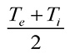
1.6 Temperature measuring instruments protected against radiation shall be placed inside and outside the body at the points specified in paragraphs 1.3 and 1.4 of this appendix.
Steady state period and duration of test
1.7 The mean outside temperatures and the mean inside temperatures of the body, taken over a steady period of not less than 12 hours, shall not vary by more than ±0.3 ºC, and these temperatures shall not vary by more than ±1.0 ºC during the preceding 6 hours.
The difference between the heating power or cooling capacity measured over two periods of not less than 3 hours at the start and at the end of the steady state period, and separated by at least 6 hours, shall be less than 3%.
The mean values of the temperatures and heating or cooling capacity over at least the last 6 hours of the steady state period will be used in K coefficient calculation.
The mean inside and outside temperatures at the beginning and the end of the calculation period of at least 6 hours shall not differ by more than 0.2 ºC.
2. INSULATING CAPACITY OF EQUIPMENT
Procedures for measuring the K coefficient
2.1 Equipment other than liquid foodstuffs tanks
2.1.1 The K coefficient shall be measured in continuous operation either by the internal cooling method or by the internal heating method. In either case, the empty body shall be placed in an insulated chamber.
Test method
2.1.2 Where the internal cooling method is used, one or more heat exchangers shall be placed inside the body. The surface area of these exchangers shall be such that, if a fluid at a temperature not lower than 0 ºC⁶ passes through them, the mean inside temperature of the body remains below + 10 ºC when continuous operation has been established. Where the internal heating method is used, electrical heating appliances (resistors, etc.) shall be used. The heat exchangers or electrical heating appliances shall be fitted with fans having a delivery rate sufficient to obtain 40 to 70 air charges per hour related to the empty volume of the tested body, and the air distribution around all inside surfaces of the tested body shall be sufficient to ensure that the maximum difference between the temperatures of any 2 of the 12 points specified in paragraph 1.3 of this appendix does not exceed 2 ºC when continuous operation has been established.
2.1.3 Heat quantity: The heat dissipated by the electrical resistance fan heaters shall not exceed a low of 1W/cm² and the heater units shall be protected by a casing of low emissivity.
The electrical energy consumption shall be determined with an accuracy of ±0.5%.
Test procedure
2.1.4 Whatever the method employed, the mean temperature of the insulated chamber shall throughout the test be kept uniform, and constant in compliance with paragraph 1.7 of this appendix, at a level such that the temperature difference between the inside of the body and the insulated chamber is 25 ºC ± 2 ºC, the average temperature of the walls of the body being maintained at +20 ºC ± 0.5 ºC.
2.1.5 During the test, whether by the internal cooling method or by the internal heating method, the mass of air in the chamber shall be made to circulate continuously so that the speed of movement of the air 10 cm from the walls is maintained at between l and 2 metres/second.
2.1.6 The appliances for generating and distributing cold or heat and for measuring the quantity of cold or heat exchanged and the heat equivalent of the air-circulating fans shall be started up. Electrical cable losses between the heat input measuring instrument and the tested body shall be established by a measurement or calculation and subtracted from the total heat input measured.
2.1.7 When continuous operation has been established, the maximum difference between the temperatures at the warmest and at the coldest points on the outside of the body shall not exceed 2 ºC.
2.1.8 The mean outside temperature and the mean inside temperature of the body shall each be read at least every 5 minutes.
2.2 Liquid-foodstuffs tanks
2.2.1 The method described below applies only to single-compartment or multiple-compartment tank equipment intended solely for the carriage of liquid foodstuffs such as milk. Each compartment of such tanks shall have at least one manhole and one discharge-pipe connecting socket; where there are several compartments they shall be separated from one another by non-insulated vertical partitions.
2.2.2 K coefficients shall be measured in continuous operation by internal heating of the empty tank in an insulated chamber.
Test method
2.2.3 An electrical heating appliance (resistors, etc.) shall be placed inside the tank. If the tank has several compartments, an electrical heating appliance shall be placed in each compartment. The electrical heating appliances shall be fitted with fans with a delivery rate sufficient to ensure that the difference between the maximum temperature and the minimum temperature inside each compartment does not exceed 3 ºC when continuous operation has been established. If the tank comprises several compartments, the difference between the mean temperature in the coldest compartment and the mean temperature in the warmest compartment shall not exceed 2 ºC, the temperatures being measured as specified in paragraph 2.2.4 of this appendix.
2.2.4 Temperature measuring instruments protected against radiation shall be placed inside and outside the tank 10 cm from the walls, as follows:
a) If the tank has only one compartment, measurements shall be made at a minimum of 12 points positioned as follows:
- The four extremities of two diameters at right angles to one another, one horizontal and the other vertical, near each of the two ends of the tank;
- The four extremities of two diameters at right angles to one another, inclined at an angle of 45º to the horizontal, in the axial plane of the tank;
b) If the tank has two compartments, the measurements shall be made at least at the following points:
- Near the end of the first compartment and near the partition with the second compartment, at the extremities of three radiuses forming 120º angles, one of the radiuses being directed vertically upwards.
- Near the end of the second compartment and near the partition with the first compartment, at the extremities of three radiuses forming 120º angles, one of the radiuses being directed vertically downwards.
c) If the tank has several compartments, the points of measurement shall be as follows:
for each of the two end compartments, at least the following:
- The extremities of a horizontal diameter near the end and the extremities of a vertical diameter near the partition;
and for each of the other compartments, at least the following:
- The extremities of a diameter inclined at an angle of 45º to the horizontal near one of the partitions and the extremities of a diameter perpendicular to the first and near the other partition.
d) The mean inside temperature and the mean outside temperature of the tank shall respectively be the arithmetic mean of all the measurements taken inside and all the measurements taken outside the tank. In the case of tanks having at least two compartments, the mean inside temperature of each compartment shall be the arithmetic mean of the measurements made in the compartment, and the number of those measurements in each compartment shall be no less than four and the total number of measurements in all compartments of the tank shall be no less than twelve.
Test procedure
2.2.5 Throughout the test, the mean temperature of the insulated chamber shall be kept uniform, and constant in compliance with paragraph 1.7 of this appendix, at a level such that the difference in temperature between the inside of the tank and that of the insulated chamber is not less than 25 ºC ± 2 ºC, with the average temperature of the tank walls being maintained at +20 ºC ± 0.5 ºC.
2.2.6 The mass of air in the chamber shall be made to circulate continuously so that the speed of movement of the air 10 cm from the walls is maintained at between l and 2 metres/second.
2.2.7 The appliances for heating and circulating the air and for measuring the quantity of heat exchanged and the heat equivalent of the air-circulating fans shall be started up.
2.2.8 When continuous operation has been established, the maximum difference between the temperatures at the warmest and at the coldest points on the outside of the tank shall not exceed 2 ºC.
2.2.9 The mean outside temperature and the mean inside temperature of the body shall each be read at least every 5 minutes.
2.3 Provisions common to all types of insulated equipment
2.3.1 Verification of the K coefficient
Where the purpose of the tests is not to determine the K coefficient but simply to verify that it is below a certain limit, the tests carried out as described in paragraphs 2.1.1 to 2.2.9 of this appendix may be stopped as soon as the measurements made show that the K coefficient meets the requirements.
2.3.2 Accuracy of measurements of the K coefficient
Testing stations shall be provided with the equipment and instruments necessary to ensure that the K coefficient is determined with an expanded uncertainty of ± 10% when using the method of internal cooling and ± 5% when using the method of internal heating. In calculating the expanded uncertainty of measurement of the K coefficient, the confidence level should be at least 95%.
3. EFFECTIVENESS OF THERMAL APPLIANCES OF EQUIPMENT
Procedures for determining the efficiency of thermal appliances of equipment
3.1 Refrigerated equipment
3.1.1 The empty equipment shall be placed in an insulated chamber whose mean temperature shall be kept uniform, and constant to within ± 0.5 ºC, at +30 ºC. The mass of air in the chamber shall be made to circulate as described in paragraph 2.1.5 of this appendix.
3.1.2 Temperature measuring instruments protected against radiation shall be placed inside and outside the body at the points specified in paragraphs 1.3 and 1.4 of this appendix.
Test procedure
3.1.3 a) In the case of equipment other than equipment with fixed eutectic plates, and equipment fitted with liquefied gas systems, the maximum weight of refrigerant specified by the manufacturer or which can normally be accommodated shall be loaded into the spaces provided when the mean inside temperature of the body has reached the mean outside temperature of the body (+30 ºC). Doors, hatches and other openings shall be closed and the inside ventilation appliances (if any) of the equipment shall be started up at maximum capacity. In addition, in the case of new equipment, a heating appliance with a heating capacity equal to 35% of the heat exchanged through the walls in continuous operation shall be started up inside the body when the temperature prescribed for the class to which the equipment is presumed to belong has been reached. No additional refrigerant shall be loaded during the test;
b) In the case of equipment with fixed eutectic plates, the test shall comprise a preliminary phase of freezing of the eutectic solution. For this purpose, when the mean inside temperature of the body and the temperature of the plates have reached the mean outside temperature (+30 ºC), the plate- cooling appliance shall be put into operation for 18 consecutive hours after closure of the doors and hatches. If the plate-cooling appliance includes a cyclically-operating mechanism, the total duration of operation of the appliance shall be 24 hours. In the case of new equipment, as soon as the cooling appliance is stopped, a heating appliance with a heating capacity equal to 35% of the heat exchanged through the walls in continuous operation shall be started up inside the body when the temperature prescribed for the class to which the equipment is presumed to belong has been reached. The solution shall not be subjected to any re-freezing operation during the test;
c) In the case of equipment fitted with liquefied gas systems, the following test procedure shall be used: when the mean inside temperature of the body has reached the mean outside temperature (+30 ºC), the receptacles for the liquefied gas shall be filled to the level prescribed by the manufacturer. Then the doors, hatches and other openings shall be closed as in normal operation and the inside ventilation appliances (if any) of the equipment shall be started up at maximum capacity. The thermostat shall be set at a temperature not more than 2 degrees below the limit temperature of the presumed class of the equipment. Cooling of the body then shall be commenced. During the cooling of the body the refrigerant consumed is simultaneously replaced. This replacement shall be effected:
- either for a time corresponding to the interval between the commencement of cooling and the moment when the temperature prescribed for the class to which the equipment is presumed to belong is reached for the first time; or
- for a duration of three hours counting from the commencement of cooling, whichever is shorter.
Beyond this period, no additional refrigerant shall be loaded during the test.
In the case of new equipment, a heating appliance with a heating capacity equal to 35% of the heat exchanged through the walls in continuous operation shall be started up inside the body when the class temperature has been reached.
Provisions common to all types of refrigerated equipment
3.1.4 The mean outside temperature and the mean inside temperature of the body shall each be read at least every 5 minutes.
3.1.5 The test shall be continued for 12 hours after the mean inside temperature of the body has reached the lower limit prescribed for the class to which the equipment is presumed to belong (A = +7 ºC; B = 10 ºC; C = 20 ºC; D = 0 ºC) or, in the case of equipment with fixed eutectic plates, after stoppage of the cooling appliance.
Criterion of satisfaction
3.1.6 The test shall be deemed satisfactory if the mean inside temperature of the body does not exceed the aforesaid lower limit during the aforesaid period of 12 hours.
3.1.7 If a refrigerating appliance of paragraph 3.1.3 (c) with all its accessories has undergone separately, to the satisfaction of the competent authority, the test in section 9 of this appendix to determine its effective refrigerating capacity at the prescribed reference temperatures, the transport equipment may be accepted as refrigerated equipment without undergoing an efficiency test if the effective refrigerating capacity of the appliance in continuous operation exceeds the heat loss through the walls for the class under consideration, multiplied by the factor 1,75.
3.1.8 If the refrigerating appliance is replaced by a unit of a different type, the competent authority may:
a) Require the equipment to undergo the determinations and verifications prescribed in paragraphs 3.1.3 to 3.1.5; or
b) Satisfy itself that the effective refrigerating capacity of the new refrigerating appliance is, at the temperature prescribed for equipment of the class concerned, at least equal to that of the unit replaced; or
c) Satisfy itself that the effective refrigerating capacity of the new refrigerating appliance meets the requirements of paragraph 3.1.7.
3.1.9 A refrigerating unit working with liquefied gas is regarded as being of the same type as the unit tested if:
a) The same refrigerant is used;
b) The evaporator has the same capacity;
c) The regulation system has the same characteristics;
d) The liquefied gas tank has the same design and its capacity is equal or upper to the capacity stated in the test report.
The diameters and the technology of the supply lines are identical.
3.2 Mechanically refrigerated equipment
Test method
3.2.1 The test shall be carried out in the conditions described in paragraphs 3.1.1 and 3.1.2 of this appendix.
Test procedure
3.2.2 When the mean inside temperature of the body reaches the outside temperature (+30 ºC), the doors, hatches and other openings shall be closed and the refrigerating appliance and the inside ventilating appliances (if any) shall be started up at maximum capacity. In addition, in the case of new equipment, a heating appliance with a heating capacity equal to 35% of the heat exchanged through the walls in continuous operation shall be started up inside the body when the temperature prescribed for the class to which the equipment is presumed to belong has been reached.
3.2.3 The mean outside temperature and the mean inside temperature of the body shall each be read at least every 5 minutes.
3.2.4 The test shall be continued for 12 hours after the mean inside temperature of the body has reached:
- either the lower limit prescribed for the class to which the equipment is presumed to belong in the case of classes A, B and C (A = 0 ºC; B = -10 ºC; C = -20 ºC); or
- a level not lower than the upper limit prescribed for the class to which the equipment is presumed to belong in the case of classes D, E, and F (D = 0 ºC; E = -10 ºC; F = -20 ºC).
Criterion of satisfaction
3.2.5 The test shall be deemed satisfactory if the refrigerating appliance is able to maintain the prescribed temperature conditions during the said 12-hour periods, with any automatic defrosting of the refrigerating unit not being taken into account.
3.2.6 If the refrigerating appliance with all its accessories has undergone separately, to the satisfaction of the competent authority, a test to determine its effective refrigerating capacity at the prescribed reference temperatures, the transport equipment may be accepted as mechanically refrigerated equipment without undergoing an efficiency test if the effective refrigerating capacity of the appliance in continuous operation exceeds the heat loss through the walls for the class under consideration, multiplied by the factor 1.75.
3.2.7 If the mechanically refrigerating unit is replaced by a unit of a different type, the competent authority may:
a) require the equipment to undergo the determinations and verifications prescribed in paragraphs 3.2.1 to 3.2.4; or
b) satisfy itself that the effective refrigerating capacity of the new mechanically refrigerating unit is, at the temperature prescribed for equipment of the class concerned, at least equal to that of the unit replaced; or
c) satisfy itself that the effective refrigerating capacity of the new mechanically refrigerating unit meets the requirements of paragraph 3.2.6.
3.3 Heated equipment
Test method
3.3.1 The empty equipment shall be placed in an insulated chamber whose temperature shall be kept uniform and constant at as low a level as possible. The atmosphere of the chamber shall be made to circulate as described in paragraph 2.1.5 of this appendix.
3.3.2 Temperature measuring instruments protected against radiation shall be placed inside and outside the body at the points specified in paragraphs 1.3 and 1.4 of this appendix.
Test procedure
3.3.3 Doors, hatches and other openings shall be closed and the heating equipment and the inside ventilating appliances (if any) shall be started up at maximum capacity.
3.3.4 The mean outside temperature and the mean inside temperature of the body shall each be read at least every 5 minutes.
3.3.5 The test shall be continued for 12 hours after the difference between the mean inside temperature and the mean outside temperature of the body has reached the level corresponding to the conditions prescribed for the class to which the equipment is presumed to belong. In the case of new equipment, the above temperature difference shall be increased by 35 per cent.
Criterion of satisfaction
3.3.6 The test shall be deemed satisfactory if the heating appliance is able to maintain the prescribed temperature difference during the 12 hours aforesaid.
3.4 Mechanically refrigerated and heated equipment
Test method
3.4.1 The test shall be carried out in two stages. The efficiency of the refrigeration unit of the refrigerating or refrigerating-heating appliance is determined in the first stage and that of the heating appliance is determined in the second stage.
3.4.2 In the first stage, the test shall be carried out in the conditions described in paragraphs 3.1.1 and 3.1.2 of this appendix; in the second stage, it shall be carried out in the conditions described in paragraphs 3.3.1 and 3.3.2 of this appendix.
Test procedure
3.4.3 (a) The general procedure for measuring the effective refrigerating capacity of mechanically refrigerated appliances stipulated in paragraph 4.1 and 4.2 shall be applied after adapting it such that it can be used to measure heating appliances using a calorimeter box.
The temperature at the air inlet of the thermal appliance or at the air inlet of the evaporator inside the calorimeter box shall be +12 ºC.
For the measurement of the effective heating capacities of classes A, E and I, one test at a mean outside temperature (Te) of -10 ºC shall be carried out.
For the measurement of the effective heating capacities of classes B, F and J, tests at two mean outside temperatures (Te) shall be carried out: one at -10 ºC and the other at -20 ºC.
For the measurement of the effective heating capacities of classes C, D, G, H, K, or L, three tests shall be carried out. One test at a mean outside temperature (Te) of -10 ºC, another test at the minimum outside temperature required by the class and one test at an intermediate outside temperature to allow an interpolation for the effective heating capacities for other in-between class temperatures.
For purely electric heating systems a minimum of one test shall be carried out to measure the effective heating capacities of classes A, B, C, D, E, F, G, H, I, J, K or L. This test should be carried out at +12 ºC at the air inlet of the evaporator and the minimum outside temperature required by the class.
(i) If the measurement of the effective heating capacity is carried out at the lowest outside temperature required by the class, no further test shall be required.
(ii) If the measurement of the effective heating capacity is not carried out at the lowest temperature required by the class, an additional functional test of the heating appliance shall be carried out. This functional test shall be done at the minimum temperature required by the class (e.g. -40 ºC for class L) to verify that the heating appliance and its drive system (e.g. diesel engine driven generator) starts and works properly at the lowest temperature.
(b) When the measurement is carried out on equipment, the basic requirements for the test procedure for the first stage are described in paragraphs 3.2.2 and 3.2.3 of this appendix; those for the second stage are described in paragraphs 3.3.3 and 3.3.4 of this appendix.
3.4.4 The second stage of the test may be initiated immediately after the end of the first stage, without the measuring equipment being dismantled.
3.4.5 In each stage, the test shall be continued for 12 hours after:
a) in the first stage, the mean inside temperature of the body has reached the lower limit prescribed for the class to which the equipment is presumed to belong;
b) in the second stage, the difference between the mean inside temperature of the body and the mean outside temperature of the body has reached the level corresponding to the conditions prescribed for the class to which the equipment is presumed to belong. In the case of new equipment, the above temperature difference shall be increased by 35 per cent.
Criterion of satisfaction
3.4.6 The results of the test shall be deemed satisfactory if:
a) in the first stage, the refrigerating or refrigerating-heating appliance is able to maintain the prescribed temperature conditions during the said 12-hour period, with any automatic defrosting of the refrigerating or refrigerating-heating unit not being taken into account;
b) in the second stage, the heating appliance is able to maintain the prescribed temperature difference during the said 12-hour period.
3.4.7 If the refrigerating unit of the refrigerating or refrigerating-heating appliance with all its accessories has undergone separately, to the satisfaction of the competent authority, a test to determine its effective refrigerating capacity at the prescribed reference temperatures, the transport equipment may be accepted as having passed the first stage of the test without undergoing an efficiency test if the effective refrigerating capacity of the appliance in continuous operation exceeds the heat loss through the walls for the class under consideration, multiplied by the factor 1.75.
3.4.8 If the mechanically refrigerating unit of the refrigerating or refrigerating-heating appliance is replaced by a unit of a different type, the competent authority may:
a) require the equipment to undergo the determinations and verifications for the first stage of testing prescribed in paragraphs 3.4.1-3.4.5 of this appendix; or
b) satisfy itself that the effective refrigerating capacity of the new mechanically refrigerating unit is, at the temperature prescribed for equipment of the class concerned, at least equal to that of the unit replaced; or
c) satisfy itself that the effective refrigerating capacity of the new mechanically refrigerating unit meets the requirements of paragraph 3.4.7 of this appendix.
4. PROCEDURE FOR MEASURING THE EFFECTIVE REFRIGERATING CAPACITY Wo OF A UNIT WHEN THE EVAPORATOR IS FREE FROM FROST
4.2 General principles
4.1.1 When attached to either a calorimeter box or the insulated body of a unit of transport equipment, and operating continuously, this capacity is:
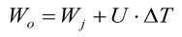
where U is the heat leakage of the calorimeter box or insulated body, Watts/ºC.
∆T is the difference between the mean inside temperature Ti and the mean outside temperature Te of the calorimeter or insulated body (ºC),
Wj is the heat dissipated by the fan heater unit to maintain each temperature difference in equilibrium.
4.2 Test method
4.2.1 The refrigeration unit is either fitted to a calorimeter box or the insulated body of a unit of transport equipment.
In each case, the heat leakage is measured at a single mean wall temperature prior to the capacity test. An arithmetical correction factor, based upon the experience of the testing station, is made to take into account the average temperature of the walls at each thermal equilibrium during the determination of the effective refrigerating capacity.
It is preferable to use a calibrated calorimeter box to obtain maximum accuracy.
Measurements and procedure shall be as described in paragraphs 1.1 to 2.1.8 above; however, it is sufficient to measure U the heat leakage only, the value of this coefficient being defined by the following relationship:
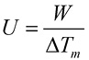
where:
W is the heating power (in Watts) dissipated by the internal heater and fans;
ΔTm is the difference between the mean internal temperature Ti and the mean external temperature Te;
U is the heat low per degree of difference between the air temperature inside and outside the calorimeter box or unit of transport equipment measured with the refrigeration unit fitted.
The calorimeter box or unit of transport equipment is placed in a test chamber. If a calorimeter box is used, U·ΔT should be not more than 35% of the effective refrigerating capacity Wo.
The calorimeter box or unit of transport equipment shall be at least normally insulated.
4.2.2 Instrumentation
Test stations shall be equipped with instruments to measure the U value to an accuracy of ± 5%. Heat transfer through air leakage should not exceed 5% of the total heat transfer through the calorimeter box or through the insulated body of the unit of transport equipment. The refrigerating capacity shall be determined with an accuracy of ±5%.
The instrumentation of the calorimeter box or unit of transport equipment shall conform to paragraphs 1.3 and 1.4 above. The following are to be measured:
a) Air temperatures: At least four thermometers uniformly distributed at the inlet to the evaporator;
At least four thermometers uniformly distributed at the outlet to the evaporator;
At least four thermometers uniformly distributed at the air inlet(s) to the refrigeration unit;
The thermometers shall be protected against radiation.
The accuracy of the temperature measuring system shall be ±0.2 ºC;
b) Energy consumption: Instruments shall be provided to measure the electrical energy or fuel consumption of the refrigeration unit.
The electrical energy and fuel consumption shall be determined with an accuracy of ±0.5%;
c) Speed of rotation: Instruments shall be provided to measure the speed of rotation of the compressors and circulating fans or to allow these speeds to be calculated where direct measurement is impractical.
The speed of rotation shall be measured to an accuracy of ±1%;
d) Pressure: High precision pressure gauges (accurate to ± 1%) shall be fitted to the condenser and evaporator and to the compressor inlet when the evaporator is fitted with a pressure regulator.
4.2.3 Test conditions
a) The average air temperature at the inlet(s) to the refrigeration unit shall be maintained at 30 ºC ± 0.5 ºC.
The maximum difference between the temperatures at the warmest and at the coldest points shall not exceed 2 ºC.
b) Inside the calorimeter box or the insulated body of the unit of transport equipment (at the air inlet to the evaporator): there shall be three levels of temperature between 25 ºC and +12 ºC depending on the characteristics of the unit, one temperature level being at the minimum prescribed for the class requested by the manufacturer with a tolerance of ±1 ºC.
The mean inside temperature shall be maintained within a tolerance of ±0.5 ºC. During the measurement of refrigerating capacity, the heat dissipated within the calorimeter box or the insulated body of the unit of transport equipment shall be maintained at a constant level with a tolerance of ± 1%.
When presenting a refrigeration unit for test, the manufacturer shall supply:
- Documents describing the unit to be tested;
- A technical document outlining the parameters that are most important to the functioning of the unit and specifying their allowable range;
- The characteristics of the equipment series tested; and
- A statement as to which prime mover(s) shall be used during testing.
4.3 Test procedure
4.3.1 The test shall be divided into two major parts, the cooling phase and the measurement of the effective refrigerating capacity at three increasing temperature levels.
a) Cooling phase; the initial temperature of the calorimeter box or transport equipment shall be 30 ºC ± 3 ºC. It shall then be lowered to the following temperatures: -25 ºC for -20 ºC class, -13 ºC for -10 ºC class or -2 ºC for 0 ºC class;
b) Measurement of effective refrigerating capacity, at each internal temperature level.
A first test to be carried out, for at least four hours at each level of temperature, under control of the thermostat (of the refrigeration unit) to stabilize the heat transfer between the interior and exterior of the calorimeter box or unit of transport equipment.
A second test shall be carried out without the thermostat in operation in order to determine the maximum refrigerating capacity, with the heating power of the internal heater producing an equilibrium condition at each temperature level as prescribed in paragraph 4.2.3.
The duration of the second test shall be not less than four hours.
Before changing from one temperature level to another, the box or unit shall be manually defrosted.
If the refrigeration unit can be operated by more than one form of energy, the tests shall be repeated accordingly.
If the compressor is driven by the vehicle engine, the test shall be carried out at both the minimum speed and at the nominal speed of rotation of the compressor as specified by the manufacturer.
If the compressor is driven by the vehicle motion, the test shall be carried out at the nominal speed of rotation of the compressor as specified by the manufacturer.
4.3.2 The same procedure shall be followed for the enthalpy method described below, but in this case the heat power dissipated by the evaporator fans at each temperature level shall also be measured.
This method may, alternatively, be used to test reference equipment. In this case, the effective refrigerating capacity is measured by multiplying the mass low (m) of the refrigerant liquid by the difference in enthalpy between the refrigerant vapour leaving the unit (h_{o}) and the liquid at the inlet to the unit (h_{i}).
To obtain the effective refrigerating capacity, the heat generated by the evaporator fans (Wf) is deducted. It is difficult to measure Wf if the evaporator fans are driven by an external motor, in this particular case the enthalpy method is not recommended. When the fans are driven by internal electric motors, the electrical power is measured by appropriate instruments with an accuracy of ± 3%, with refrigerant low measurement being accurate to ±3%.
The heat balance is given by the formula:

An electric heater is placed inside the equipment in order to obtain the thermal equilibrium.
4.3.3 Precautions
As the tests for effective refrigerating capacity are carried out with the thermostat of the refrigeration unit disconnected, the following precautions shall be observed:
If the equipment has a hot gas injection system, it shall be inoperative during the test;
with automatic controls of the refrigeration unit which unload individual cylinders (to tune the capacity of the refrigeration unit to motor output) the test shall be carried out with the number of cylinders appropriate for the temperature.
4.3.4 Checks
The following should be verified and the methods used indicated on the test report:
a) the defrosting system and the thermostat are functioning correctly;
b) the rate of air circulation shall be measured using an existing standard;
If the air circulation of a refrigeration unit’s evaporator fans is to be measured, methods capable of measuring the total delivery volume shall be used. Use of one of the relevant existing standards, i.e. ISO 5801: 2017 and AMCA 210-16 is recommended;
c) the refrigerant used for tests is that specified by the manufacturer.
4.4 Test result
4.4.1 The refrigeration capacity for ATP purposes is that relating to the mean temperature at the inlet(s) of the evaporator. The temperature measuring instruments shall be protected against radiation.
4.5 Procedure for testing mechanically refrigeration units if there is a change of refrigerants
4.5.1 General principles
The test is in line with the procedure described in section 4, paragraphs 4.1 to 4.4 and based on a complete test of the refrigeration unit with one refrigerant, the reference refrigerant.
The refrigeration unit, its refrigeration circuit and the components of the refrigeration circuit shall not be different when using replacement refrigerants. Only very limited modifications are permitted that are:
a) Modification and change of expansion device (type, setting);
b) Exchange of the lubricant;
c) Exchange of gaskets.
Making it a retrofit refrigerant, a replacement refrigerant must have thermo-physical and chemical properties similar to the reference refrigerant and shall result in a similar behavior in the refrigeration circuit especially in terms of refrigerating capacities.
4.5.2 Test procedure
Due to the similar behavior of the retrofit and the reference refrigerants the number of tests necessary for a type approval can be reduced. In terms of refrigerating capacity the retrofit refrigerants must comply with a criterion of equivalence which allows an at maximum 10% lower refrigerating capacity for the retrofit refrigerant when compared with the approved reference refrigerant.
The criterion of equivalence is defined by the formula:
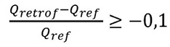
where:
Qref is the refrigerating capacity of the unit tested with the reference refrigerant,
Qretrof is the refrigerating capacity of the unit tested with the retrofit refrigerant.
The number of tests and the evaluation of the retrofit refrigerants is based on the differences in test results when compared with the reference refrigerant. At least a test at the lowest and at the highest temperature of the respective temperature class in the mode of drive with the highest refrigerating capacities has to be carried out.
In the case of a range of refrigeration units the test program may be further reduced according to paragraph 4.5.3.
Dependent on the results of these tests further measurements may be necessary. Distinctions are made for the following cases:
(i) Strict equivalence: is the case when the difference between the refrigerating capacities of the retrofit refrigerant is lower than or equal to 10% less at all tested temperatures of the respective temperature class when compared to the reference refrigerant. In the case of higher or up to 5% lower refrigerating capacities, the refrigerating capacities of the reference refrigerant can be kept in the test report of the retrofit refrigerant. In the case of more than 5% lower refrigerating capacities, the refrigerating capacities of the retrofit refrigerant may be calculated based on the test results.
(ii) Restricted equivalence: is the case when at least at one tested temperature of the respective temperature class the difference between the refrigerating capacities of the retrofit refrigerant is less than or equal to 10% lower when compared to the reference refrigerant. In this case a further measurement at an intermediate temperature as specified by the manufacturer is necessary in order to confirm the tendency of the deviation and to calculate the refrigerating capacities of the retrofit refrigerant based on the test results.
If the power consumption tested with the retrofit refrigerant deviates from the results obtained with the reference refrigerant, the data of power consumption shall be adjusted according to the measured values by means of calculation, as well in case of strict as in case of restricted equivalence.
4.5.3 Test procedure for a range of refrigeration units
A range of refrigeration units describes a model range of a specific type of refrigeration units of different sizes and different refrigerating capacities but with the same setup of refrigeration circuit and same type of components of the refrigeration circuit.
In case of a range of refrigeration units a further reduction of tests is possible.
If at least two refrigeration units of the range including the units with the smallest and the highest refrigerating capacities tested with the retrofit refrigerant have been proven by the test procedure described in 4.5.2 to be equivalent to the results of the approved reference refrigerant, test reports for all other units of this range of refrigeration units may be established by calculating the refrigerating capacities based on the test reports of the refrigerating units operating with the reference refrigerant and based on this limited number of tests with the retrofit refrigerant.
The conformity of the tested refrigeration units and each other regarded refrigeration unit with the range of refrigeration units has to be confirmed by the manufacturer. In addition, the competent authority shall take adequate measures to verify that each regarded unit is in conformity to this range of refrigeration units.
4.5.4 Test report
An addendum containing both, the test results of the retrofit refrigerant and the approved reference refrigerant, shall be added to the test report of the refrigeration unit operated by a retrofit refrigerant. All modifications of the refrigerating unit according to 4.5.1 have to be documented in this addendum.
In case the refrigerating capacities and maybe also the power consumption of the refrigeration unit containing the retrofit refrigerant have been established by calculation, the procedure of calculation has to be described in this addendum too.
5. CHECKING THE INSULATING CAPACITY OF EQUIPMENT IN SERVICE
For the purpose of checking the insulating capacity of each piece of equipment in service as prescribed in appendix 1, paragraphs 1 (b) and 1 (c), to this annex, the competent authorities may:
Apply the methods described in paragraphs 2.1.1 to 2.3.2 of this appendix; or
Appoint experts to assess the fitness of the equipment for retention in one or other of the categories of insulated equipment. These experts shall take the following particulars into account and shall base their conclusions on information as indicated below.
5.1 General examination of the equipment
This examination shall take the form of an inspection of the equipment to determine the following:
a) the durable manufacturer’s plate affixed by the manufacturer;
b) the general design of the insulating sheathing;
c) the method of application of insulation;
d) the nature and condition of the walls;
e) the condition of the insulated compartment;
f) the thickness of the walls;
and to make all appropriate observations concerning the effective insulating capacity of the equipment. For this purpose the experts may cause parts of the equipment to be dismantled and require all documents they may need to consult (plans, test reports, specifications, invoices, etc.) to be placed at their disposal.
5.2 Examination for air-tightness (not applicable to tank equipment)
The inspection shall be made by an observer stationed inside the equipment, which shall be placed in a brightly-illuminated area. Any method yielding more accurate results may be used.
5.3 Decisions
a) If the conclusions regarding the general condition of the body are favourable, the equipment may be kept in service as insulated equipment of its initial class for a further period of not more than three years. If the conclusions of the expert or experts are not acceptable, the equipment may be kept in service only following a satisfactory measurement of the K coefficient according to the procedure described in paragraphs 2.1.1 to 2.3.2 of this appendix; it may then be kept in service for a further period of six years.
b) In the case of heavily insulated equipment, if the conclusions of an expert or experts show the body to be unsuitable for keeping in service in its initial class but suitable for continuing in service as normally insulated equipment, then the body may be kept in service in an appropriate class for a further three years. In this case, the distinguishing marks (as in appendix 4 of this annex) shall be changed appropriately.
c) If the equipment consists of units of serially-produced equipment of a particular type satisfying the requirements of appendix l, paragraph 6, to this annex and belonging to one owner, then in addition to an inspection of each unit of equipment, the K coefficient of not less than 1% of the number of units involved, may be measured in conformity with the provisions of sections 2.1, 2.2 and 2.3 of this appendix. If the results of the examinations and measurements are acceptable, all the equipment in question may be kept in service as insulating equipment of its initial class for a further period of six years.
6. VERIFYING THE EFFECTIVENESS OF THERMAL APPLIANCES OF EQUIPMENT IN SERVICE
To verify as prescribed in appendix 1, paragraphs 1 (b) and (c), to this annex the effectiveness of the thermal appliance of each item of refrigerated, mechanically refrigerated, heated or mechanically refrigerated and heated equipment in service, the competent authorities may:
- Apply the methods described in sections 3.1, 3.2, 3.3 and 3.4 of this appendix; or
- Appoint experts to apply the particulars described in sections 5.1 and 5.2 of this appendix, when applicable, as well as the following provisions.
6.1 Refrigerated equipment other than equipment with fixed eutectic accumulators
It shall be verified that the inside temperature of the empty equipment, previously brought to the outside temperature, can be brought to the limit temperature of the class to which the equipment belongs, as prescribed in this annex, and maintained below the said limit temperature for a period t

ΔT is the difference between +30 ºC and the said limit temperature, and
ΔT’ is the difference between the mean outside temperature during the test and the class limit temperature, the outside temperature being not lower than +15 ºC.
If the results are acceptable, the equipment may be kept in service as refrigerated equipment of its initial class for a further period of not more than three years.
6.2 Mechanically refrigerated equipment
6.2.1 Independent equipment
(i) Equipment constructed from 2 January 2012
It shall be verified that, when the outside temperature is not lower than +15 ºC, the inside temperature of the empty equipment can be brought to the class temperature within a maximum period (in minutes), as prescribed in the table below:
Outside temperature | 30 | 29 | 28 | 27 | 26 | 25 | 24 | 23 | 22 | 21 | 20 | 19 | 18 | 17 | 16 | 15 | °C
Class C,F | 360 | 350 | 340 | 330 | 320 | 310 | 300 | 290 | 280 | 270 | 260 | 250 | 240 | 230 | 220 | 210 | min
Class B,E | 270 | 262 | 253 | 245 | 236 | 228 | 219 | 211 | 202 | 194 | 185 | 177 | 168 | 160 | 151 | 143 | min
Class A,D | 180 | 173 | 166 | 159 | 152 | 145 | 138 | 131 | 124 | 117 | 110 | 103 | 96 | 89 | 82 | 75 | min
The inside temperature of the empty equipment must have been previously brought to the outside temperature.
If the results are acceptable, the equipment may be kept in service as mechanically refrigerated equipment of its initial class for a further period of not more than three years.
(ii) Transitional provisions applicable to equipment in service
For equipment constructed prior to the date given in 6.2 (i), the following provisions shall apply:
It shall be verified that, when the outside temperature is not lower than +15 ºC, the inside temperature of the empty equipment, which has been previously brought to the outside temperature, can be brought within a maximum period of six hours:
- In the case of equipment in classes A, B or C, to the minimum temperature, as prescribed in this annex;
- In the case of equipment in classes D, E or F, to the limit temperature, as prescribed in this annex.
If the results are acceptable, the equipment may be kept in service as mechanically refrigerated equipment of its initial class for a further period of not more than three years.
(iii) Multi-compartment equipment
The test prescribed in (i) shall be conducted simultaneously for all compartments. During the tests, if the dividing walls are movable, they shall be positioned such that the volumes of the compartments correspond with the maximum refrigeration demand.
Measurements shall be taken until the warmest temperature measured by one of the two sensors located inside each compartment matches the class temperature.
For multi-compartment equipment whose compartment temperatures may be modified, a supplementary reversibility test shall then be conducted:
The temperatures of the compartments shall be selected in such a way that adjacent compartments are, to the extent possible, at different temperatures during the test. Certain compartments shall be brought to the class temperature (-20 ºC) while others shall be at 0 ºC. Once such temperatures are reached, the temperature settings shall be reversed for each compartment, thus bringing the compartments that were at 0 ºC to -20 ºC and those that were at -20 ºC to 0 ºC.
It is verified that compartments at 0 ºC have a correct temperature regulation at 0 ºC ± 3 ºC for at least 10 minutes when the other compartments are at -20 ºC. Subsequently, the settings for each of the compartments shall be reversed and the same verifications shall be conducted.
In the case of equipment fitted with a heating function, the tests shall begin after the efficiency test when the temperature is -20 ºC. Without opening doors, the compartments whose settings had been set at 0 ºC shall be warmed, while the other compartments are kept at a temperature of -20 ºC. When the control criterion is met, the compartments’ settings shall be reversed. There shall be no time limit to carry out these tests.
In the case of equipment without a heating function, it shall be permitted to open the doors of the compartments to expedite the temperature rise of the compartments in question.
The equipment shall be considered compliant if:
a) For each compartment, the class temperature has been reached within the time limit shown in the table in (i). To define this time limit, the lowest (coldest) mean outside temperature shall be selected from the two sets of measurements taken with the two outside sensors; and
b) The additional tests mentioned in (iii), when required, are satisfactory.
6.2.2 Non-independent equipment
(iv) Non-independent equipment, the refrigeration unit of which is powered by the engine of the vehicle
It shall be verified that, when the outside temperature is not lower than 15º C, the inside temperature of the empty equipment can be maintained at the class temperature, after cool-down and stabilization, when the engine is running at the idle speed set by the manufacturer (where applicable), for a minimum period of one hour and thirty minutes.
If the results are satisfactory, the equipment may be kept in service as mechanically refrigerated equipment in its initial class for a further period of not more than three years.
(v) Transitional provisions for non-independent equipment in service:
For equipment constructed prior to 6 January 2018, this provision need not be applied. In this case the equipment shall comply with the requirements of (i) or (ii) of this paragraph as applicable for the date of construction.
6.2.3 At the request of the manufacturer, replacement of the original refrigerant fluid of a mechanically refrigerated equipment in service is allowed for the refrigerants described in the table below on the following conditions:
Original refrigerant | Drop-in refrigerant
R404A | R452A
a) a test report or addendum confirming equivalence to a similar mechanically refrigerated unit with the drop-in refrigerant fluid is available; and
b) an efficiency test according to 6.2.1 has been successfully carried out.
The manufacturer plate shall be modified or replaced to indicate the replacement refrigerating fluid and the required charge.
The original test report number shall be retained on the ATP certificate of compliance supplemented by a reference to the test report or addendum on which the replacement is based.
6.3 Heated equipment
It shall be verified that the difference between the inside temperature of the equipment and the outside temperature which governs the class to which the equipment belongs as prescribed in this annex (a difference of 22 ºC in the case of class A, 32 ºC in the case of class B, 42 ºC in the case of class C and 52 ºC in the case of class D) can be achieved and be maintained for not less than 12 hours. If the results are acceptable, the equipment may be kept in service as heated equipment of its initial class for a further period of not more than three years.
6.4 Mechanically refrigerated and heated equipment
The check is carried out in two stages.
(i) During the first stage, it shall be verified that, when the outside temperature is not lower than + 15 ºC, the inside temperature of the empty equipment can be brought to the class temperature within a maximum period (in minutes), as prescribed in the table in paragraph 6.2 of this appendix.
The inside temperature of the empty equipment shall have been previously brought to the outside temperature.
(ii) In the second stage, it shall be verified that the difference between the inside temperature of the equipment and the outside temperature which governs the class to which the equipment belongs as prescribed in this annex (a difference of 22 ºC in the case of classes A, E and I, of 32 ºC in the case of classes B, F and J, of 42 ºC in the case of classes C, G and K, and of 52 ºC in the case of classes D, H, and L), can be achieved and maintained for not less than 12 hours.
If the results are acceptable, the equipment may be kept in service as mechanically refrigerated and heated equipment of its initial class for a further period of not more than three years.
6.5 Temperature measuring points
Temperature measuring points protected against radiation shall be placed inside the body and outside the body.
For measuring the inside temperature of the body (Ti), at least 2 temperature measuring points shall be placed inside the body at a maximum distance of 50 cm from the front wall, 50 cm from the rear door at a height of a minimum of 15 cm and a maximum of 20 cm above the floor area.
For measuring the outside temperature of the body (Te), at least 2 temperature measuring points shall be placed:
(i) One measuring point vertically within 20 cm around the middle height of the body, at a distance of 10 to 20 cm from the side wall, and
(ii) Another measuring point 20 to 50 cm from the air inlet of the condenser unit.
The final reading shall be from the warmest measuring point inside the body at the end of the cool down test. The outside temperature used to determine the maximum cool down time, in case of equipment manufactured from 2 January 2012, is the average temperature of all readings from the outside measuring points until the class temperature has been reached.
6.6 Provisions common to refrigerated, mechanically refrigerated and heated equipment
(i) If the results are not acceptable, refrigerated, mechanically refrigerated, heated, or mechanically refrigerated and heated equipment may be kept in service in its initial class only if it passes at a testing station the tests described in sections 3.1, 3.2, 3.3 and 3.4 of this appendix; it may then be kept in service in its initial class for a further period of six years.
(ii) If the equipment consists of units of serially-produced refrigerated, mechanically refrigerated, heated, or mechanically refrigerated and heated equipment of a particular type satisfying the requirements of appendix l, paragraph 6, to this annex and belonging to one owner, then in addition to an inspection of the thermal appliances to ensure that their general condition appears to be satisfactory, the effectiveness of the cooling or heating appliances of not less than 1% of the number of units may be determined at a testing station in conformity with the provisions of sections 3.1, 3.2, 3.3 and 3.4 of this appendix. If the results of the examinations and of the determination of effectiveness are acceptable, all the equipment in question may be kept in service in its initial class for a further period of six years.
7. PROCEDURE FOR MEASURING THE CAPACITY OF MECHANICAL MULTI-TEMPERATURE REFRIGERATION UNITS AND DIMENSIONING MULTI-COMPARTMENT EQUIPMENT
7.1 Definitions
a) Multi-compartment equipment: Equipment with two or more insulated compartments for maintaining a different temperature in each compartment;
b) Multi-temperature mechanical refrigeration unit: Mechanical refrigeration unit with compressor and common suction inlet, condenser and two or more evaporators set at different temperatures in the various compartments of multi-compartment equipment;
c) Host unit: Refrigeration unit with or without an integral evaporator;
d) Unconditioned compartment: a compartment considered to have no evaporator or for which the evaporator is inactive for the purposes of dimensioning calculations and certification;
e) Multi-temperature operation: Operation of a multi-temperature mechanical refrigeration unit with two or more evaporators operating at different temperatures in multi-compartment equipment;
f) Nominal refrigerating capacity: Maximum refrigerating capacity of the refrigeration unit in mono- temperature operation with two or three evaporators operating simultaneously at the same temperature;
g) Individual refrigerating capacity (Pind-evap): The maximum refrigerating capacity of each evaporator in solo operation with the host unit;
h) Effective refrigerating capacity (Pef-frozen-evap): The refrigerating capacity available to the lowest temperature evaporator when two or more evaporators are each operating in multi-temperature mode, as prescribed in paragraph 7.3.5.
7.2 Test procedure for multi-temperature mechanical refrigeration units
7.2.1 General procedure
The test procedure shall be as defined in section 4 of this appendix.
The host unit shall be tested in combination with different evaporators. Each evaporator shall be tested on a separate calorimeter, if applicable.
The nominal refrigerating capacity of the host unit in mono-temperature operation, as prescribed in paragraph 7.2.2, shall be measured with a single combination of two or three evaporators including the smallest and largest.
The individual refrigerating capacity shall be measured for all evaporators, each in mono-temperature operation with the host unit, as prescribed in paragraph 7.2.3.
This test shall be conducted with two or three evaporators including the smallest, the largest and, if necessary, a mid-sized evaporator.
If the multi-temperature unit can be operated with more than two evaporators:
- The host unit shall be tested with a combination of three evaporators: the smallest, the largest and a mid-sized evaporator.
- In addition, on demand of the manufacturer, the host unit can be tested optionally with a combination of two evaporators: the largest and smallest.
The tests are done in independent mode and stand by.
7.2.2 Determination of the nominal refrigerating capacity of the host unit
The nominal refrigerating capacity of the host unit in mono-temperature operation shall be measured with a single combination of two or three evaporators operating simultaneously at the same temperature. This test shall be conducted at -20 ºC and at 0 ºC.
The air inlet temperature of the host unit shall be +30 ºC.
The nominal refrigerating capacity at -10 ºC shall be calculated by linear interpolation from the capacities at -20 ºC and 0 ºC.
7.2.3 Determination of the individual refrigerating capacity of each evaporator
The individual refrigerating capacity of each evaporator shall be measured in solo operation with the host unit. The test shall be conducted at -20 ºC and 0 ºC. The air inlet temperature of the refrigeration unit shall be +30 ºC.
The individual refrigerating capacity at -10 ºC shall be calculated by linear interpolation from the capacities at 0 ºC and -20 ºC.
7.2.4 Test of the remaining effective refrigerating capacities of a set of evaporators in multi- temperature operation at a reference heat load
The remaining effective refrigerating capacity shall be measured for each tested evaporator at -20 ºC with the other evaporator(s) operating under control of a thermostat set at 0 ºC with a reference heat load of 20% of the individual refrigerating capacity at -20 ºC of the evaporator in question. The air inlet temperature of the host unit shall be +30 ºC.
For multi-temperature refrigeration units with more than one compressor such as cascade systems or units with two-stage compression systems, where the refrigerating capacities can be simultaneously maintained in the frozen and chilled compartments, the measurement of the effective refrigerating capacity, shall be done at one additional heat load.
7.3 Dimensioning and certification of refrigerated multi-temperature equipment
7.3.1 General procedure
The refrigerating capacity demand of multi-temperature equipment shall be based on the refrigerating capacity demand of mono-temperature equipment as defined in this appendix.
For multi-compartment equipment, a K coefficient less than or equal to 0.40 W/m²ºC for the outer body as a whole shall be approved in accordance with subsections 2 to 2.2 of this appendix.
The insulation capacities of the outer body walls shall be calculated using the K coefficient of the body approved in accordance with this Agreement. The insulation capacities of the internal dividing walls shall be calculated using the K coefficients in the table in paragraph 7.3.7.
For issuance of an ATP certificate:
- The nominal refrigerating capacity of the multi-temperature refrigeration unit shall be at least equal to the heat loss through the outer body walls of the equipment as a whole multiplied by the factor 1.75 as specified in paragraph 3.2.6 of this appendix.
- In each compartment, the calculated remaining effective refrigerating capacity at the lowest temperature of each evaporator in multi-temperature operation shall be greater than or equal to the maximum refrigeration demand of the compartment in the most unfavourable conditions, as prescribed in paragraphs 7.3.5 and 7.3.6, multiplied by the factor 1.75 as specified in paragraph 3.2.6 of this appendix.
7.3.2 Conformity of the entire body
The outer body shall have a K value K ≤ 0.40 W/m²ºC.
The internal surface of the body shall not vary by more than 20%.
The equipment shall conform to:
Pnominal > 1.75 · Kbody · Sbody · ΔT
Where:
Pnominal is the nominal refrigerating capacity of the multi-temperature refrigeration unit,
Kbody is the K value of the outer body,
Sbody is the geometric mean surface area of the full body,
ΔT is the difference in temperature between outside and inside the body.
7.3.3 Determination of the refrigerating demand of chilled evaporators
With the bulkheads in given positions, the refrigerating capacity demand of each chilled evaporator is calculated as follows:
Pchilled demand = (Schilled-comp - ΣSbulk) · Kbody · ΔText + Σ (Sbulk · Kbulk · ΔTint)
Where:
Kbody is the K value given by an ATP test report for the outer body,
Schilled-comp is the surface of the chilled compartment for the given positions of the bulkheads,
Sbulk are the surfaces of the bulkheads,
Kbulk are the K values of the bulkheads given by the table in paragraph 7.3.7,
ΔText is the difference in temperatures between the chilled compartment and +30 ºC outside the body,
ΔTint is the difference in temperatures between the chilled compartment and other compartments. For unconditioned compartments a temperature of +20 ºC shall be used for calculations.
7.3.4 Determination of the refrigerating demand of frozen compartments
With the bulkheads in given positions, the refrigerating capacity demand of each frozen compartment is calculated as follows:
Pfrozen demand = (Sfrozen-comp - ΣSbulk) · Kbody · ΔText + Σ (Sbulk · Kbulk · ΔTint)
Where:
Kbody is the K value given by an ATP test report for the outer body,
Sfrozen-comp is the surface of the frozen compartment for the given positions of the bulkheads,
Sbulk are the surfaces of the bulkheads,
Kbulk are the K values of the bulkheads given by the table in paragraph 7.3.7,
ΔText is the difference in temperatures between the frozen compartment and +30 ºC outside the body,
ΔTint is the difference in temperatures between the frozen compartment and other compartments. For insulated compartments a temperature of +20 ºC shall be used for calculations.
7.3.5 Determination of the effective refrigerating capacity of frozen evaporators
The effective refrigerating capacity, in given positions of the bulkheads, is calculated as follows:
Peff-frozen-evap = Pind-frozen-evap · [1 - Σ (Peff-chilled-evap / Pind-chilled-evap)]
Where:
Peff-frozen-evap is the effective refrigerating capacity of the frozen evaporator with a given configuration,
Pind-frozen-evap is the individual refrigeration capacity of the frozen evaporator at -20 ºC,
Peff-chilled-evap is the effective refrigeration capacity of each chilled evaporator in the given configuration as defined in paragraph 7.3.6,
Pind-chilled-evap is the individual refrigerating capacity at -20 ºC for each chilled evaporator.
This calculation method is only approved for multi-temperature mechanical refrigeration units with a single one-stage compressor. For multi-temperature refrigeration units with more than one compressor such as cascade systems or units with two-stage compression systems, where the refrigerating capacities can be simultaneously maintained in the frozen and the chilled compartments, this calculation method shall not be used, because it will lead to an underestimation of the effective refrigerating capacities. For this equipment, the effective refrigerating capacities shall be interpolated between the effective refrigerating capacities measured with two different heat loads given in the tests reports as prescribed in 7.2.4.
7.3.6 Conformity declaration
The equipment is declared in conformity in multi-temperature operation if, for each position of the bulkheads, and each distribution of temperature in the compartments:
Peff-frozen-evap ≥ 1.75 · Pfrozen demand
Peff-chilled-evap ≥ 1.75 · Pchilled demand
Where:
Peff-frozen-evap is the effective refrigeration capacity of the considered frozen evaporator at the class temperature of the compartment in the given configuration,
Peff-chilled-evap is the effective refrigeration capacity of the considered chilled evaporator at the class temperature of the compartment in the given configuration,
Pfrozen demand is the refrigerating demand of the considered compartment at the class temperature of the compartment in the given configuration as calculated according to 7.3.4,
Pchilled demand is the refrigerating demand of the considered compartment at the class temperature of the compartment in the given configuration as calculated according to 7.3.3.
It shall be considered that all the positions of the bulkheads have been dimensioned if the wall positions from the smallest to the largest compartment sizes are checked by iterative methods whereby no input step change in surface area is greater than 20%.
A declaration of conformity shall be provided in a supplementary document to the certificate of compliance issued by the competent authority of the country of manufacture. The document shall be based on information given by the manufacturer. The declaration shall conform to the layout given in Model No. 14 of this appendix.
This document shall include at least:
a) A sketch showing the actual compartment configuration and evaporator arrangement;
b) Proof by calculation that the multi-compartment equipment meets the requirements of ATP for the user’s intended degree of freedom with regards to compartment temperatures and compartment dimensions.
7.3.7 Internal dividing walls
Thermal losses through internal dividing walls shall be calculated using the K coefficients in the following table.
 | K coefficient  [W/m²ºC] |  | Minimum foam thickness [mm]
 | Fixed | Removable
Longitudinal - alu floor | 2 | 3 | 25
Longitudinal - GRP floor | 1,5 | 2 | 25
Transversal - alu floor | 2 | 3,2 | 40
Transversal - GRP floor | 1,5 | 2,6 | 40
K coefficients of movable dividing walls include a safety margin for specific ageing and unavoidable thermal leakages.
For specific designs with additional heat transfer caused by additional thermal bridges compared to a standard design, the partition K coefficient shall be increased.
7.3.8 The requirements of section 7 shall not apply to equipment produced before the entry into force of the requirements and having undergone equivalent tests as multi-temperature equipment. Equipment produced before the entry into force of this section may be operated in international transport but may only be transferred from one country to another with the agreement of the competent authorities of the countries concerned.
8. TEST REPORTS
A test report of the type appropriate to the equipment tested shall be drawn up for each test in conformity with one or other of the models 1 to 14 hereunder.
--------
⁵ The relevant figures can be found in the ATP Handbook at the following link: https://unece.org/atp-handbook
⁶ To prevent frosting.
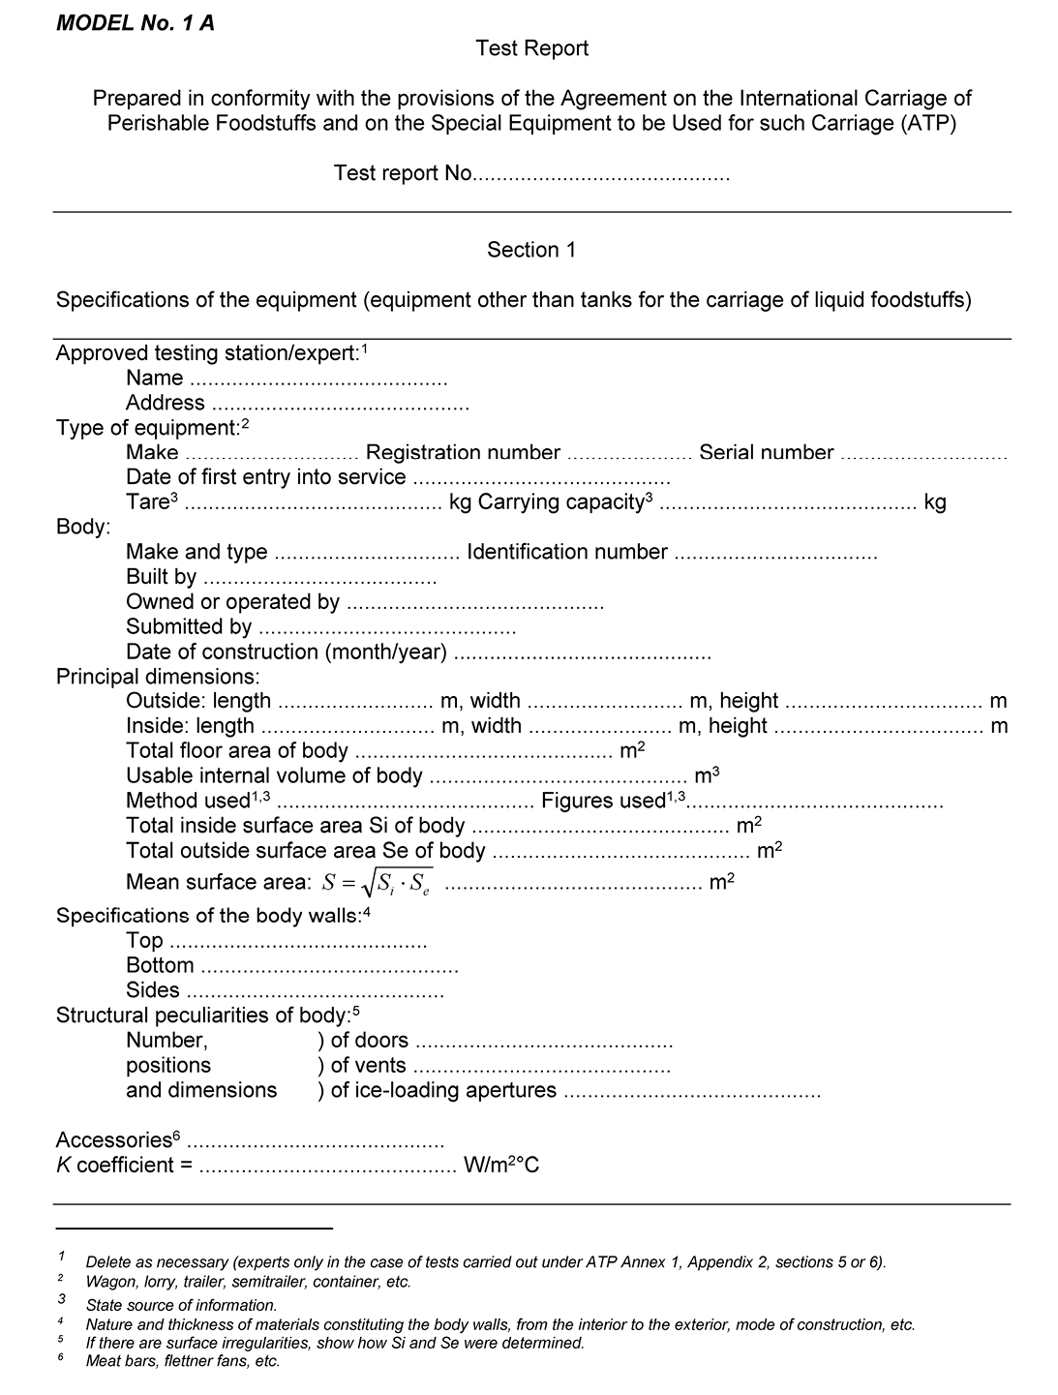
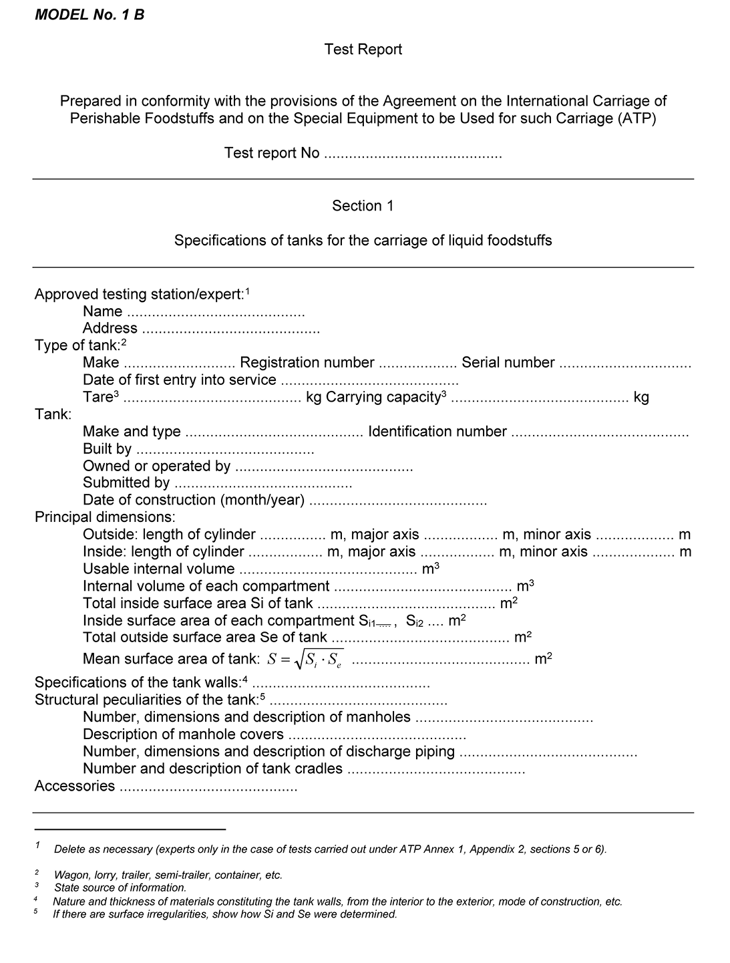
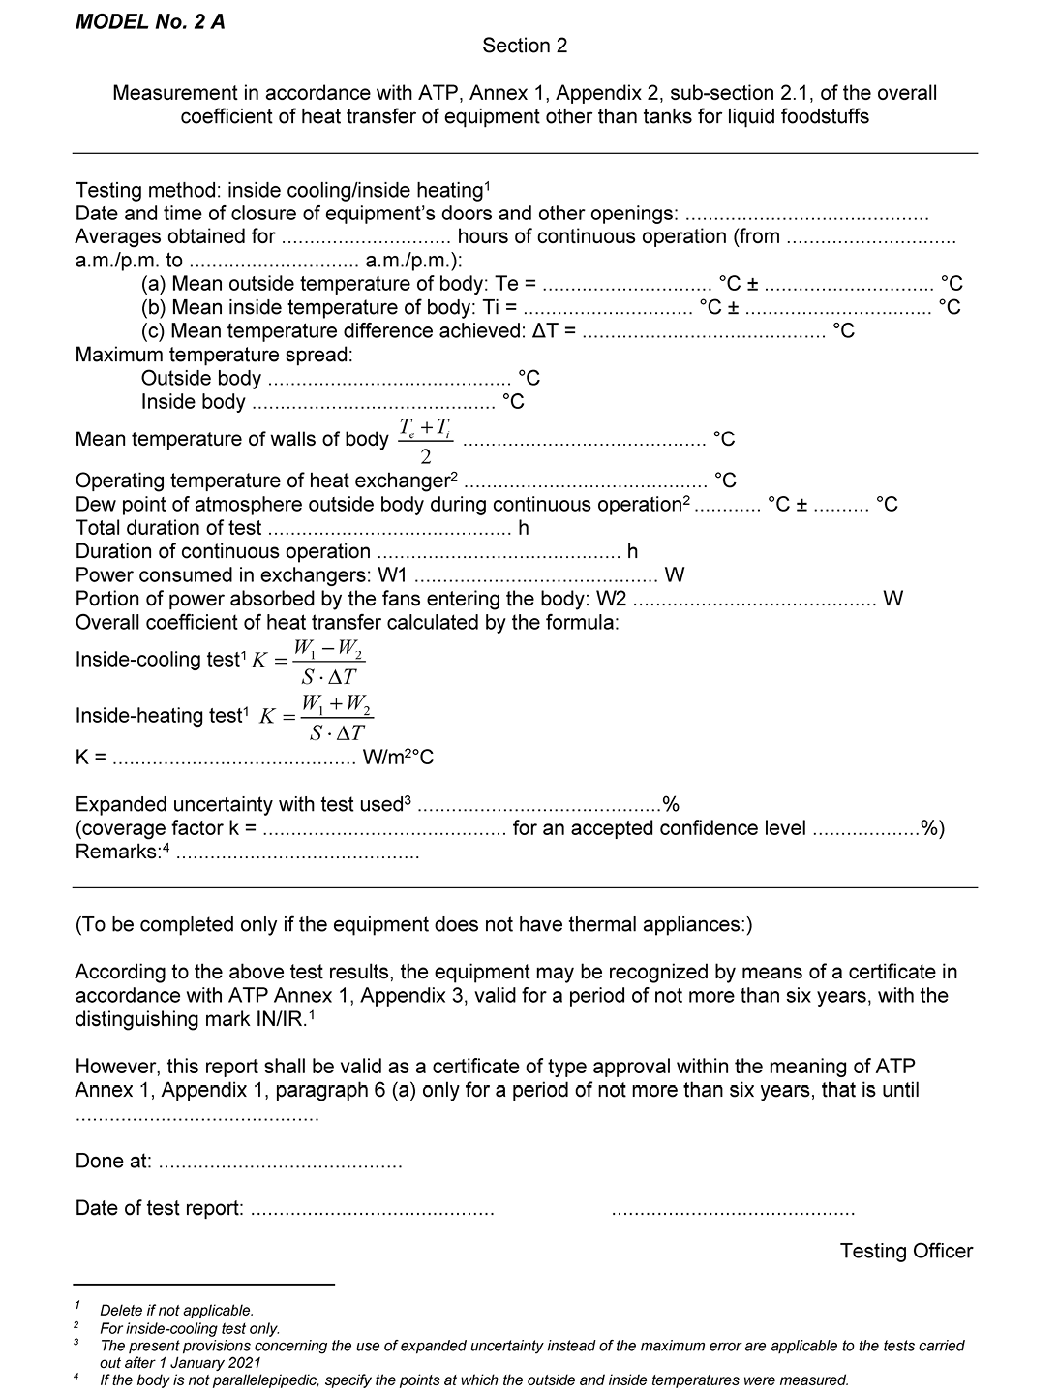
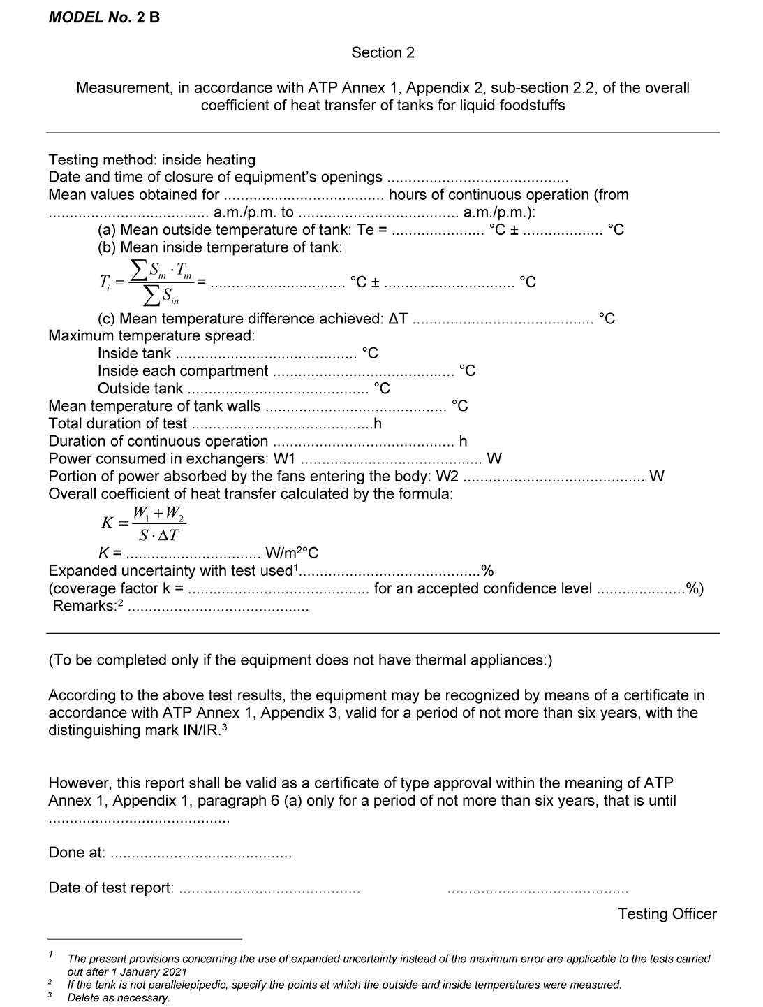
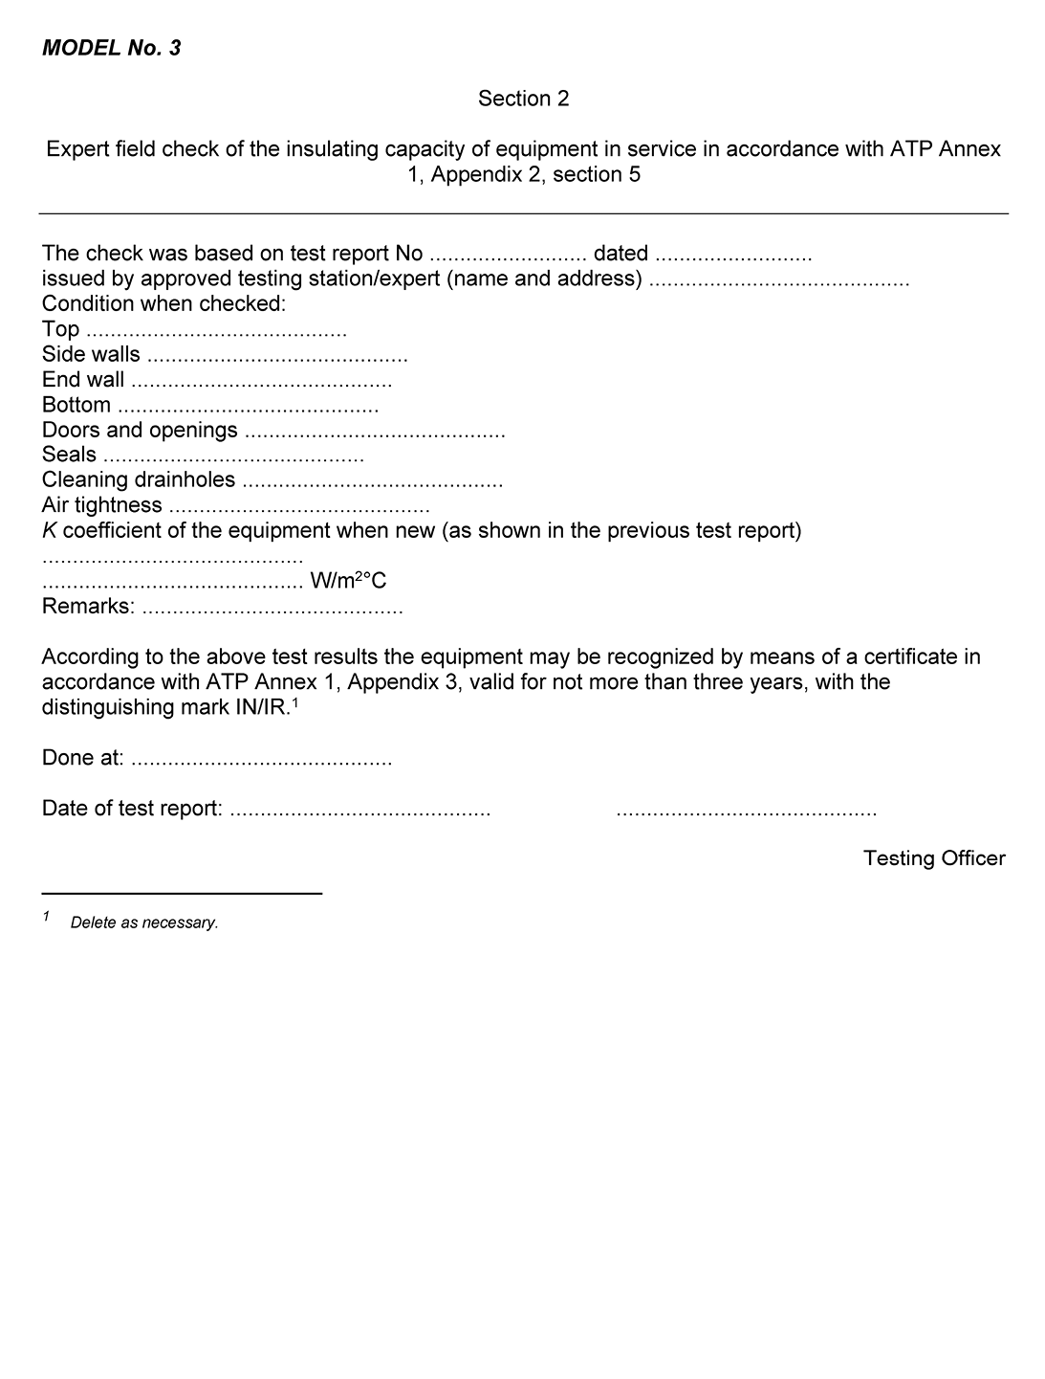
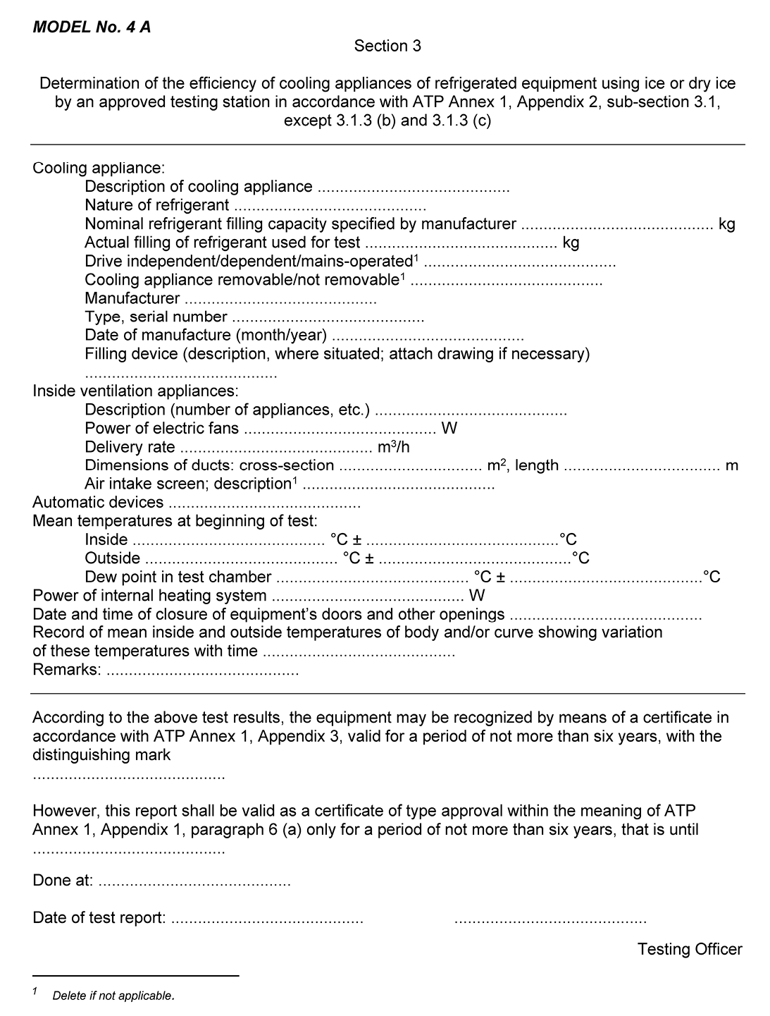
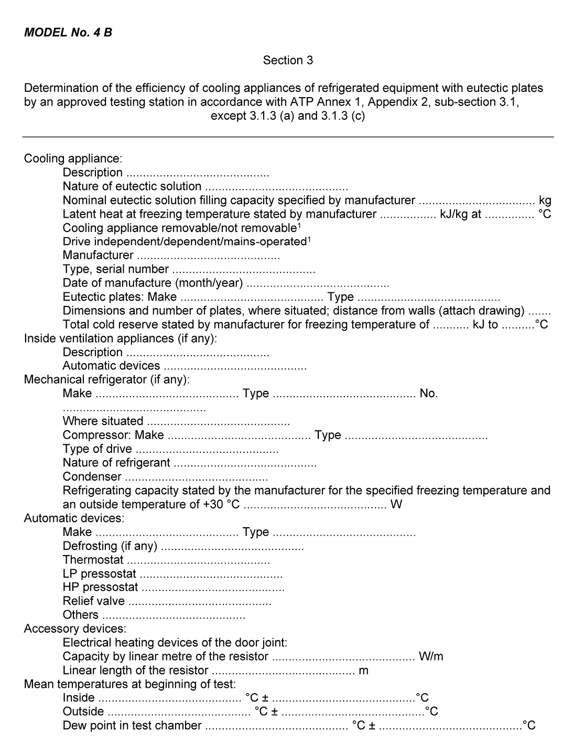
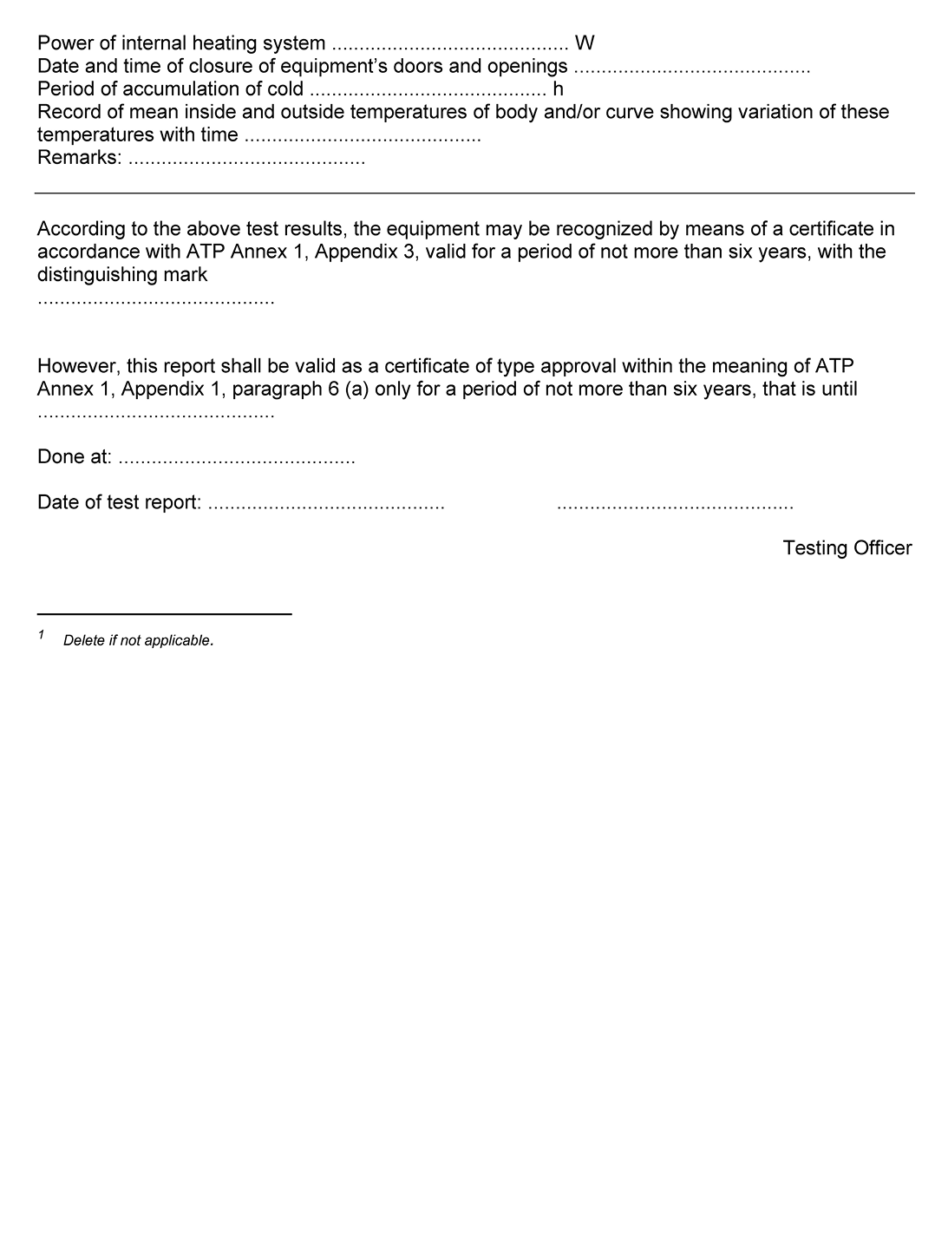
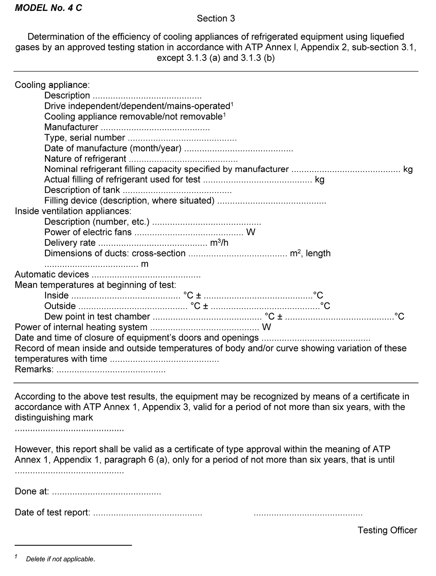
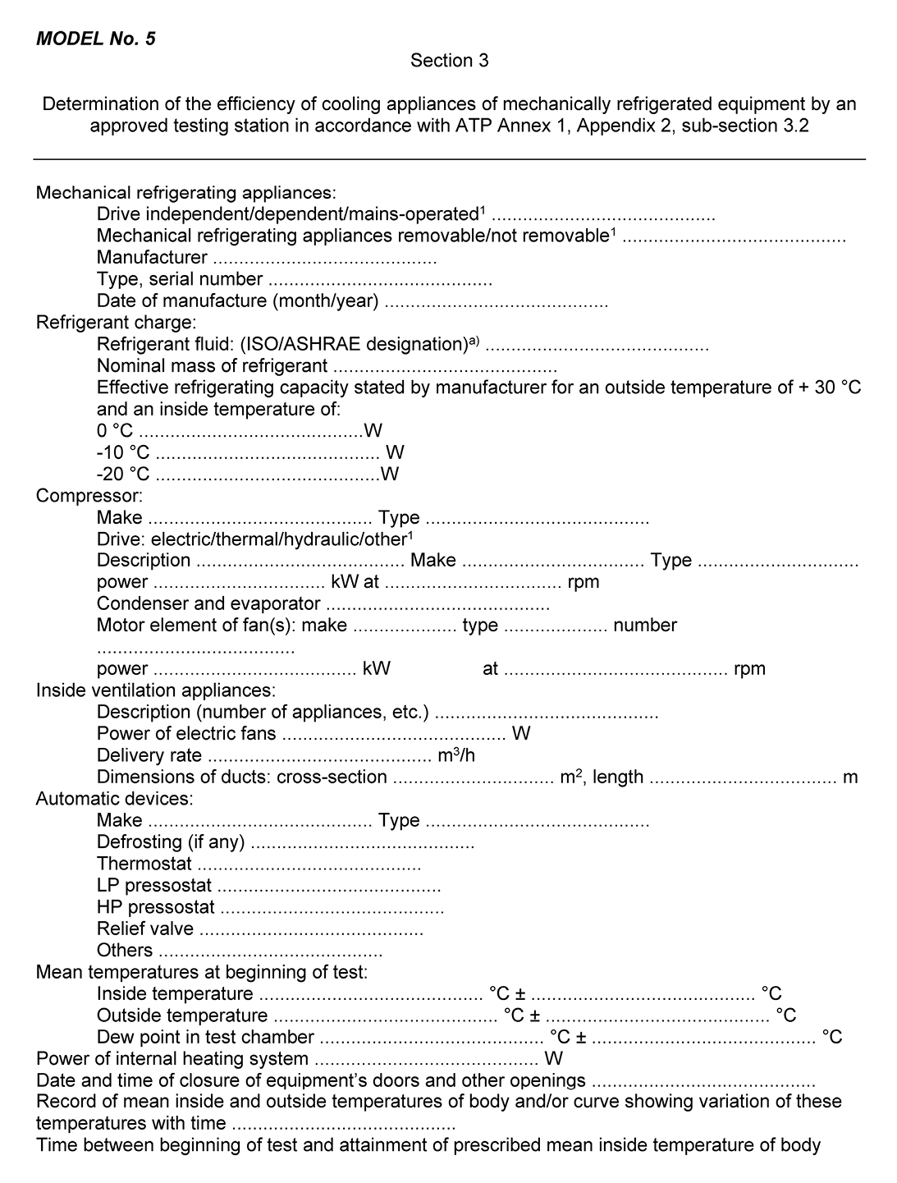
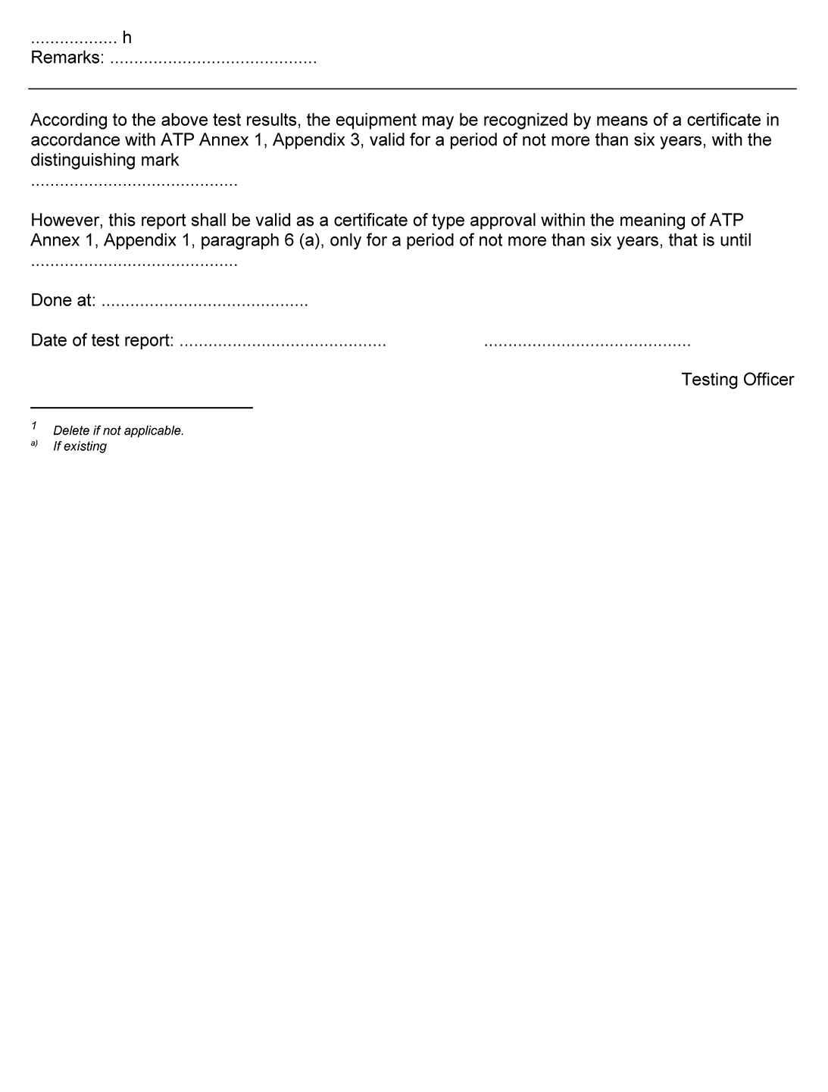
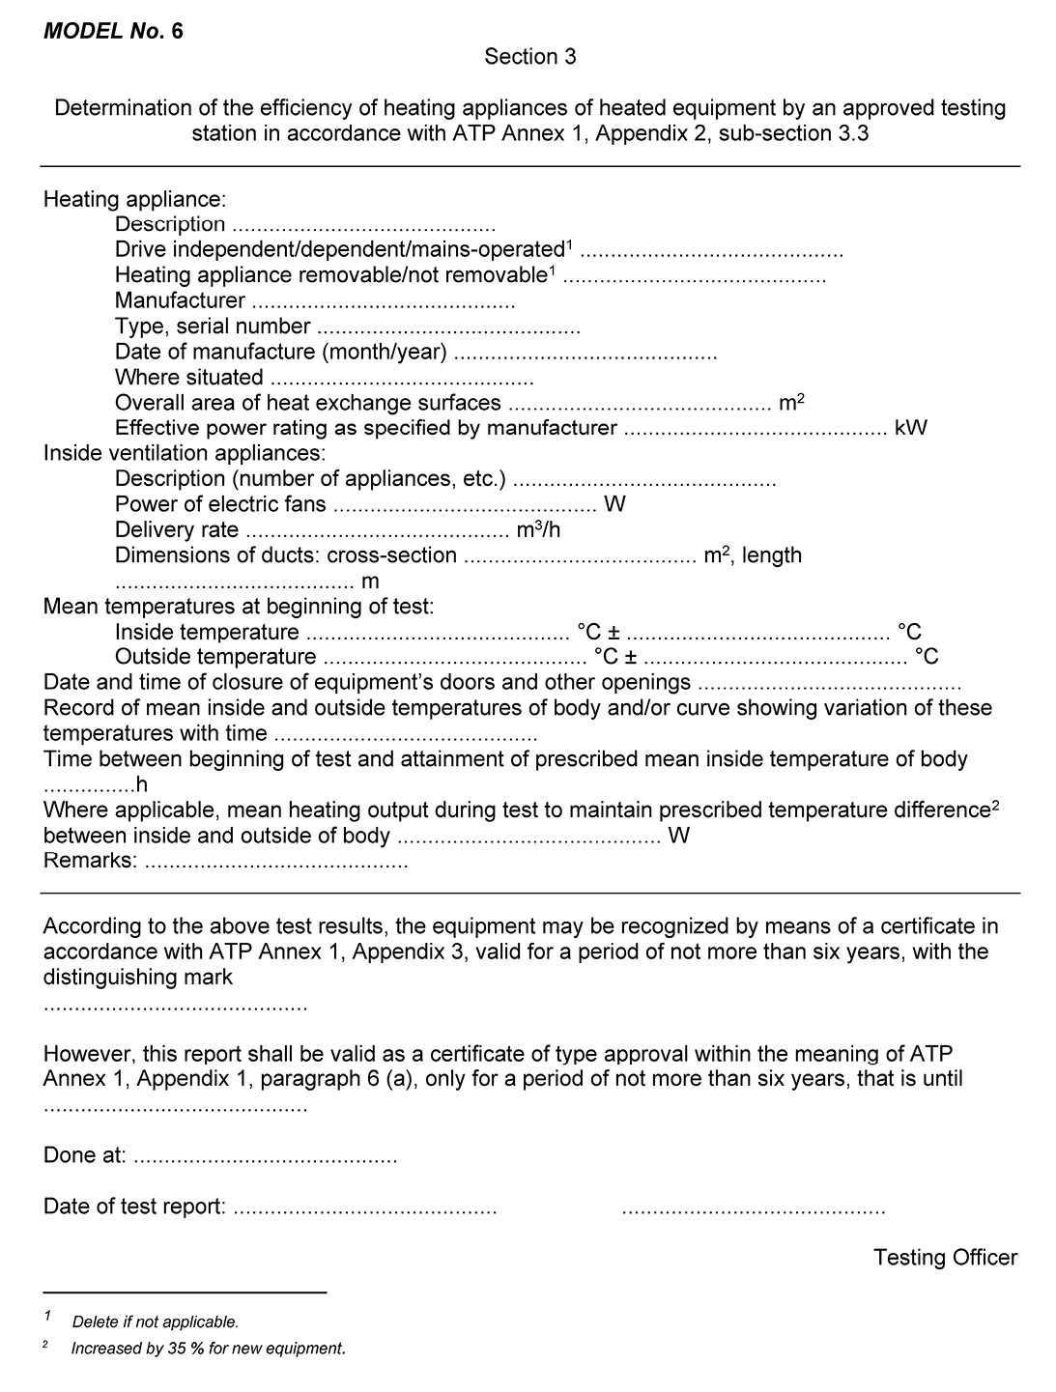
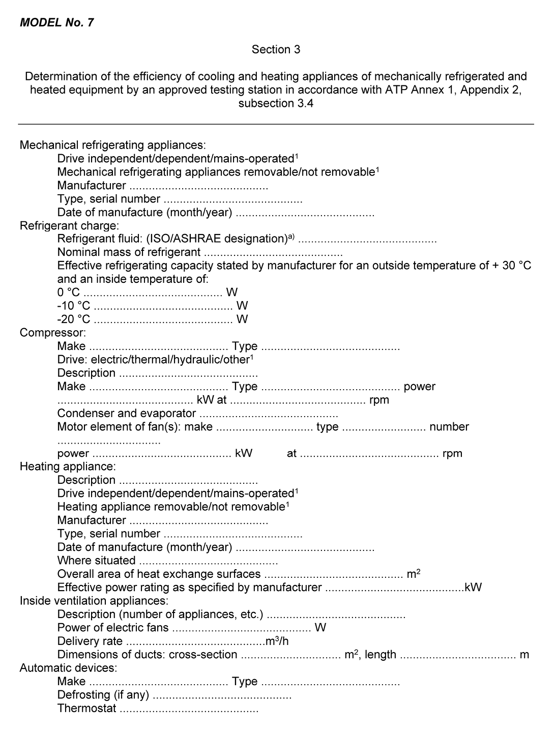
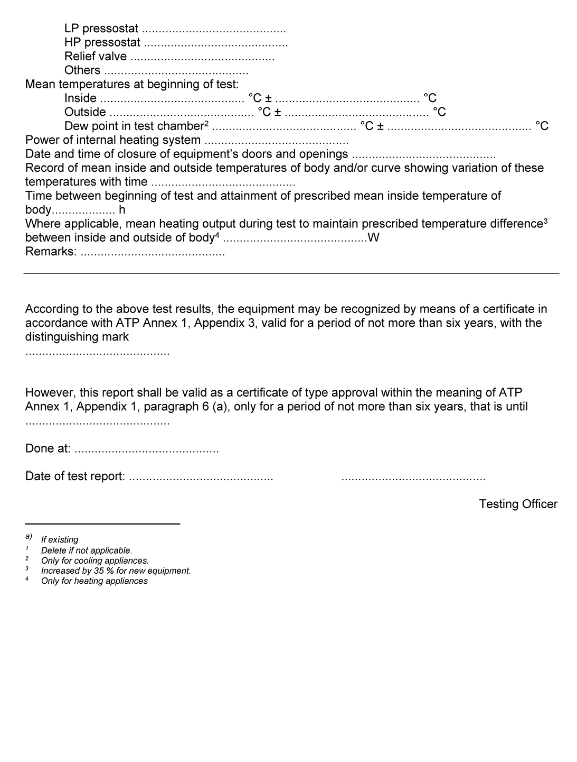
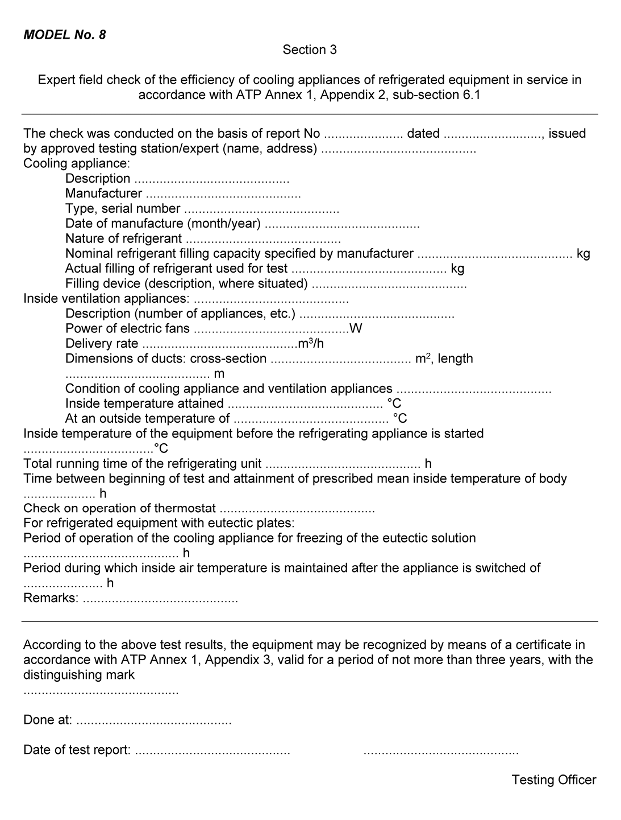
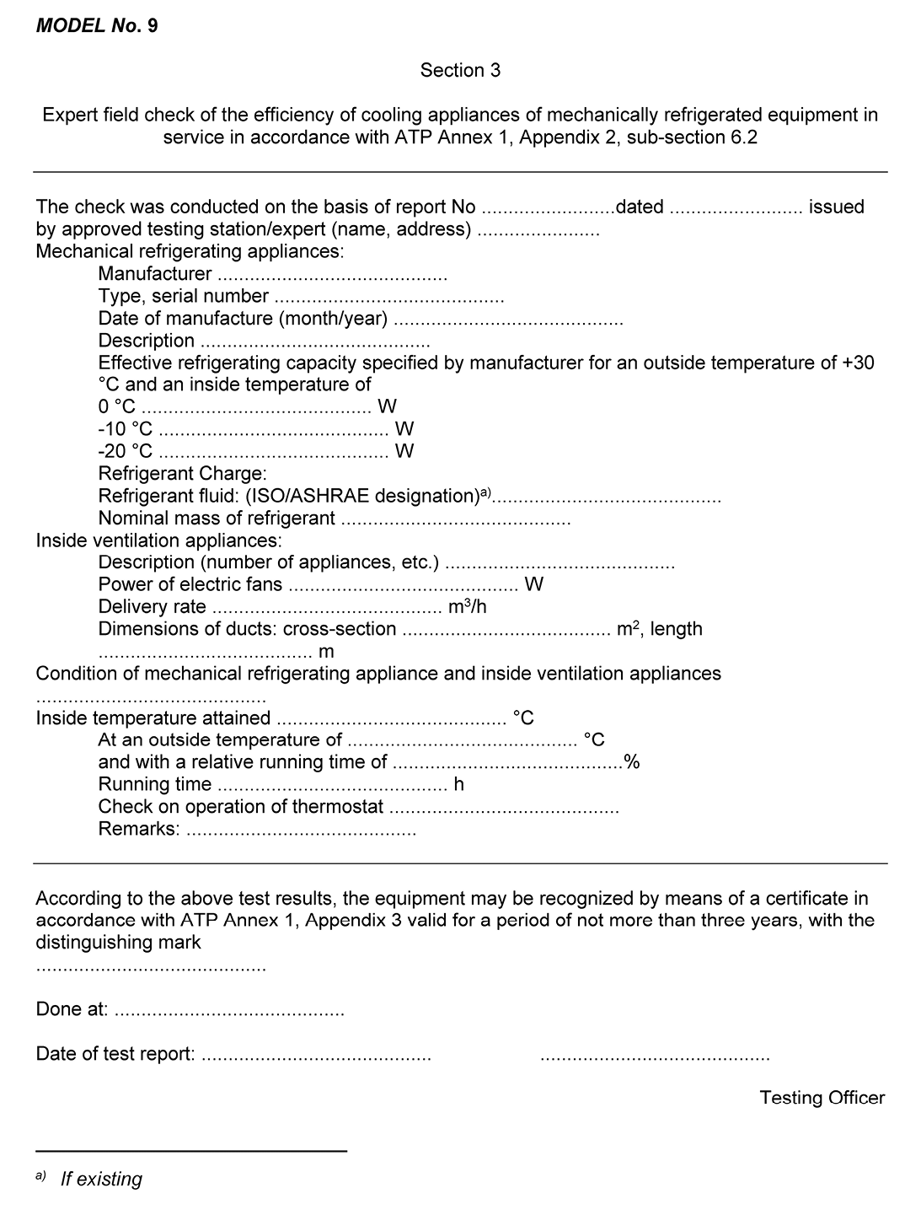
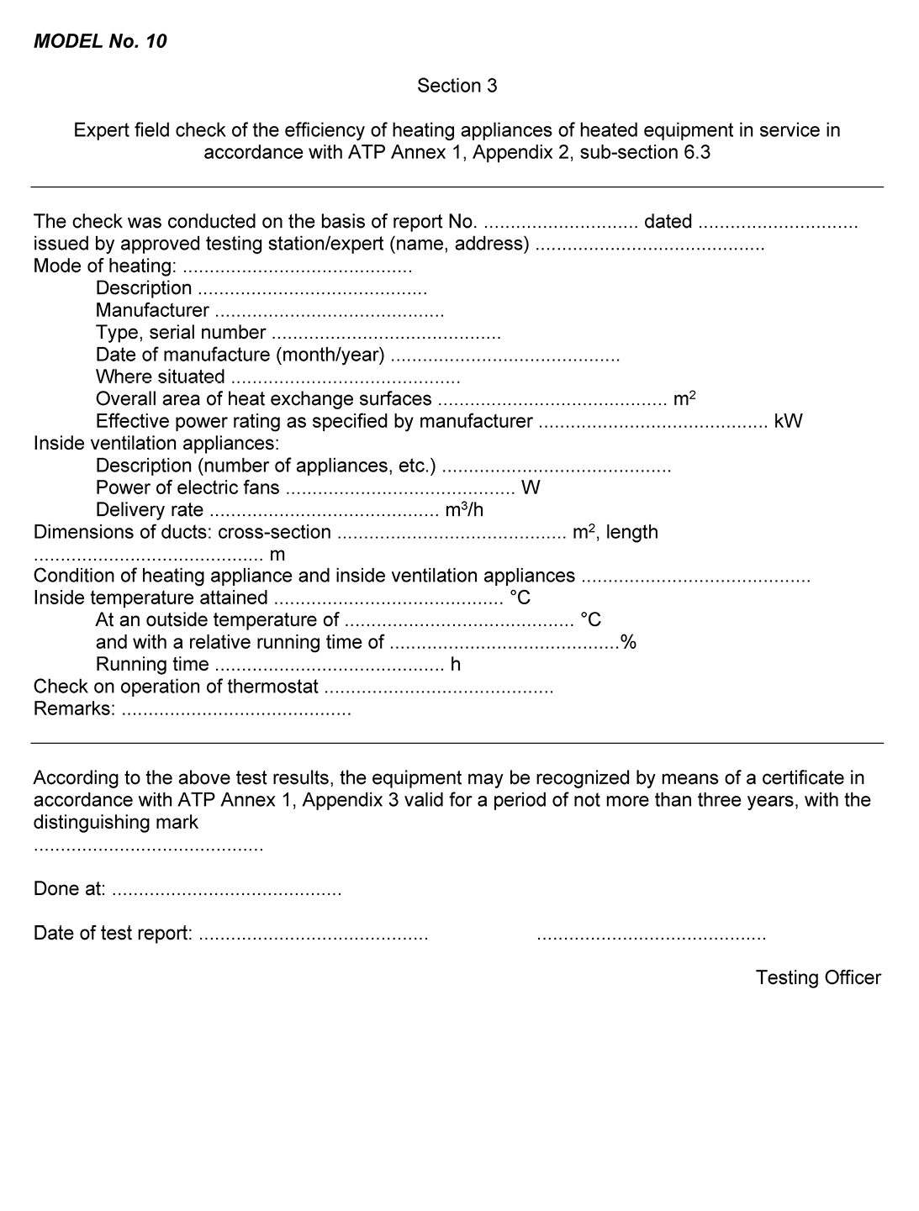
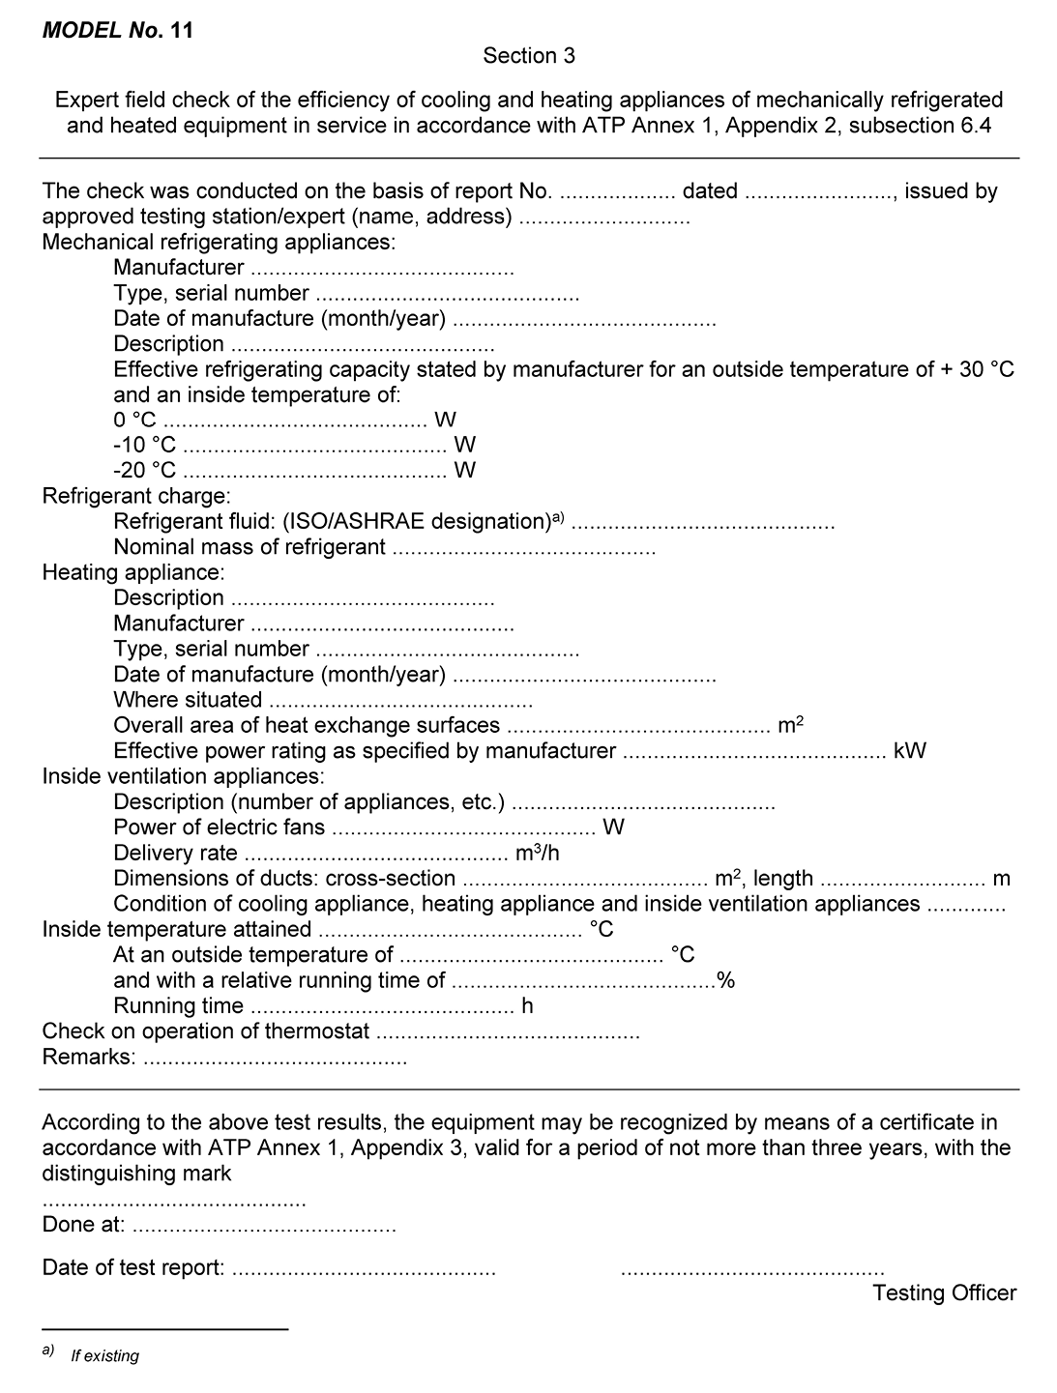
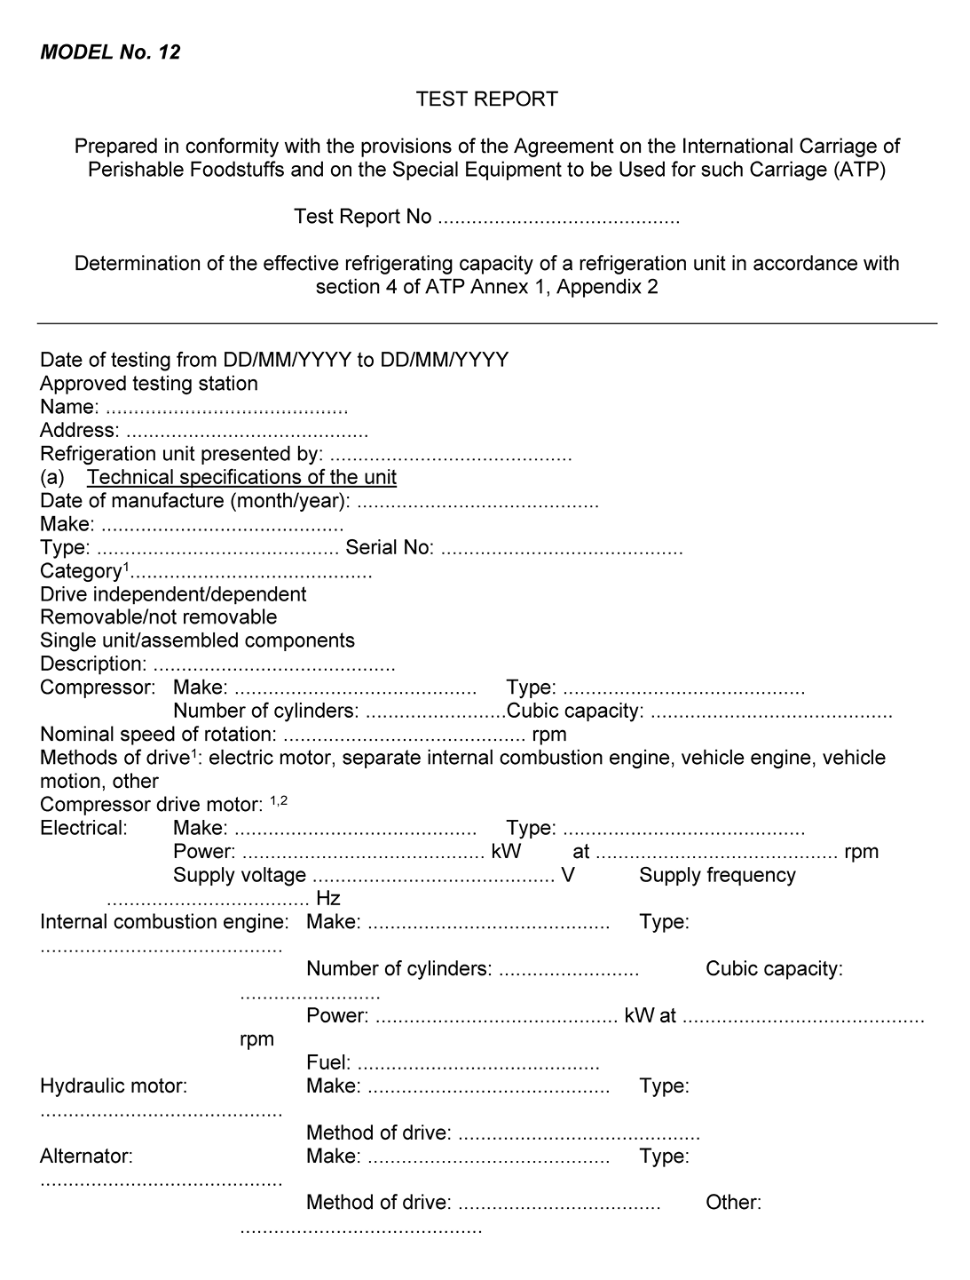
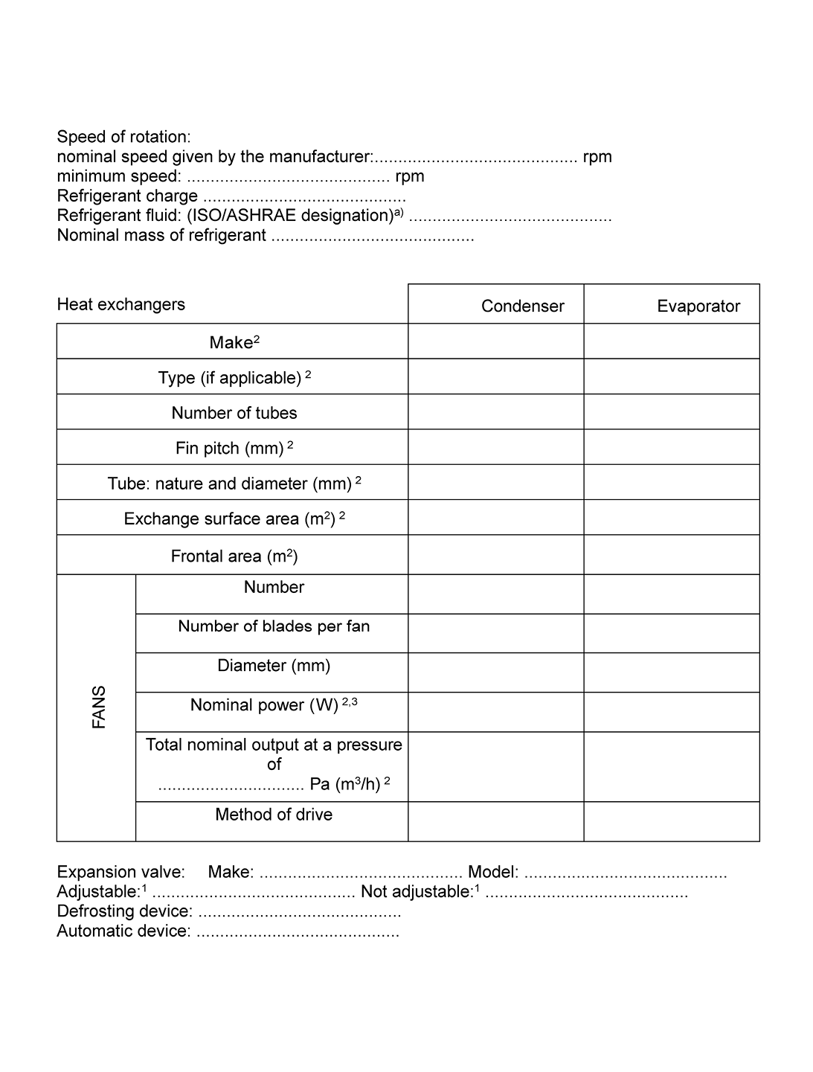
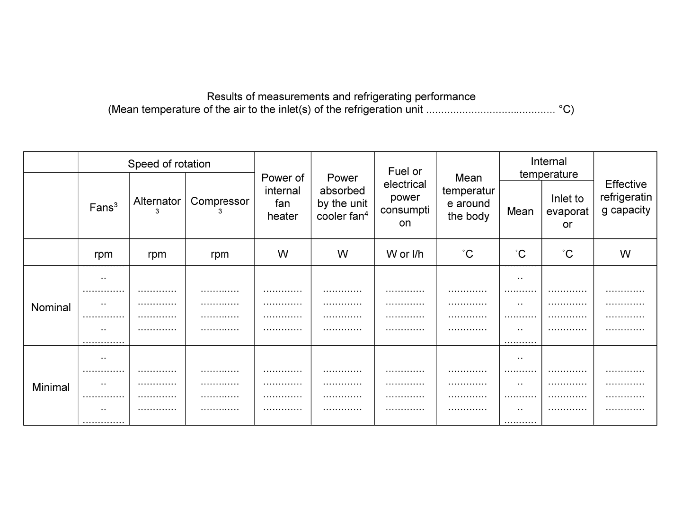
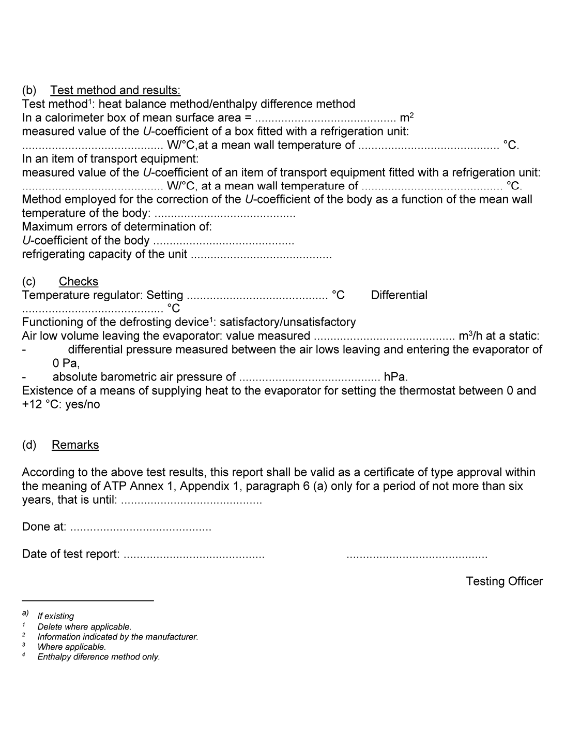
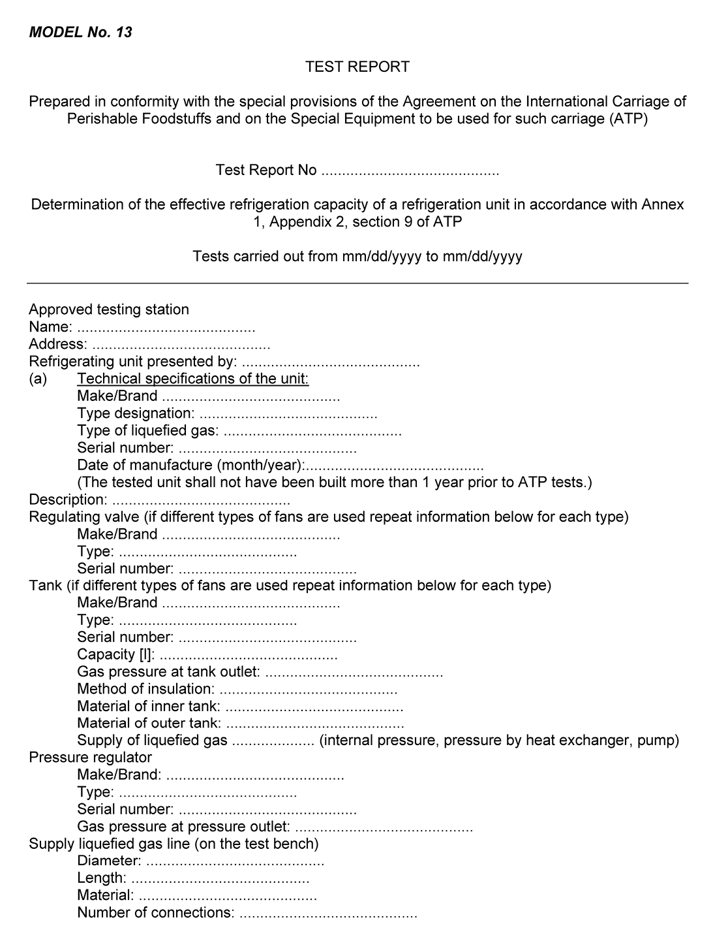
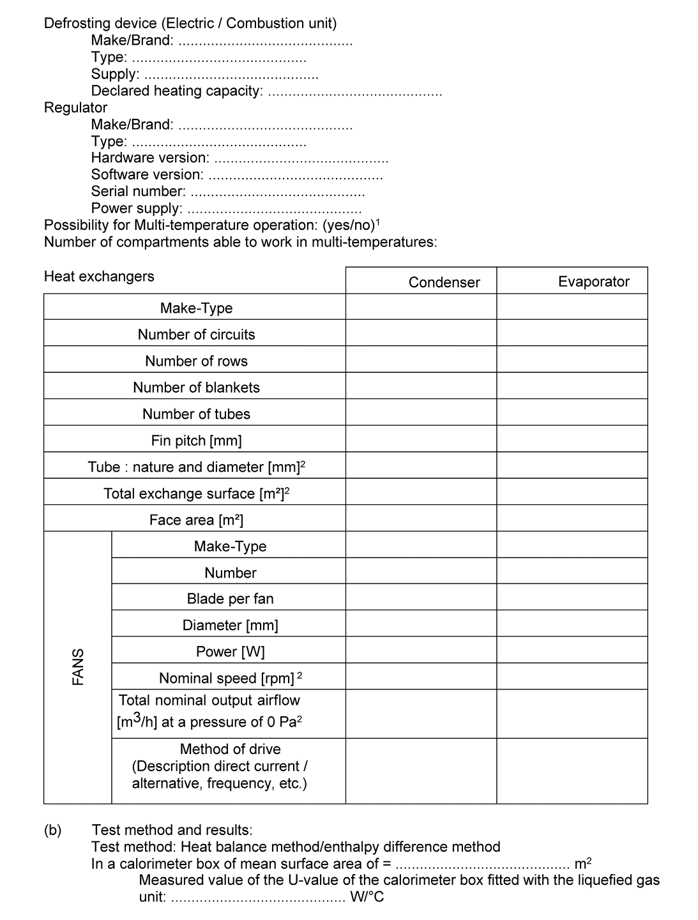
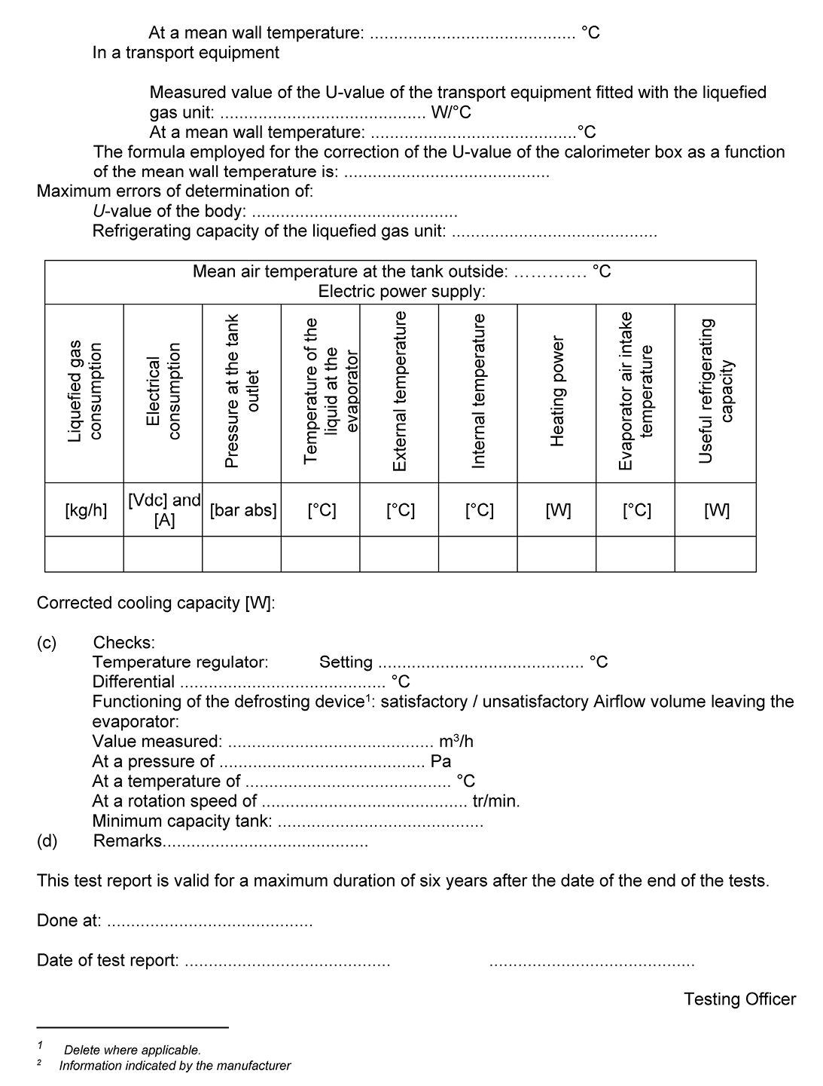
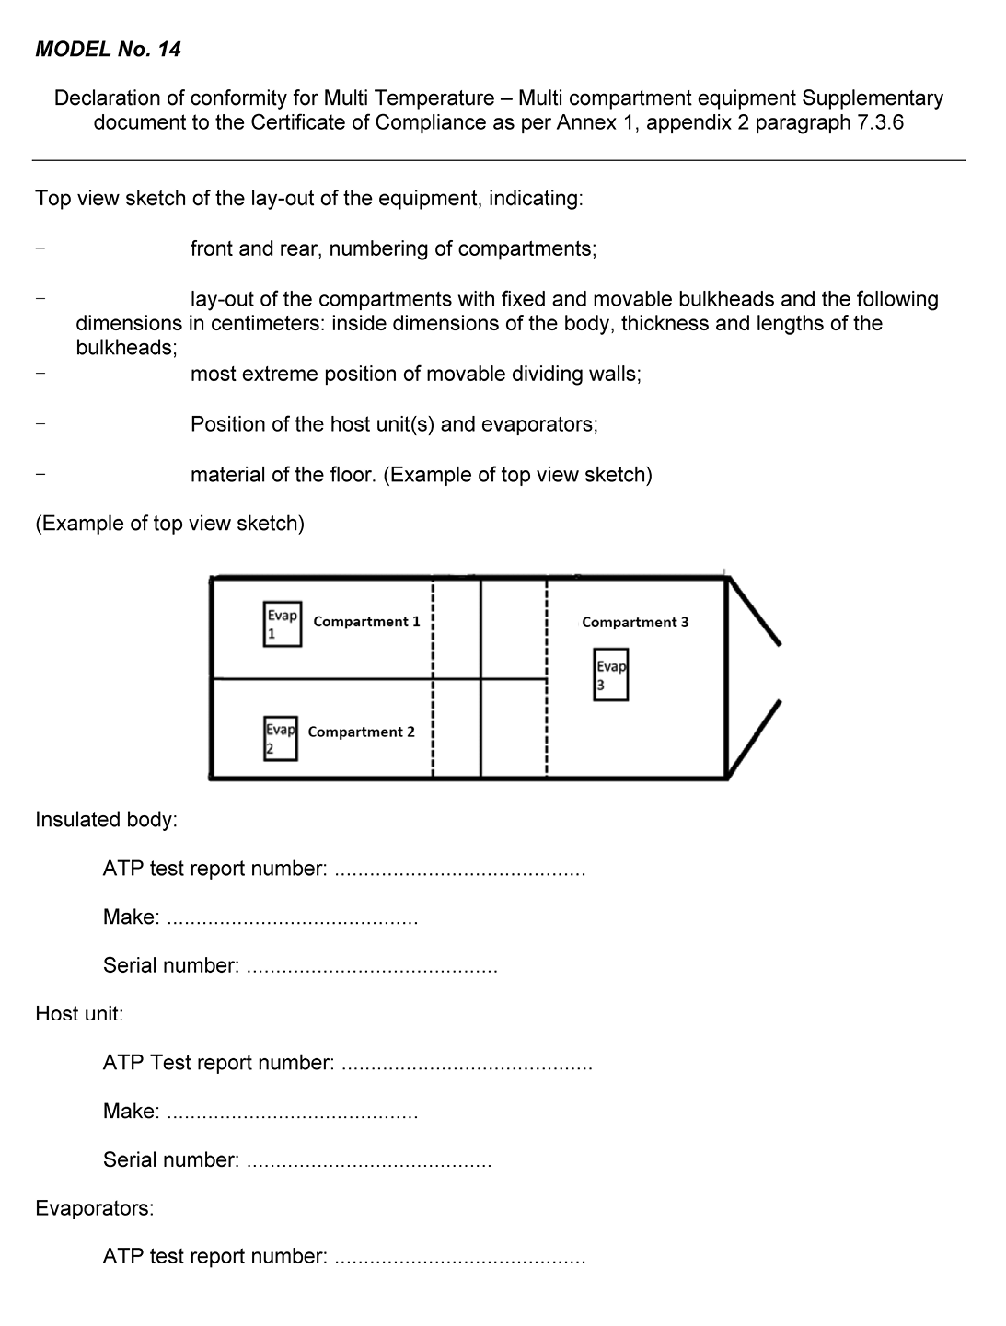
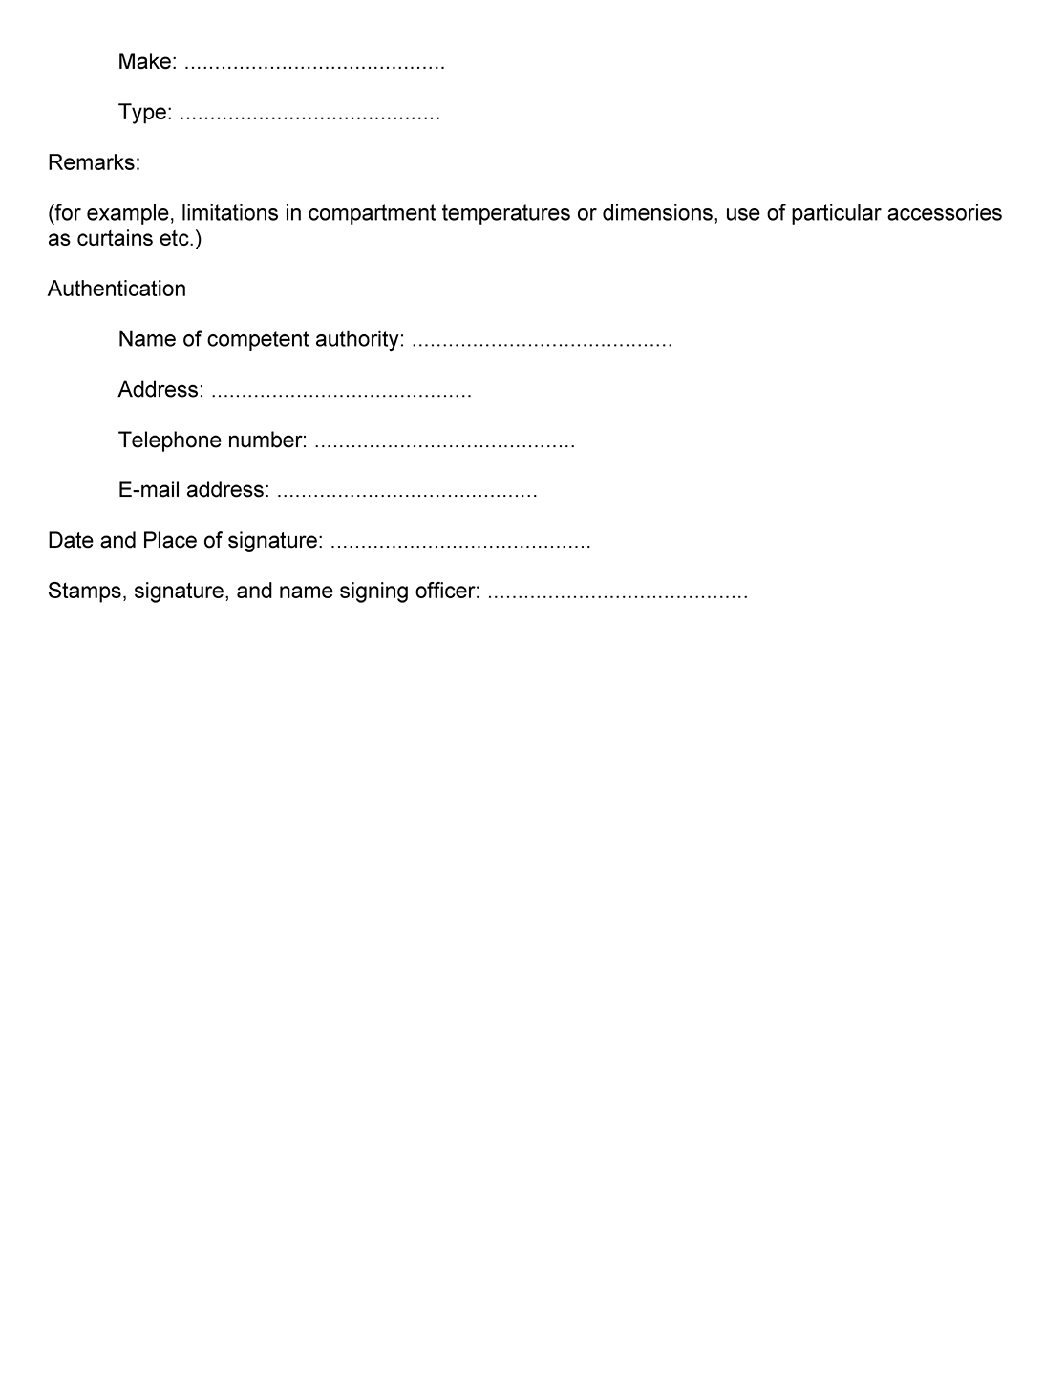
9. PROCEDURE FOR MEASURING THE CAPACITY OF LIQUEFIED GAS UNITS AND DIMENSIONING THE EQUIPMENT THAT USES THESE UNITS
9.1 Definitions
a) A liquefied gas unit is composed of a tank containing liquefied gas, a regulating system, an interconnection system, a muffler if applicable and one or more evaporator;
b) Primary evaporator: any minimal structure comprising a liquefied gas unit intended to absorb thermal capacity in an insulated compartment;
c) Evaporator: any composition made up of primary evaporators located in an insulated compartment;
d) Maximum nominal evaporator: any composition made up of primary evaporators located in one or more insulated compartments;
e) Mono-temperature liquefied gas unit: liquefied gas unit made up of a liquefied gas tank connected to a single evaporator for regulating the temperature of a single insulated compartment;
f) Multi-temperature liquefied gas unit: liquefied gas unit made up of a liquefied gas tank connected to at least two evaporators, each regulating the temperature of a single, distinct insulated compartment in the same multi-compartment equipment;
g) Mono-temperature operation: operation of a mono- or multi-temperature liquefied gas unit in which a single evaporator is activated and maintains a single compartment in mono-compartment or multi-compartment equipment;
h) Multi-temperature operation: operation of a multi-temperature liquefied gas unit with two or more activated evaporators that maintain two different temperatures in insulated compartments in multi-compartment equipment;
i) Maximum nominal refrigerating capacity (Pmax-nom): the maximum specified refrigerating capacity set by the manufacturer of the liquefied gas unit;
j) Nominal installed refrigeration capacity (Pnom-ins): the maximum refrigeration capacity within the maximum nominal refrigerating capacity that can be provided by a given configuration of evaporators in a liquefied gas unit;
k) Individual refrigerating capacity (Pind-evap): the maximum refrigerating capacity generated by each evaporator when the liquefied gas unit is operating as a mono-temperature unit;
l) Effective refrigerating capacity (Pef-frozen-evap): the refrigerating capacity available to the lowest temperature evaporator when the liquefied gas unit is operating as described in paragraph 9.2.4.
9.2 Test procedure for liquefied gas units
9.2.1 General procedure
The test procedure shall be as specified in annex 1, appendix 2, section 4 of ATP, taking account of the following particularities.
The tests shall be conducted for the different primary evaporators. Each primary evaporator shall be tested on a separate calorimeter, if applicable, and placed in a temperature-controlled test cell.
For mono-temperature liquefied gas units, only the refrigeration capacity of the regulating unit with the maximum nominal capacity evaporator will be measured. A third temperature level is added in accordance with annex 1, appendix 2, paragraph 4 of ATP.
For multi-temperature liquefied gas units, the individual refrigerating capacity shall be measured for all primary evaporators, each operating in mono-temperature mode as specified in paragraph 9.2.3.
The refrigerating capacities are determined by using a liquefied gas tank provided by the manufacturer that allows a complete test to be carried out without intermediate refilling.
All the elements of the liquefied gas refrigeration unit shall be placed in a thermostatic enclosure maintained at an ambient temperature of 30 ± 0.5 ºC.
For each test, the following shall also be recorded:
The flow, temperature and pressure of the liquefied gas emerging from the tank in use;
The voltage, electrical current and total electrical consumption absorbed by the liquefied gas unit
(i.e. fan…);
The gas flow is equal to the mean mass consumption of fluid throughout the test in question.
Except when determining the liquefied gas flow, each quantity shall be physically captured for a fixed period equal to or less than 10 seconds and each quantity shall be recorded for a fixed maximum period of 2 minutes, subject to the following:
Each temperature recorded at the air intake of the ventilated evaporator or each air temperature recorded inside the body of the non-ventilated evaporator shall comply with the expected class temperature ± 1 ºC.
If the electrical components of the liquefied gas unit can be fed by more than one electrical power supply, the tests shall be repeated accordingly.
If the tests show equivalent maximum nominal refrigerating capacities, regardless of the operating mode of the liquefied gas refrigeration unit, then the tests may be restricted to a single electrical power supply mode, taking into account the potential impact on the air flow expelled by the evaporators, where applicable. Equivalence is demonstrated if:
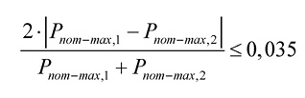
Where:
P_{nom-max,1}: The maximum nominal capacity of the liquefied gas unit for a given electrical power supply mode,
P_{nom-max,2}: The second maximum nominal capacity of the liquefied gas unit for a different electrical power supply mode.
9.2.2 Determination of the maximum nominal refrigerating capacity of the liquefied gas unit
The test shall be conducted at reference temperatures of -20 ºC and 0 ºC.
The nominal refrigerating capacity at -10 ºC shall be calculated by linear interpolation of the capacities at -20 ºC and 0 ºC.
The maximum nominal refrigerating capacity of the regulating unit in mono-temperature operation shall be measured with the maximum nominal evaporator offered by the manufacturer. This evaporator is formed of the primary refrigeration evaporator(s).
The test shall be conducted with the unit operating at a single reference temperature, corresponding to the temperature of the air intake in the case of ventilated evaporators or the temperature of the air inside the body in the case of non-ventilated evaporators.
The maximum nominal refrigerating capacity shall be estimated at each level of temperature as follows:
A first test shall be carried out, for at least four hours, under control of the thermostat (of the refrigeration unit) to stabilize the heat transfer between the interior and exterior of the calorimeter box.
After re-filling of the tank (if needed), a second test shall be carried out for at least three hours for the measurement of the maximum nominal refrigerating capacity in which:
a) The set point of the liquefied gas unit shall be set to the chosen test temperature with a set point shift if necessary, in accordance with the instructions of the test sponsor;
b) The electrical power dissipated in the calorimeter box shall be adjusted throughout the test to ensure that the reference temperature remains constant.
The refrigerating capacity drift during this second test shall be lower than a rolling average of 5% per hour and shall not exceed 10% during the course of the test. If this is the case, the refrigeration capacity obtained corresponds to the minimum refrigeration capacity recorded during the course of the test.
Only for the measurement of the maximum nominal refrigerating capacity of the liquefied gas unit, a single additional test of one hour shall be conducted with the smallest tank sold with the unit to quantify the impact of its volume on the regulation of the refrigerating capacity. The new refrigerating capacity obtained shall not vary by more than 5% from the lower value or compared to the value found with the tank used for the tests of three hours or more. Where the impact is greater, a restriction on the volume of the tank shall be included in the official test report.
9.2.3 Determination of the individual refrigerating capacity of each primary evaporator of a liquefied gas unit
The individual refrigerating capacity of each primary evaporator shall be measured in mono-temperature operation. The test shall be conducted at -20 ºC and 0 ºC, as prescribed in paragraph 9.2.2.
The individual refrigerating capacity at -10 ºC shall be calculated by linear interpolation of the capacities at -20 ºC and 0 ºC.
9.2.4 Determination of the remaining effective refrigerating capacity of a liquefied gas unit in multi-temperature operation at a reference heat load
Determination of the remaining effective capacity of a liquefied gas refrigeration unit requires the simultaneous use of two or three evaporators, as follows:
a) For a two-compartment unit, the evaporators with the highest and lowest individual refrigerating capacities;
b) For a unit with three or more compartments, the same evaporators as above and as many others as needed, with intermediate refrigerating capacity.
Setting of the reference heat load:
a) The set points of all but one of the evaporators shall be set in such a way as to obtain an air intake temperature, or, if not applicable, an air temperature inside the body, of 0 ºC;
b) A heat load shall be applied to each calorimeter/ evaporator pair under control of the thermostat, except the one not selected;
c) The heat load shall be equal to 20% of the individual refrigerating capacity at -20 ºC of each evaporator.
The effective capacity of the remaining evaporator shall be determined at an air intake temperature, or, if not applicable, an air temperature inside the body, of -20 ºC.
Once the effective capacity of the remaining evaporator has been determined, the test shall be repeated after conducting a circular permutation of the temperature classes.
9.3 Refrigerating capacity of evaporators
Refrigeration evaporators can be created on the basis of refrigeration capacity tests carried out on primary evaporators. The refrigeration capacity and liquefied gas consumption of the evaporators equal the arithmetic sum of the refrigeration capacity and of the liquefied gas consumption, respectively, of the primary evaporators within the limit of the maximum nominal refrigerating capacity and of the associated flow of liquefied gas.
9.4 Dimensioning and certification of refrigerated multi-temperature liquefied gas equipment
The dimensioning and certification of refrigerated equipment using liquefied gas refrigeration units shall be carried out as prescribed in section 3.2.6 for mono-temperature equipment, with the following capacity equivalents:
Pnom-ins = Peff (effective refrigerating capacity)
or section 7.3 for multi-temperature refrigerating equipment, with the following capacity equivalents:
Pmax-nom = Pnominal
In addition, the usable volume of liquefied gas tanks shall be such as to permit the liquefied gas unit to maintain the temperature for that class of equipment for a minimum of 12 hours.
Annex 1, Appendix 3
A. Model form of certificate of compliance of the equipment, as prescribed in Annex 1, Appendix 1, paragraph 3
FORM OF CERTIFICATE FOR INSULATED, REFRIGERATED, MECHANICALLY REFRIGERATED, HEATED OR MECHANICALLY REFRIGERATED AND HEATED EQUIPMENT USED FOR THE INTERNATIONAL CARRIAGE OF PERISHABLE FOODSTUFFS BY LAND
Certificates of compliance of equipment issued before 2 January 2011 in accordance with the requirements regarding the model of the certificate in Annex 1, Appendix 3 in force until 1 January 2011 shall remain valid until their original date of expiry.
Certificates of compliance issued before the date of entry into force of the modification to item 3 of the model certificate (30 September 2015) shall remain valid until their original date of expiry.
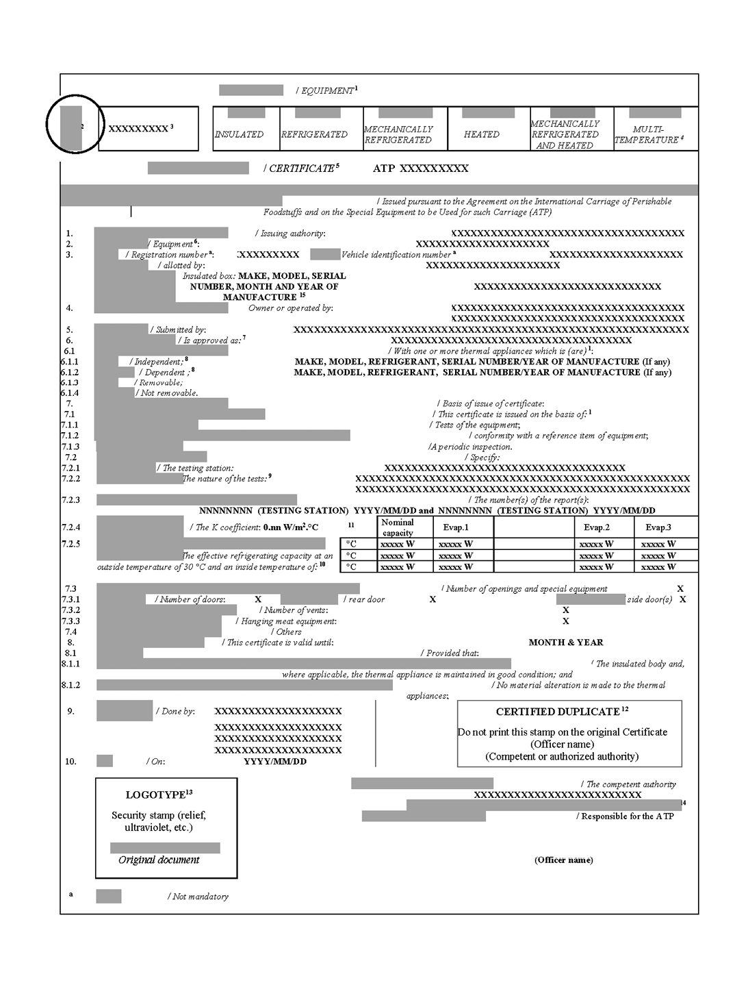
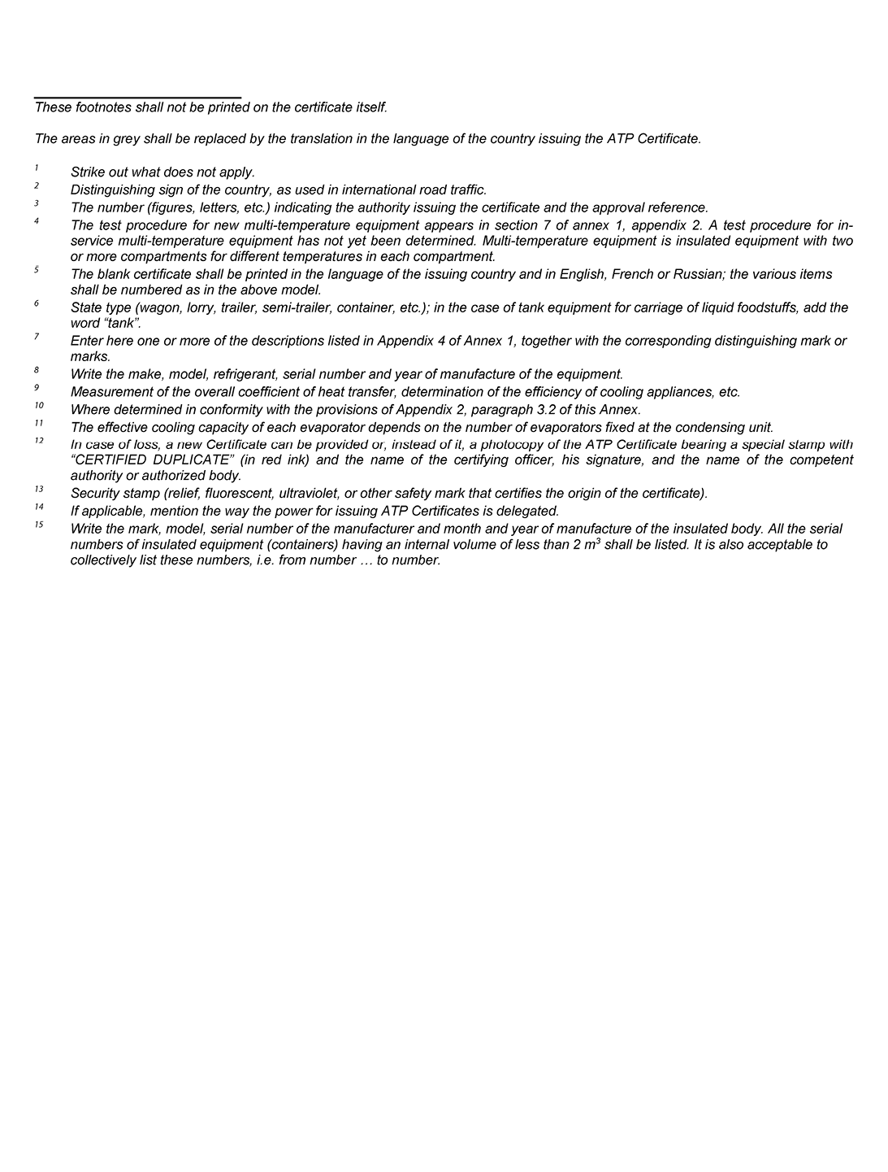
B. Certification plate of compliance of the equipment, as provided for in Annex 1, Appendix 1, paragraph 3
1. The certification plate shall be affixed to the equipment permanently and in a clearly visible place adjacent to any other approval plate issued for official purposes. The plate, conforming to the model reproduced below, shall take the form of a rectangular, corrosion-resistant and ire-resistant plate measuring at least 160 mm by 100 mm. The following particulars shall be indicated legibly and indelibly on the plate in at least the English or French or Russian language:
a) The Latin letters "ATP" followed by the words "APPROVED FOR TRANSPORT OF PERISHABLE FOODSTUFFS";
b) "APPROVAL NUMBER" followed by the distinguishing sign (in international road traffic) of the State in which the approval was granted and the number (figures, letters, etc.) of the approval reference;
c) "EQUIPMENT NUMBER" followed by the individual number assigned to identify the particular item of equipment (which may be the manufacturer’s number);
d) "ATP MARK" followed by the distinguishing mark prescribed in annex l, appendix 4, corresponding to the class and the category of the equipment;
e) "VALID UNTIL" followed by the date (month and year) when the approval of the unit of equipment expires. If the approval is renewed following a test or inspection, the subsequent date of expiry may be added on the same line.
2. The letters "ATP" and the letters of the distinguishing mark should be approximately 20 mm high. Other letters and figures should not be less than 5 mm high.
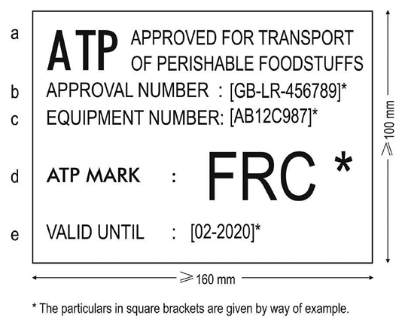
Annex 1, Appendix 4
DISTINGUISHING MARKS TO BE AFFIXED TO SPECIAL EQUIPMENT
The distinguishing marks prescribed in appendix 1, paragraph 4 to this annex shall consist of capital Latin letters in dark blue on a white ground. The height of the letters shall be at least 100 mm for the classification marks and at least 50 mm for the expiry dates. For special equipment, such as a laden vehicle with maximum mass not exceeding 3.5 t, the height of the classification marks could likewise be 50 mm and at least 25 mm for the expiry dates.
The classification and expiry marks shall at least be affixed externally on both sides in the upper corners near the front.
The marks shall be as follows:
Equipment | Distinguishing  mark
Normally insulated equipment | IN
Heavily insulated equipment | IR
Class A refrigerated equipment with normal insulation | RNA
Class A refrigerated equipment with heavy insulation | RRA
Class B refrigerated equipment with heavy insulation | RRB
Class C refrigerated equipment with heavy insulation | RRC
Class D refrigerated equipment with normal insulation | RND
Class D refrigerated equipment with heavy insulation | RRD
Class A mechanically refrigerated equipment with normal insulation | FNA
Class A mechanically refrigerated equipment with heavy insulation | FRA
Class B mechanically refrigerated equipment with heavy insulation | FRB
Class C mechanically refrigerated equipment with heavy insulation | FRC
Class D mechanically refrigerated equipment with normal insulation | FND
Class D mechanically refrigerated equipment with heavy insulation | FRD
Class E mechanically refrigerated equipment with heavy insulation | FRE
Class F mechanically refrigerated equipment with heavy insulation | FRF
Class A heated equipment with normal insulation | CNA
Class A heated equipment with heavy insulation | CRA
Class B heated equipment with heavy insulation | CRB
Class C heated equipment with heavy insulation | CRC
Class D heated equipment with heavy insulation | CRD
Class A mechanically refrigerated and heated equipment with normal insulation | BNA
Class A mechanically refrigerated and heated equipment with heavy insulation | BRA
Class B mechanically refrigerated and heated equipment with heavy insulation | BRB
Class C mechanically refrigerated and heated equipment with heavy insulation | BRC
Class D mechanically refrigerated and heated equipment with heavy insulation | BRD
Class E mechanically refrigerated and heated equipment with heavy insulation | BRE
Class F mechanically refrigerated and heated equipment with heavy insulation | BRF
Class G mechanically refrigerated and heated equipment with heavy insulation | BRG
Class H mechanically refrigerated and heated equipment with heavy insulation | BRH
Class I mechanically refrigerated and heated equipment with heavy insulation | BRI
Class J mechanically refrigerated and heated equipment with heavy insulation | BRJ
Class K mechanically refrigerated and heated equipment with heavy insulation | BRK
Class L mechanically refrigerated and heated equipment with heavy insulation | BRL
In the case of multi-compartment road equipment divided in two compartments the equipment mark shall consist in the distinguishing marks of each compartment (example: FRC-FRA) starting with the compartment located at the front or on the left side of the equipment.
In the case of other multi-compartment equipment, the distinguishing mark shall be selected only for the highest ATP class, i.e. the class that permits the highest difference between inside and outside temperatures, and supplemented by the letter M (example: FRC-M).
This marking is mandatory for all equipment built from 1 October 2020.
If the equipment is fitted with a removable or dependent thermal appliance and if special conditions exist for the use of the thermal appliance, the distinguishing mark or marks shall be supplemented by the letter X in the following cases:
1. FOR REFRIGERATED EQUIPMENT:
Where the eutectic plates have to be placed in another chamber for freezing;
2. FOR MECHANICALLY REFRIGERATED EQUIPMENT AND MECHANICALLY REFRIGERATED AND HEATED EQUIPMENT:
2.1 Where the compressor is powered by the vehicle engine;
2.2 Where the refrigeration or refrigeration-heating unit itself or a part is removable, which would prevent its functioning.
The date (month, year) entered under section A, item 8 in appendix 3 of this annex as the date of expiry of the certificate issued in respect of the equipment shall be quoted under the distinguishing mark or marks aforesaid.
Model:
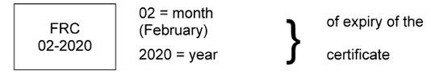
Annex 2
SELECTION OF EQUIPMENT AND TEMPERATURE CONDITIONS TO BE OBSERVED FOR THE CARRIAGE OF QUICK (DEEP)-FROZEN AND FROZEN FOODSTUFFS
1. For the carriage of the following quick (deep)-frozen and frozen foodstuffs, the transport equipment has to be selected and used in such a way that during carriage the highest temperature of the foodstuffs at any point of the load does not exceed the indicated temperature.
By that means the equipment used for the transport of quick-frozen foodstuffs shall be fitted with the device referred to in appendix 1 to this annex. If however one should proceed to the verification of the temperature of the foodstuff, this shall be done according to the procedure laid down in appendix 2 to this annex.
2. Accordingly, the temperature of the foodstuffs at any point in the load must be at or below the indicated value on loading, during carriage and on unloading.
3. Where it is necessary to open the equipment, e.g. to carry out inspections, it is essential to ensure that the foodstuffs are not exposed to procedures or conditions contrary to the objectives of this annex and those of the International Convention on the Harmonization of Frontier Controls of Goods.
4. During certain operations, such as defrosting the evaporator of mechanically refrigerated equipment, a brief rise of the temperature of the surface of the foodstuffs of not more than 3 ºC in a part of the load, e.g. near the evaporator, above the appropriate temperature may be permitted.
Ice cream | -20 ºC
Frozen or quick (deep)-frozen fish, fish products, molluscs and crustaceans and all other quick (deep)-frozen foodstuffs -18 ºC
All other frozen foodstuffs (except butter) | -12 ºC
Butter | -10 ºC
Deep-frozen and frozen foodstuffs mentioned below to be immediately further processed at destination:
Butter
Concentrated fruit juice
--------
1 The deep-frozen and frozen foodstuffs listed, when intended for immediate further processing at destination, may be permitted gradually to rise in temperature during carriage so as to arrive at their destination at temperatures no higher than those specified by the sender and indicated in the transport contract. This temperature should not be higher than the maximum temperature authorized for the same foodstuff when refrigerated as mentioned in annex 3. The transport document shall state the name of the foodstuff, whether it is deep-frozen or frozen and that it is immediately to be further processed at destination. This carriage shall be undertaken with ATP-approved equipment without use of a thermal appliance to increase the temperature of the foodstuffs1
Annex 2, Appendix 1
MONITORING OF AIR TEMPERATURE FOR TRANSPORT OF QUICK-FROZEN PERISHABLE FOODSTUFFS
The transport equipment shall be fitted with an instrument capable of measuring and recording air temperatures and storing the data obtained (hereinafter referred to as the instrument) to monitor the air temperatures to which quick-frozen foodstuffs intended for human consumption are subjected.
The instrument shall be verified in accordance with EN 13486:2002 by an accredited body and the documentation shall be available for the approval of ATP competent authorities.
The instrument shall comply with standard EN 12830:2018.
Temperature recorders in service that comply with EN 12830:1999 may continue to be used.
Temperature recordings obtained in this manner must be dated and stored by the operator for at least one year or longer, according to the nature of the food.
Annex 2, Appendix 2
PROCEDURE FOR THE SAMPLING AND MEASUREMENT OF TEMPERATURE FOR CARRIAGE OF CHILLED, FROZEN AND QUICK-FROZEN PERISHABLE FOODSTUFFS
A. GENERAL CONSIDERATIONS
1. Inspection and measurement of temperatures stipulated in annexes 2 and 3 should be carried out so that the foodstuffs are not exposed to conditions detrimental to the safety or quality of the foodstuffs. Measuring of food temperatures should be carried out in a refrigerated environment, and with the minimum delays and minimum disruption of transport operations.
2. Inspection and measurement procedures, as referred to in paragraph 1, shall preferably be carried out at the point of loading or unloading. These procedures should not normally be carried out during transport, unless serious doubt exists about the conformity of the temperatures of the foodstuffs stipulated in annexes 2 and 3.
3. Where possible, the inspection should take account of information provided by temperature monitoring devices during the journey before selecting those loads of perishable foodstuffs for sampling and measurement procedures. Progression to temperature measurement of the food should only be undertaken where there is reasonable doubt of the temperature control during carriage.
4. Where loads have been selected, a non-destructive measurement (between-case or between-pack) should at first be used. Only where the results of the non-destructive measurement do not conform with the temperatures laid down in annexes 2 or 3 (taking into account allowable tolerances), are destructive measurements to be carried out. Where consignments or cases have been opened for inspection, but no further action has been taken, they should be resealed giving the time, date, place of inspection, and the official stamp of the inspection authority.
B. SAMPLING
5. The types of package selected for temperature measurement shall be such that their temperature is representative of the warmest point of the consignment.
6. Where it is necessary to select samples during transport whilst the consignment is loaded, two samples should be taken from the top and bottom of the consignment adjacent to the opening edge of each door or pair of doors.
7. Where samples are taken during unloading of the consignment, four samples should be chosen from any of the following locations:
- top and bottom of the consignment adjacent to the opening edge of the doors;
- top rear corners of the consignment (i.e. furthest away from the refrigeration unit);
- centre of the consignment;
- centre of the front surface of the consignment (i.e. closest to the refrigeration unit);
- top or bottom corners of the front surface of the consignment (i.e. closest to the return air intake of the refrigeration unit).
8. In the case of chilled foods in annex 3, samples should also be taken from the coldest location to ensure that freezing has not occurred during transportation.
C. TEMPERATURE MEASUREMENT OF PERISHABLE FOODSTUFFS
9. The temperature measuring probe should be precooled to as close to the product temperature as possible before measurement.
I. Chilled foods
10. Non-destructive measurement. Measurement between-case or between-pack should be made with a probe with a flat head, which gives a good surface contact, low thermal mass, and high thermal conductivity. When placing the probe between the cases or food packs, there should be sufficient pressure to give a good thermal contact, and sufficient length of probe inserted to minimize conductivity errors.
11. Destructive measurement. A probe with a rigid, robust stem and sharpened point should be used, made from a material which is easy to clean and disinfect. The probe should be inserted into the centre of the food pack, and the temperature noted when a steady reading is reached.
II. Frozen and quick-frozen foods
12. Non-destructive measurement. Same as paragraph 10.
13. Destructive measurement. Temperature probes are not designed to penetrate frozen foods. Therefore, it is necessary to make a hole in the product in which to insert the probe. The hole is made by a precooled product penetration instrument, which is a sharp pointed metallic instrument such as an ice punch, hand drill or an auger. The diameter of the hole should provide a close it to that of the probe. The depth to which the probe is inserted will depend on the type of product:
(i) Where product dimensions allow, insert the probe to a depth of 2.5 cm from the surface of the product;
(ii) Where (i) is not possible because of the size of the product, the probe should be inserted to a minimum depth from the surface of 3 to 4 times the diameter of the probe;
(iii) It is not possible or practical to make a hole in certain foods because of their size or composition e.g. diced vegetables. In these cases, the internal temperature of the food package should be determined by insertion of a suitable sharp-stemmed probe to the centre of the pack to measure the temperature in contact with the food.
After inserting the probe, the temperature should be read when it has reached a steady value.
D. GENERAL SPECIFICATIONS FOR THE MEASURING SYSTEM
14. The measuring system (probe and read-out) used in determining temperature shall meet the following specifications:
(i) the response time should achieve 90% of the difference between the initial and final reading within three minutes;
(ii) the system must have an accuracy of ± 0.5 ºC within the measurement range -20 ºC to + 30 ºC¹;
(iii) the measuring accuracy must not change by more than 0.3 ºC during operation in the ambient temperature range -20 ºC to + 30 ºC;
(iv) the display resolution of the instrument should be 0.1 ºC;
(v) the accuracy of the system should be checked at regular intervals;
(vi) the system should have a current certificate of calibration from an approved institution;
(vii) the electrical components of the system should be protected against undesirable effects due to condensation of moisture;
(viii) the system should be robust and shock proof.
E. ALLOWABLE TOLERANCES IN THE MEASUREMENT OF TEMPERATURE
15. Certain tolerances should be allowed in the interpretation of temperature measurements:
(i) operational - in the case of frozen and quick-frozen foods, a brief rise of up to 3 ºC on the temperature permitted in annex 2 is allowed for the surface temperature of the food;
(ii) methodology - non-destructive measurement can give up to a maximum of 2ºC difference in the reading compared to the true product temperature measurement, especially with the thickness of cardboard in case packaging. This tolerance does not apply to the destructive measurement of temperature.
--------
1The procedure will be definеd.
Annex 3
SELECTION OF EQUIPMENT AND TEMPERATURE CONDITIONS TO BE OBSERVED FOR THE CARRIAGE OF CHILLED FOODSTUFFS
1. For the carriage of the following chilled foodstuffs, the transport equipment has to be selected and used in such a way that during carriage the highest temperature of the foodstuffs at any point of the load does not exceed the indicated temperature. If, however, the verification of the temperature of the foodstuff is carried out, it shall be done according to the procedure laid down in Appendix 2 to Annex 2 to this Agreement.
2. Accordingly, the temperature of the foodstuffs at any point in the load must not exceed the temperature as indicated below on loading, during carriage and on unloading.
3. Where it is necessary to open the equipment, e.g. to carry out inspections, it is essential to ensure that the foodstuffs are not exposed to procedures or conditions contrary to the objectives of this Annex and those of the International Convention on the Harmonization of Frontier Controls of Goods.
4. The temperature control of foodstuffs specified in this Annex should be such as not to cause freezing at any point of the load.
 |  | Maximum temperature
I. | Raw milk¹ | + 6 °C
II. | Red meat² and large game (other than red offal) | + 7 °C
III. | Meat products³, pasteurized milk, butter, fresh dairy products (yoghurt, kefir, cream and fresh cheese⁴), ready cooked foodstuffs (meat, fish, vegetables), ready to eat prepared raw vegetables and vegetable products⁵, concentrated fruit juice and fish products³ not listed below | Either at + 6 ºC or at temperature indicated on the label and/or on the transport documents
IV. | Game (other than large game), poultry² and rabbits | + 4 °C
V. | Red offal² | + 3 °C
VI. | Minced meat² | Either at +2 ºC or at temperature indicated on the label and/or on the transport documents
VII. | Untreated fish, molluscs and crustaceans⁶ | On melting ice or at temperature of melting ice
--------
¹When milk is collected from the farm for immediate processing, the temperature may rise during carriage to +10 ºC.
² Any preparations thereof.
³ Except for products fully treated by salting, smoking, drying or sterilization.
⁴ "Fresh cheese" means a non-ripened (non-matured) cheese which is ready for consumption shortly after manufacturing and which has a limited conservation period.
⁵ Raw vegetables which have been diced, sliced or otherwise size reduced, but excluding those which have only been washed, peeled or simply cut in half.
⁶ Except for live fish, live molluscs and live crustaceans.

