FRAMEWORK LOAN AGREEMENT

BETWEEN COUNCIL OF EUROPE DEVELOPMENT BANK AND THE REPUBLIC OF SERBIA BIO4 CAMPUS PROJECT LOAN
("Off. Herald of RS - Treaties", No. 6/2023)

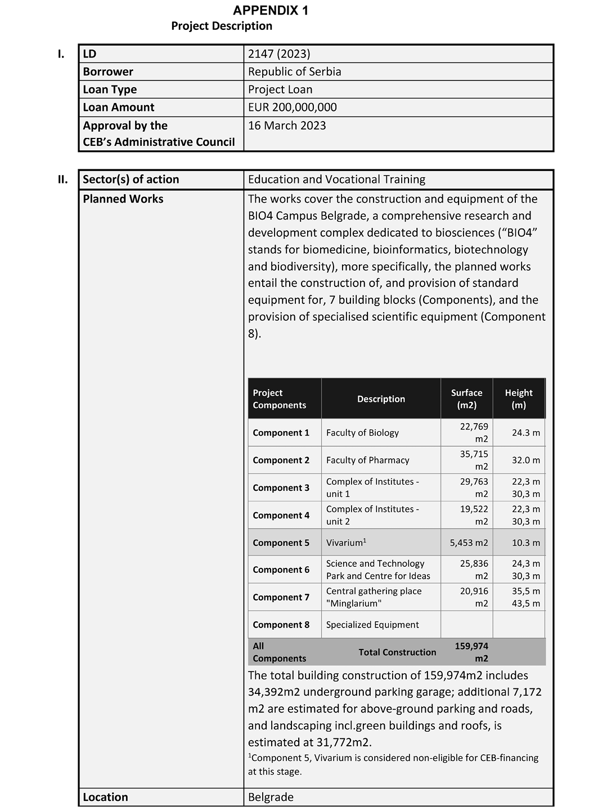
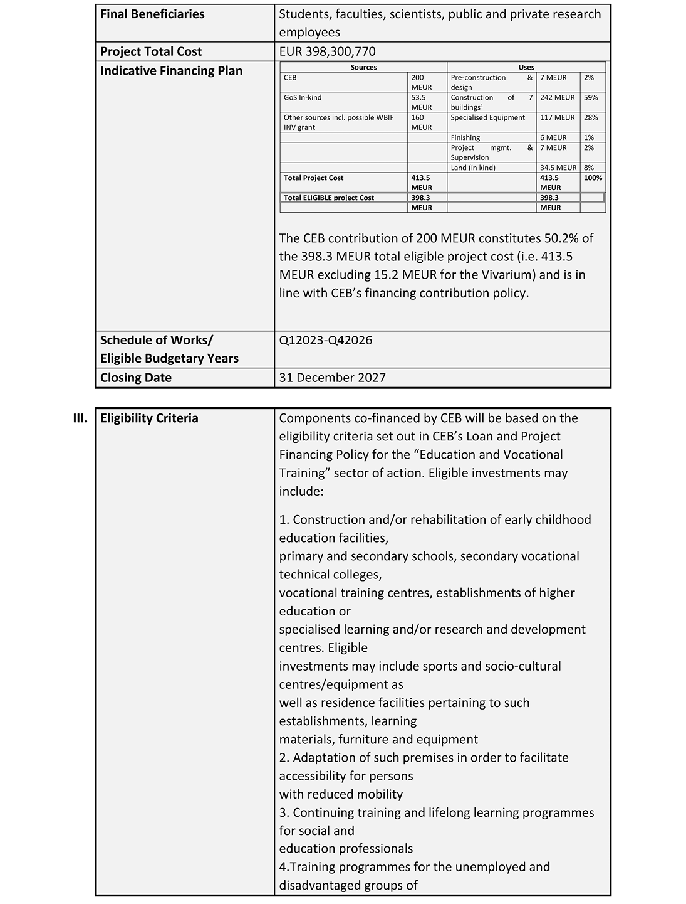
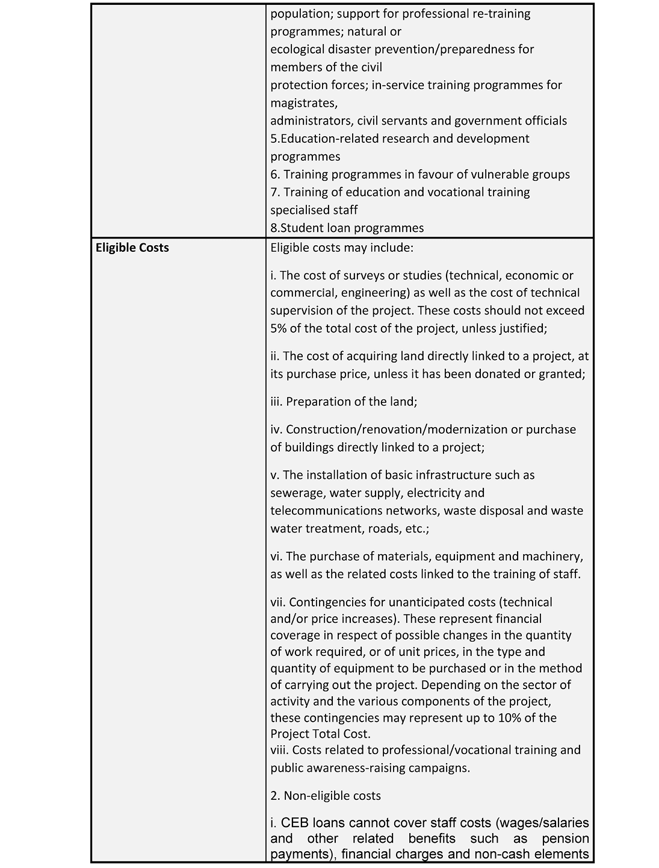
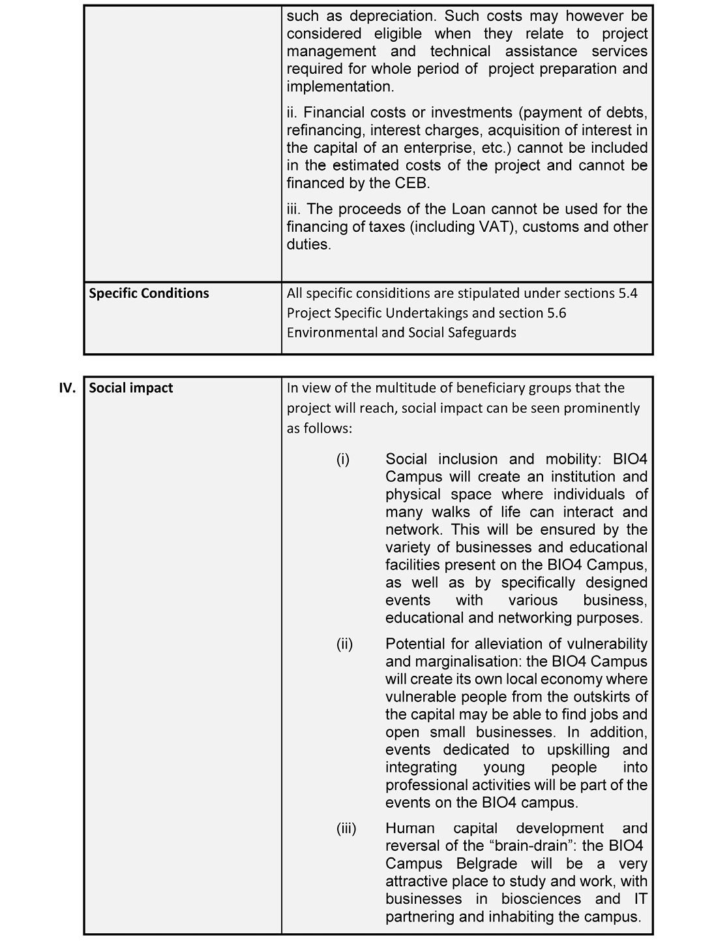
APPENDIX 2
Form of Legal Opinion (Framework Loan Agreement)
Council of Europe Development Bank
55, avenue Kléber
75116 Paris (France)
Attn: Projects Department
Cc: Office of the General Counsel
[INSERT DATE]
Re:Framework Loan Agreement between the Council of Europe Development Bank and the Republic of Serbia (Reference LD 2147 (2023))
Dear Sir or Madam,
In my capacity as the Minister of Justice, I hereby submit this opinion in line with the provisions of Article 4.5(a)(i) of the Framework Loan Agreement LD 2147 (2023) between Council of Europe Development Bank and Republic of Serbia, for an amount of 200,000,000 EUR, signed on _____ and effective as of _____ (hereinafter referred to as the "Loan Agreement"). All the terms that are used here, if not otherwise defined, have the same meaning as in the Loan Agreement.
I have reviewed the Loan Agreement and the provisions of the Constitution of the Republic of Serbia ("Official Gazette of the Republic of Serbia" No. 98/2006), as well as legal documents and other regulations, and I have undertaken other activities that I deemed necessary in order to submit this opinion.
According to the aforementioned, my opinion is as follows:
(a) Pursuant to the provision of Article 123, Item 1 of the Constitution of the Republic of Serbia, it is provided that the Government shall establish and pursue the policy, and pursuant to the provision of Article 2, Paragraph 1 and Article 43, Paragraph 3 of the Law on Government ("Official Gazette of the Republic of Serbia" No. 55/05, 71/05-corrigendum, 101/07, 65/08, 16/11, 68/12-Constitutional Court, 72/12, 7/14 - Constitutional Court, 44/14 and 30/18-other law) it is provided that the Government shall establish and pursue the policy of the Republic of Serbia, and when it does not pass other acts, the Government adopts conclusions. In line with the referred provisions, the Government at its session held on _______ adopted the Conclusion No: _______, whereby it adopted the Draft Loan Agreement and authorized ______________, to sign the Loan Agreement on behalf of the Government as the representative of the Republic of Serbia;
(b) Pursuant to the provision of Article 99, Paragraph 1, Item 4 of the Constitution of the Republic of Serbia, it is provided that the National Assembly of the Republic of Serbia ratifies the international treaties when their ratification is provided by law, and subject to the provision under Article 2, Paragraph 1 of the Law on Conclusion and Execution of International Treaties ("Official Gazette of the Republic of Serbia" No. 32/13) which provides that an international treaty shall be a treaty which the Republic of Serbia concludes in written form with one or more countries or one or more international organizations, which is governed by international law. Pursuant to the provision of Article 5, Paragraph 2 of the Law on Public Debt ("Official Gazette of the Republic of Serbia" No. 61/05, 107/09, 78/11, 68/15, 95/18, 91/19 and 149/20) it is provided that the National Assembly of the Republic of Serbia decides on borrowing of the Republic of Serbia by taking long-term loans, borrowing for investment and program projects financing by taking long-term loans, issuing guarantees, and on direct taking over of the liabilities as a debtor under issued guarantee. In line with the stated provisions, the National Assembly of the Republic of Serbia rendered the Law on Ratification of Framework Loan Agreement LD 2147 (2023) between Council of Europe Development Bank and Republic of Serbia, Project Loan ("Official Gazette of the Republic of Serbia - International Treaties", No. ______);
(c) There are no other provisions according to which it would be necessary to submit, record or register the Loan Agreement with any court or state authority or organization in order to secure its legality, effectiveness and enforceability;
(d) The choice of the law set forth in Article 14 of the Loan Agreement, is legally valid and binding on the Borrower under the laws of the Republic of Serbia;
(е) Pursuant to Article 15 of the Loan Agreement, the arbitration provisions set forth in Chapter 4 of the CEB Loan Regulations shall apply for any claim or dispute between the Republic of Serbia and the Council of Europe Development Bank arising from the Loan Agreement, and any decision of the arbitration tribunal pertaining to the Loan Agreement can be executed in the Republic of Serbia without re-examination or re-litigation of the matters thereby adjudicated. In line with the aforementioned the waiver of immunity pursuant to Article 15 of the Loan Agreement is legally valid and binding;
(f) No taxes, customs duties, fees or other impositions, including without limitation taxes, fees or other levies for registration or transfers that are applicable in the Republic of Serbia, or any other unit of territorial autonomy or local government, shall be payable in connection with the conclusion or execution of the Loan Agreement, or in connection with the payments that the Republic of Serbia is to make to the Council of Europe Development Bank under the Loan Agreement;
(g) No exchange control restrictions are in place or consents are required in order to permit the receipt of all amounts to be disbursed under the Loan Agreement and to permit the repayment of the Loan and the payment of interest and all other amounts due under this Loan Agreement;
(h) The execution of the Loan Agreement did not, and its performance will not violate any norms of the Republic of Serbia or cause any material breach of any agreement or undertaking to which the Republic of Serbia is bound.
In view of everything stated above, I am of the opinion that all conditions that are stipulated by the Constitution, laws and other acts of the Republic of Serbia which could be applied to the Loan Agreement are met, that the provisions of the Loan Agreement are in full force and effect and that the Loan Agreement is legally valid, binding and enforceable in the Republic of Serbia in accordance with its terms.
Yours faithfully,
1. MINISTER
APPENDIX 3
DISBURSEMENT REQUEST (TEMPLATE)
LD 2147 - [•] Tranche
With reference to the Framework Loan Agreement dated [●] (hereinafter, the "Agreement") between the Council of Europe Development Bank (hereinafter, the "CEB") and the Republic of Serbia (hereinafter, the "Borrower"), the Borrower hereby requests the CEB, in accordance with Sub-clause 4.3(a) of the Agreement, to proceed with the disbursement of a Tranche under the specific terms and conditions set out below.
Terms defined in the Agreement shall have the same meaning herein, unless otherwise specified.
Currency/Amount² | [●]
Disbursement Date | [●]
Principal Repayment Period | [●] years [including a grace period of [●] years]
Principal Repayment Date(s) | [●]
Maturity Date | [●]
Interest Rate | Fixed | Maximum [●] per annum
 | Floating | Reference Rate: | [[●]-month EURIBOR/INSERT ANY OTHER REFERENCE RATE] per annum
 |  | Spread | Maximum [●] basis points
Interest Period | [Quarterly] [Semi-annually] in arrears
Interest Payment Dates | The interest payment will take place on [●] every year and for the first time on [●]
Day Count Convention | Modified Following Business Day Convention
Business Day | [●]
Borrower’s Account | Beneficiary’s Name |  | [●]
 | Beneficiary’s Bank |  | Name | [●]
 |  |  | City | [●]
 |  |  | SWIFT | [●]
 |  |  | IBAN | [●]
 |  |  | Reference | [●]
 | Correspondent Bank (if applicable) |  | Name | [●]
 |  |  | City | [●]
 |  |  | SWIFT | [●]
 |  |  | IBAN | [●]
2 [In case of Sub-Tranches, a separate table shall indicate the Amount, Principal Repayment Period, Principal Repayment Date(s), Interest Rate, Interest Period, Interest Payment Dates for each Sub-Tranche.]
[•], on [•].
For the Borrower
[INSERT NAME(S)/TITLE(S)]
DISBURSEMENT NOTICE (TEMPLATE)
LD 2147 - [•] Tranche
In response to your Disbursement Request dated [●] with reference to the Framework Loan Agreement dated [●] (hereinafter, the "Agreement") between the Council of Europe Development Bank (hereinafter, the "CEB") and the Republic of Serbia (hereinafter, the "Borrower"), the CEB hereby notifies to the Borrower, in accordance with Sub-clause 4.3(b) of the Agreement, the terms and conditions of the disbursement of the relevant Tranche.
Terms defined in the Agreement shall have the same meaning herein, unless otherwise specified.
Currency/Amount³ | [●]
Disbursement Date | [●]
Principal Repayment Period | [●] years [including a grace period of [●] years]
Principal Repayment Date(s) | [●]
Maturity Date | [●]
Interest Rate | Fixed | [●] per annum
 | Floating | Reference Rate: | [[●]-month EURIBOR/INSERT ANY OTHER REFERENCE RATE] per annum
 |  | Spread | [●] basis points
Interest Period | [Quarterly] [Semi-annually] in arrears
Interest Payment Dates | The interest payment will take place on [●] every year and for the first time on [●]
Day Count Convention | Modified Following Business Day Convention
Business Day | [●]
Borrower’s Account | Beneficiary’s Name | [●]
 | Beneficiary’s Bank | Name | [●]
 |  | City | [●]
 |  | SWIFT | [●]
 |  | IBAN | [●]
 |  | Reference | [●]
 | Correspondent Bank (if applicable) | Name | [●]
 |  | City | [●]
 |  | SWIFT | [●]
 |  | IBAN | [●]
CEB’s account | Beneficiary’s Name | Council of Europe Development Bank
 | Beneficiary’s SWIFT | CEFPFRPP
 | Beneficiary’s Bank | Name | Deutsche Bank
 |  | City | Frankfurt (Germany)
 |  | SWIFT | DEUTDEFF
 |  | IBAN | DE44 5007 0010 0928 7384 00
3 [In case of Sub-Tranches, a separate table shall indicate the Amount, Principal Repayment Period, Principal Repayment Date(s), Interest Rate, Interest Period, Interest Payment Dates for each Sub-Tranche.]
Paris, on [•]
For the CEB
[INSERT NAME(S)/TITLE(S)]
APPENDIX 4
Form of Certificate
[INSERT LETTERHEAD]
To: Council of Europe Development Bank
From: [BORROWER]
Date: [NOT EARLIER THAN FIVE (5) BUSINESS DAYS BEFORE THE DISBURSEMENT REQUEST]
Subject: Framework Loan Agreement between Council of Europe Development Bank and [BORROWER] dated [●] (the "Agreement").
Dear Sir or Madam,
Terms defined in the Agreement have the same meaning when used in this Certificate. For the purposes of Sub-clause 4.5 of the Agreement, we hereby certify to you as follows:
(a) No Material Adverse Change has occurred, as compared with the situation at the date of signature of the Agreement;
(b) No Cross-Default Event has occurred;
(c) None of the Borrower’s Debt Instruments includes loss-of-rating, financial ratios or pari passu provisions that are stricter than any equivalent provision of the Agreement;
(d) The representations and warranties to be made or repeated by us under Clause 8 of the Agreement are true in all respects; in particular, no Security has been granted to a third party in breach of Sub-clause 7.2 of the Agreement; and
(e) No event or circumstance which could give rise to the early reimbursement, suspension or cancellation of the Loan under the terms of Articles 3.3 (Early reimbursement of disbursed loans), 3.5 (Suspension by the Bank of undisbursed loans) and 3.6 (Cancellation by the Bank of undisbursed loans) of the Loan Regulations has occurred or may reasonably be expected to/is likely to occur.
For the [BORROWER]
APPENDIX 5
Reporting Template (annual progress and completion reports)
PROJECT TITLE: _______________
ANNUAL PROGRESS REPORT
REPORTING PERIOD: dd/mm/yyyy - dd/mm/yyyy
Prepared by (name and signature) _______________
Department______________
Date_______________
Table of Contents
1. Narrative Report
1.1 Summary of the Project
1.2 Activities undertaken and Results achieved
1.3 Vulnerability
1.4 Impact Prospects (to be presented in the completion report)
1.5 Communication and Visibility Activities
1.6 Deviations from the Plan and difficulties encountered, if any, and mitigation measures
1.7 Conditions precedent before disbursement
1.8 Project Specific Undertakings
1.9 Environmental and Social Safeguards
1.10 Project Specific Recomentations
2. Monitoring tables
Table 1: Project Costs and Financing Sources
Table 2A: Procurement Plan
Table 2B: List of Awarded Contracts
Table 3: Implementation Schedule
Table 4: Output/Outcome Indicators
1. Narrative Report
1.1 Summary of the Project
Title of the Project
Objective
Framework Loan Agreement (FLA) entry into force
Project Implementing Structure
Estimated project cost | Original: | Revised:
Approved CEB loan amount
Maximum CEB financing of total eligible costs (in percentage)
Other sources of financing
Implementation period | Original: mm/yy-mm/yy | Revised:
Closing date for CEB loan disbursement
1.2 Activities undertaken and Results achieved
Please describe the progress of activities in relation to the Project, including, but not limited to:
Activity | Progress and results
Land acquisition and preparation
Studies and Design
Procurement related activities
Works, including photos showing the latest progress
Equipment
Management of environmental, social and occupational health and safety risks and related issues (information on any incident occurred; compliance and corrective actions taken)
1.3 Vulnerability
Please describe how vulnerability factors are being addressed in this project and how the project is enhancing social cohesion defined as "the capacity of a society to ensure the well-being of all its members, minimising disparities and avoiding marginalisation"⁴
------------
4 See CEB Strategic Framework and Council of Europe. (2008). Report of the High-Level Task Force on Social Cohesion in the 21st Century, page 14.
Vulnerability factors are related to: (a) where people live (place-based vulnerability factors), (b) their socio-economic status (socio-economic vulnerability factors), and (c) vulnerability factors related to individual characteristics.
1.4 Impact Prospects (to be presented in the completion report)
Provide information and comments as appropriate on the Project’s contribution to achieving the overall objective.
1.5 Communication and Visibility Activities
Please inform about the communication and visibility activities (public announcements, media/newspaper articles that mention CEB and/or other partners) including links of any media events and articles.
1.6 Deviations from the Plan and difficulties encountered, if any, and mitigation measures
Provide information on any major constraints/deviations from the plan, especially, but not limited to, problems that risk delaying the project. Explain the reasons for such deviations and propose corrective measures in the table below.
Proposed Action Plan to solve issues (if any):
Constraint/ Deviation | Corrective Measure | Responsible | Completion Date
1.7 Conditions precedent before disbursement
Please detail conditions yet to be fulfilled in line with Framework Loan Agreement requirements and inform on the progress in addressing the conditions.
1.8 Project Specific Undertakings
Please outline progress in addressing the project specific undertakings as defined in the FLA and please note per the FLA, the Borrower shall comply with the undertakings provided before the Project’s end day, except where a specific deadline with respect to such compliance is provided for herein.
The Borrower shall ensure that:
(i) the PIE and PIU shall inform the CEB as soon as possible about any revision in the Project’s costs which exceed 10% of the initially estimated Project’s costs as set forth in Appendix 5 table 1 of the FLA;
(ii) The Borrower through the PIE and PIU shall inform the CEB in case subsidies are needed to ensure the long-term viability of the investment, e.g. to cover operations and maintenance costs; the Borrower through the PIE shall ensure the availability of funds for such purposes;
(iv) The Borrower through the PIE and PIU shall ensure that further undertakings with regards to environmental and social safeguards as stipulated in Sub-clause 5.6 of the FLA are complied with;
(v) The Borrower through the PIE and PIU shall ensure that all assets and plants under the Project are permanently insured, maintained and operated in accordance with international best practices;
(vi) The Borrower through the PIE and PIU shall ensure that all the land, real property rights and permits required for the implementation of the Project are timely available;
(vii) The Borrower through the PIE and PIU shall prepare and share with the CEB - preferably before starting construction and in any case no later than end-year 2023 - an exhaustive and integrated programme covering all phases of the Project, from concept design to entry of tenants, using an appropriate / professional planning tool;
(viii) The Borrower through the PIE and PIU shall confirm - before end-year 2023 - the financing plan for the Project, including how the funding gap, if any, will be covered. A formal estimate of the value of the plot of land, on which the Project is being developed, is to be provided at the same occasion;
(ix) The Borrower through the PIE and PIU shall share as soon as available and no later than year-end 2023 the approved terms of reference for the design services for the Project, which should include design supervision during the construction phase of the Project;
(x) The Borrower through the PIE and PIU shall inform the CEB by time the first Tranche of the Loan is allocated as regards the legislation applicable regarding protection of animals used for scientific purposes, and any identified gaps with regards to the Directive 2010/63/EU on the protection of animals used for scientific purposes. The Borrower through the PIE and PIU shall also inform the CEB of any understeps taken regarding the transposition of the Directive 2010/63/EU on the protection of animals used for scientific purposes into Serbian legislation;
(xi) The Borrower through the PIE and PIU shall develop an overall waste management plan for the management of medical and hazardous waste (if any are expected to be generated) in the facilities in addition to non-medical and non-hazardous waste generated by the Project and shall share it with the CEB for information as soon as such plan becomes available and in any event before completion of the Project;
(xii) The Borrower through the PIE and PIU shall inform the CEB of the specific conditions set by the Secretariat for Environmental Protection following the Project’s concept design review process;
(xiii) The Borrower through the PIE and PIU shall provide the CEB with a copy of the Energy Performance Certificate of one representative campus building at the minimum, once said Certificate has been issued ;
(xiv) The Borrower through the PIE and PIU shall undertake the following concerning the Project’s alignment with the Paris Agreement:
- Include in the detailed (and final) design of the Project all measures identified in the concept design to effectively mitigate risks stemming from heatwaves and droughts (including cooling systems and water efficiency measures);
- Ensure that the maximum amount of primary energy consumed by the buildings to be developed as part of the Project for heating does not exceed the maximum limit of the "B" energy performance class, according to the different building types and the classification established in the "Regulation on the conditions, content and manner of issuing certificates on the energy properties of buildings (Official Gazette of the Republic of Serbia, no. 69/2012, 44/2018 - other laws and 111/2022)" (or the most up-to-date legislation regarding energy performance).
1.9 Environmental and Social Safeguards
Please outline progress in related to the following undertakings as outlined in sub-clause 5.6. of the FLA:
- The expropriation process conducted for the purposes of the Project shall be undertaken in line with the Environmental and Social Safeguards Standard 2, as appended in Appendix 6 hereof;
- A specific Project-level grievance mechanism shall be put in place for the purposes of the Project. The Borrower, through the PIU, shall put in place a system allowing it to monitor complaints and any potential issue or accident during the construction phase of the Project, and shall report to the CEB on a Project-level the complaints filed thereunder; such reporting is to be included in the Project monitoring reports to be delivered under Clause 6.1 of the Agreement.
Such monitoring reports shall also include specific sections on:
- The expropriation activities conducted for the purposes of the Project, so as to keep the CEB informed of the progress of the expropriation process, including potential complaints filed with respect to such activities; and
- environmental and social safeguards, where any environmental, social and / or occupational health and safety incidents that may occur and actions to manage them will be included. Any potential complaints that may be voiced in relation to the Project will also be included, as well as any actions undertaken by the Borrower related to stakeholder engagement for the Project.
1.10 Project Specific Recommendations
Please outline progress in related to addressing the following project recommendations
(i) Set-up a thorough project risk management system, if needed with expert assistance to support the initial risk assessment and train MPI staff to manage risks throughout the project.
(ii) Envisage support from a specialist consultant in project scheduling during the preparation phase so as to prepare a detailed and integrated programme covering all phases and scope components.
(iii) Envisage support from a specialist consultant to cover Environmental, Social and Climate related aspects - from a safeguards perspective, as required by applicable legislation, as well as to possibly improve the project’s social and environmental sustainability and results, at least during the preparation / design phase. This should include green and socially responsible procurement considerations such as, inter alia, environmental requirements as selection criterion (selection based on the life-cycle costs of the equipment), environmental clauses as a "performance condition" in the contracts, etc.
(iv) Envisage support from a specialist consultant to survey the equipment market and confirm the equipment procurement strategy, with a particular focus on the justification for equipment that could be subject to direct negotiation.
(v) Pay particular attention to price revision mechanisms when contracting works and services, so that project costs remain sustainable in the current inflationary context.
(vi) In terms of animal welfare: make efforts to avoid welfare risks to animals during their required transfer; promote and implement ethical practices in relation to any animal-based research, including testing, that may take place on the campus, and undertake any activities related to use of live animals for scientific purposes on the basis of the provisions of Directive 2010/63/EU.
(vii) Assess gender aspects during the detailed design stage and inform the CEB of the resulting gender considerations for the project, in the monitoring reports.
(viii) Consider the certification of the campus buildings by an international green construction certification scheme (such as LEED, BREEAM, EDGE or other).
(ix) Limit the maximum amount of primary energy consumed for heating of the campus buildings so that it does not exceed the maximum limit of the "A" energy performance class, according to the classification established in "Regulation on the conditions, content and manner of issuing certificates on the energy properties of buildings (Official Gazette of RS, no. 69/2012, 44/2018 - other laws and 111/2022)" (or the most up-to-date legislation regarding energy performance).
(x) Assess several options for the energy mix of the campus, with different energy and electricity sources, including renewables such as photovoltaics.
(xi) Undertake strong stakeholder engagement during the detailed design stage to assess the social impacts of the project during the construction as well as the operational stages. The PIU shall take an oversight role in this process.
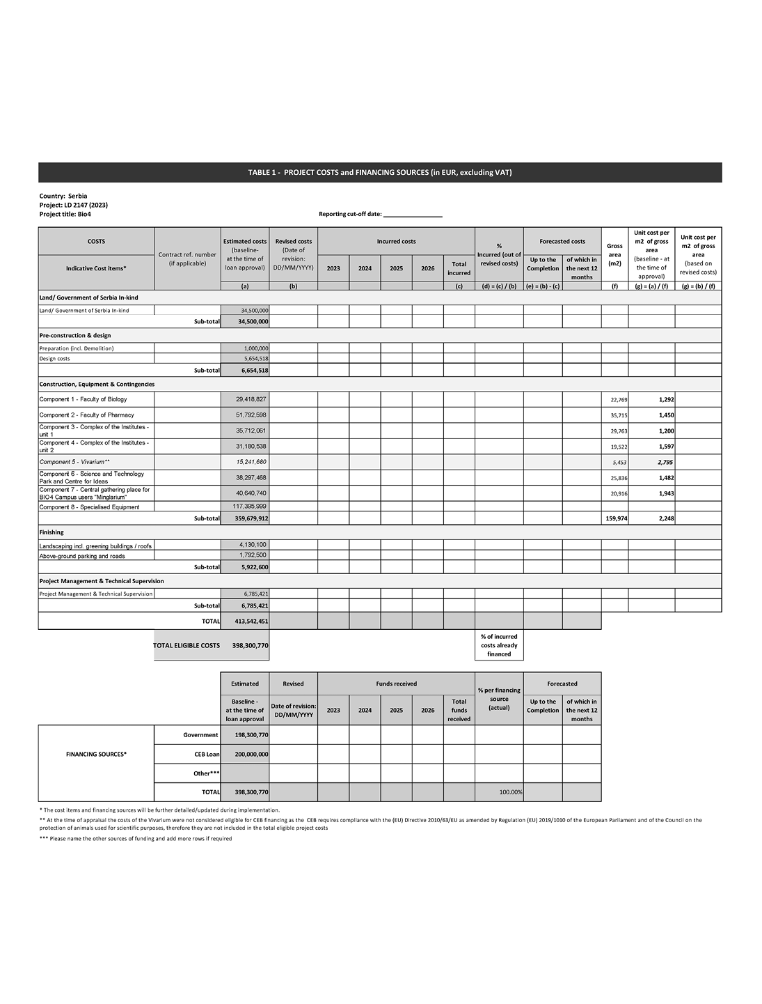
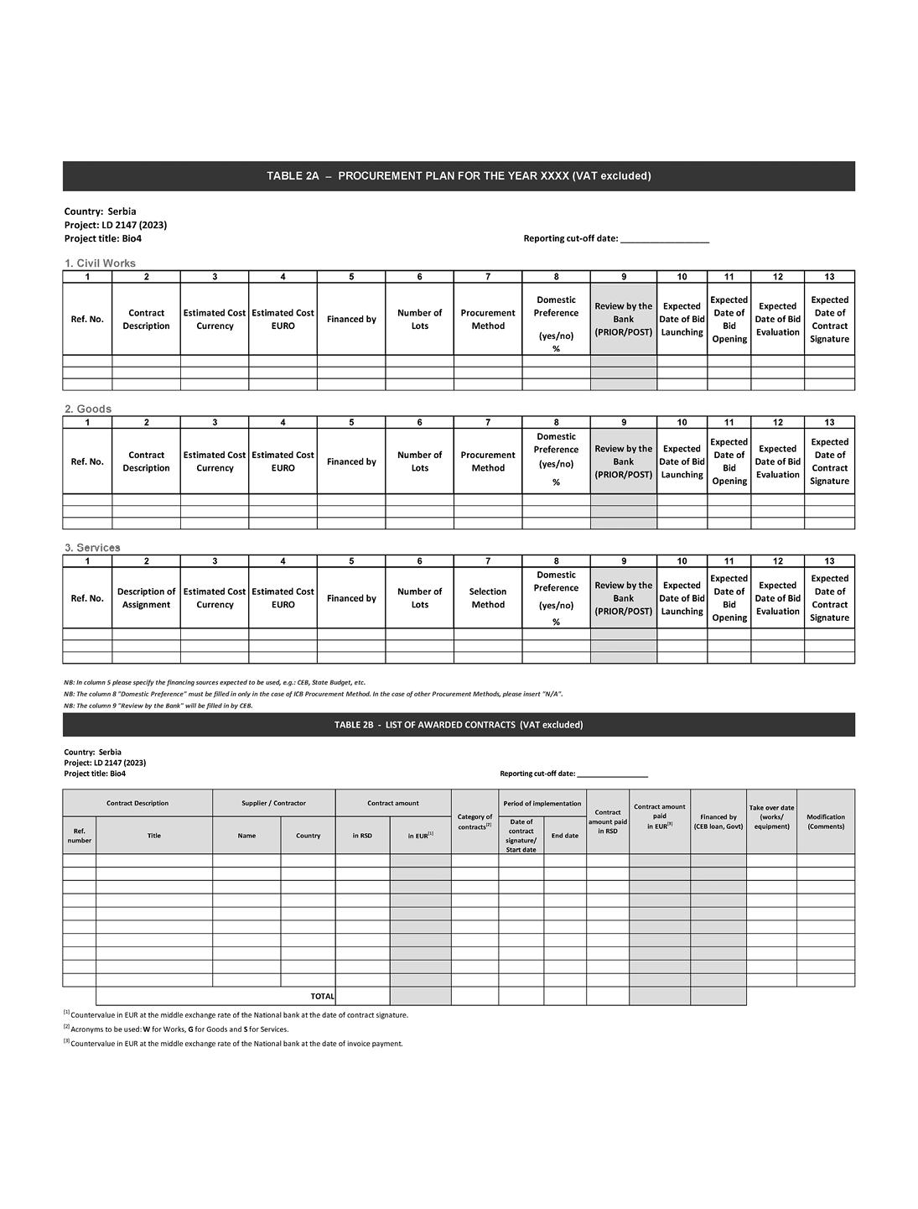
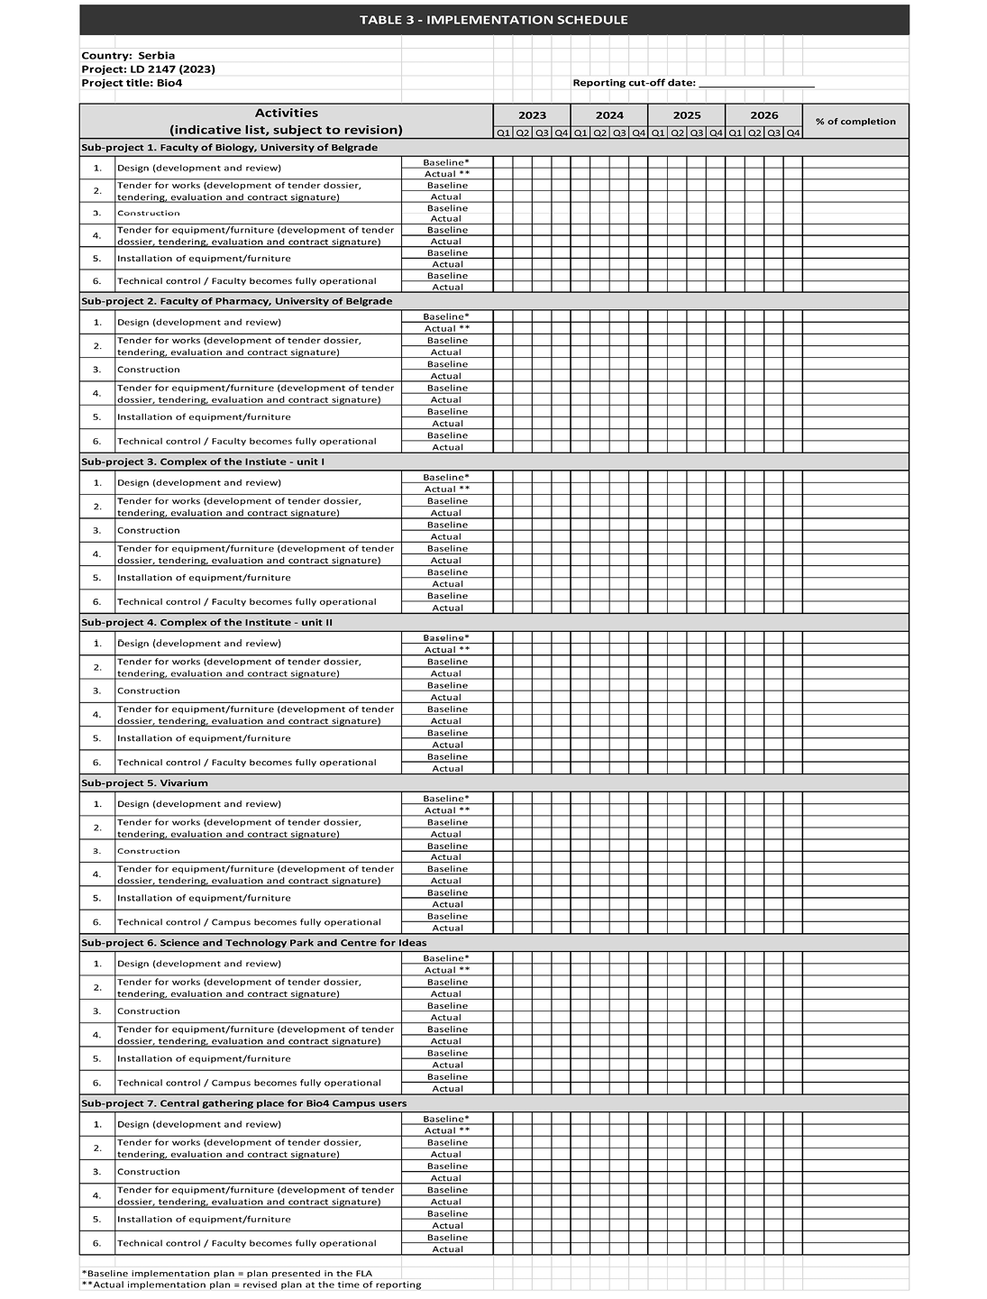
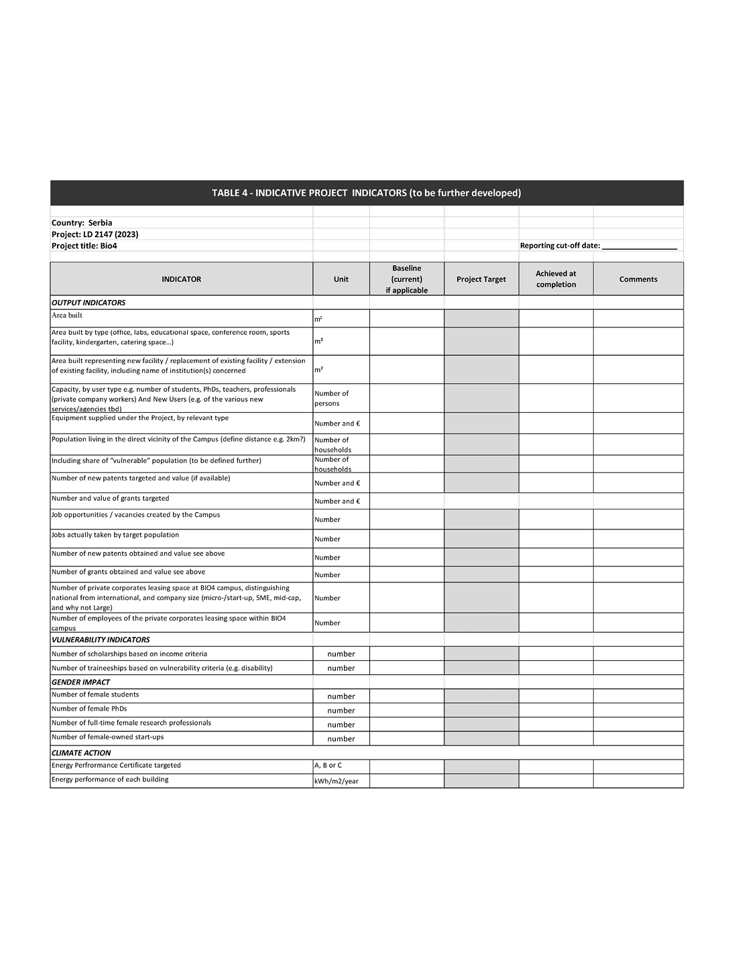
APPENDIX 6:
ESSS 2 - Land acquisition, economic displacement and involuntary resettlement
INTRODUCTION
1. Involuntary resettlement resulting from project-induced land acquisition and/or restrictions on land-use covers:
1.1 Physical displacement (relocation or loss of shelter); and
1.2 Economic displacement (loss of assets or resources, and/or loss of access to assets or resources that leads to loss of income sources or means of livelihood)
2. Resettlement is involuntary when affected persons do not have the right to refuse land acquisition, or restrictions on land use, that result in displacement. This concerns:
2.1 Lawful expropriation or restrictions on land use based on eminent domain;
2.2 Negotiated settlements in which the buyer can resort to expropriation or impose legal restrictions on land use if negotiations with the seller fail.
3. Involuntary resettlement needs to be managed appropriately to avoid:
3.1 Lasting hardship and impoverishment for affected persons, damage to the environment, and adverse socio-economic impacts in host communities;
3.2 Adverse effects on project implementation, including budget overruns, litigation and reputational risk.
4. The objectives of ESSS 2 are to:
4.1 Avoid or, when unavoidable, minimise, involuntary resettlement by exploring alternative project options;
4.2 Mitigate adverse social and economic impacts from project induced land acquisition or restrictions on affected persons’ use of, and access to, assets and land;
4.3 Restore or, where possible, improve the livelihoods and standards of living of displaced persons to pre-displacement levels;
4.4 Improve living conditions among physically displaced persons through the provision of adequate housing.
SCOPE AND APPLICATION
5. ESSS 2 applies if the project’s due-diligence process indicates that the project would involve Involuntary Resettlement (including Involuntary Resettlement in the recent past or foreseeable future that is directly linked to the project).
6. This ESSS does not apply to resettlement resulting from voluntary land transactions (market transactions in which the seller is not obliged to sell and the buyer cannot resort to expropriation or to other compulsory procedures if negotiations fail) and where such a transaction affects only those with legal rights.
REQUIREMENTS
7. The borrower is required to pro-actively manage project-related land acquisition, economic displacement and involuntary resettlement and to ensure that the actions indicated in the following paragraphs are undertaken and documented.
Avoiding/minimising involuntary resettlement
8. Consider feasible alternative project options to avoid or at least minimise physical and/or economic displacement, while balancing environmental, social, and economic costs and benefits.
Scope and Planning
9. Determine the required scope of Involuntary Resettlement planning, through a survey of land and assets, a full census of persons to be displaced, and an evaluation of socio-economic conditions specifically related to Involuntary Resettlement risks and adverse impacts. This establishes baseline information on assets, productive resources and status of livelihoods. Include consideration of customary rights and collective or communal forms of land tenure. Take gender into account in conducting the above.
10. Ensure that the resettlement planning process and documentation is proportional to the extent and degree of the impacts. The degree of impacts is determined by: (a) the scope of physical and economic displacement; and (b) the vulnerability of the persons to be displaced by the project.
11. Review the host country’s legal framework applicable to project-related land acquisition, economic displacement and involuntary resettlement and analyse potential gaps with the ESSS 2 and propose an approach to address these gaps in the Resettlement Plan/Framework, or Livelihood Restoration Plan/Framework.
Preparation of Resettlement Plan/Livelihood Restauration Plan
12. When displacement is physical, prepare a Resettlement Plan that defines the displaced people’s entitlements, income and livelihood restoration strategy, institutional arrangements, monitoring and reporting framework, budget and a time-bound implementation schedule. Involve affected persons in consultation on the resettlement plan and disclose the draft resettlement documentation in accordance with the information and consultation requirements in the ESSP.
13. The Resettlement Plan complements the broader analysis of social risks and adverse impacts in the environmental and social assessment and should provide appropriate guidance to address the specific issues associated with Involuntary Resettlement, including land acquisition, changes in land use rights, customary rights, physical and economic displacement, and potential design adjustments that may reduce the nature and/or extent of the resettlement.
14. When displacement is only economic, prepare a Livelihood Restoration Plan. Provide measures to be taken in case of disputes over compensation.
15. Where impacts on the entire displaced population are minor, or fewer than 50 households are displaced, the borrower/project promoter may, with the prior approval of the Bank, undertake the preparation of an abbreviated Resettlement Plan, covering specific elements which may be determined by the Bank. Impacts are considered "minor" if the affected persons are not physically displaced and less than 10 percent of their productive assets are lost.
Preparation of Resettlement Planning Framework/Livelihood Restoration Framework
16. Subject to the Bank’s agreement, and in the specific circumstances indicated in the subjacent bullets, the borrower/project promoter may undertake, as a preliminary approach to addressing project-related land acquisition, economic displacement and involuntary resettlement issues, undertake the preparation of a Resettlement Planning Framework or Livelihood Restoration Framework if:
16.1 the project is likely to involve Involuntary Resettlement but consists of a programme or series of activities the details of which are not yet identified at the time the project is approved by the CEB; or
16.2 the Bank determines that the environmental and social safeguard assessment of identified project activities involving Involuntary Resettlement may be conducted using a phased approach.
17. The Resettlement Planning Framework or Livelihood Restoration Framework should be prepared as early as possible in the project planning stage and should contain at least the following elements:
17.1 Review of the host country’s legal framework applicable to project-related land acquisition, economic displacement and involuntary resettlement and analysis of potential gaps with the ESSS;
17.2 Arrangements foreseen for the preparation of specific Resettlement Plans or Livelihood Restoration Plans where appropriate;
17.3 Budgetary provisions to cover the potential costs of project-related land acquisition, economic displacement and involuntary resettlement.
Consultations
18. Carry out meaningful consultations with persons who will be displaced by the project, host communities and relevant non-governmental organisations, and facilitate their informed participation in the consultations. Consult with all persons who will be displaced on their rights within the resettlement process, entitlements and resettlement options, within the resettlement process and their further participation in the process. Ensure their involvement in planning, implementation, monitoring and evaluation of the Resettlement Plan.
19. Pay particular attention to the needs of vulnerable groups, especially those below the poverty line, the landless, the elderly, women and children, and those without legal title to land, and facilitate their participation in consultations.
Resettlement Assistance and Social Support
20. Provide persons displaced by the project with the necessary assistance, including the following: (a) if there is relocation, security of tenure (with tenure rights that are as strong as the rights the displaced persons had to the land or assets from which they have been displaced) of relocation land (and assets, as applicable), proper housing at resettlement sites with comparable access to employment and production opportunities, integration of resettled persons economically and socially into their host communities and extension of the project benefits to host communities to facilitate the resettlement process; (b) transitional support and development assistance, such as land development, credit facilities, training or employment opportunities; and (c) civic infrastructure and community services, as required.
21. Support the social and cultural institutions of persons displaced by the project and their host population to address resettlement. Where Involuntary Resettlement risks and impacts are highly complex and sensitive, consider implementation of a social preparation phase to build the capacity of vulnerable groups to address resettlement issues, consisting of consultation with affected persons and the host population before key compensation and resettlement decisions are made. The cost of social preparation should be included in the resettlement budget.
Livelihood Restoration and Standards of Living
22. Improve, or at least restore, the livelihoods of all persons displaced by the project through: (a) where possible, land-based resettlement strategies when affected livelihoods are land-based or where land is collectively owned; or cash compensation at the replacement value for land, including transitional costs, when the loss of land does not undermine livelihoods; (b) prompt replacement of assets with assets of equal or higher value; (c) prompt compensation at the full replacement cost for assets that cannot be restored; and (d) capacity building programmes to support improved use of livelihood resources and to enhance access to alternative sources of livelihood. Include transaction costs in determining compensation. Examine the opportunities for the provision of additional revenues and services through benefit-sharing, as the nature and objectives of the project allows.
23. Improve the standards of living for the poor and for other vulnerable groups displaced by the project, including women, children and persons with disabilities, to at least national minimum standards, including access to social protection systems. In rural areas provide these groups with legal and affordable access to land and resources, and in urban areas provide them with appropriate income sources and legal and affordable access to adequate housing.
Persons without Title or Legal Rights
24. Ensure that persons displaced by the project who are without title to land or any recognisable legal rights to land, are eligible for, and receive, resettlement assistance and compensation for loss of non-land assets, in accordance with cut-off dates established in the resettlement plan. Include them in the resettlement consultation process. Do not include compensation for these persons for the illegally settled land. Conduct land survey and census as early as possible in project preparation to establish clear cut-off dates for eligibility and to prevent encroachment. If claims have been made by these displaced persons that are currently under administrative or legal review, develop procedures to address these situations.
Negotiated Settlement
25. Develop procedures in a transparent, consistent and equitable manner if land acquisition or changes in land use rights are acquired through negotiated settlement under the project, to ensure that those persons who enter into negotiated settlements maintain the same or improve income and livelihood status.
Information Disclosure
26. Disclose the draft Resettlement Plan, or Livelihood Restoration Plan including documentation of the consultation process, in the project area, in a timely manner in accordance with the information disclosure arrangements of the ESSP. The information should be in an accessible location, in a format and language(s) understandable to persons displaced by the project and the relevant stakeholders.
27. Disclose the final version of the Resettlement Plan, or Livelihood Restoration Plan to affected persons and other stakeholders in the same manner. Regularly disclose updated environmental and social safeguard information, along with information on any relevant material changes in the project.
Implementation and monitoring
28. Design and execute Involuntary Resettlement or Livelihood Restoration activities as part of the project. Include the full costs of resettlement in the presentation of the project’s costs and benefits. For a project with significant Involuntary Resettlement impacts, consider implementing the Involuntary Resettlement component of the project as a stand-alone project.
29. Provide compensation and other resettlement entitlements before any physical or economic displacement of the affected persons takes place under the project.
30. Closely supervise implementation of the Resettlement Plan or Livelihood Restoration plan throughout project implementation.
31. For projects subject to a Resettlement Plan, monitor and assess resettlement results and their impacts on the standards of living of displaced persons and whether the objectives of the Resettlement Plan have been achieved, by taking into account the baseline conditions and the results of resettlement monitoring.
32. Disclose monitoring reports in accordance with the Information Disclosure bullet above. Consider the use of suitably qualified and experienced third parties to support monitoring programmes.
Handling of complaints from persons subject to involuntary resettlement
33. Establish, as part of the Resettlement Plan/Framework, or Livelihood Restauration Plan/Framework a procedure which foresees the reporting and handling of concerns or complaints of persons who are subject to involuntary resettlement related to the project’s implementation.
34. Assign the responsibility for the application of the complaints handling procedure to an appropriately qualified staff member⁵ of the project management team
------------
5 Or a number of staff members proportionate to the scale of the Project and the associated risks

