|  |  |
| --- | --- |
| futer logo | FRAMEWORK LOAN AGREEMENT  BETWEEN COUNCIL OF EUROPE DEVELOPMENT BANK AND THE REPUBLIC OF SERBIA  ("Off. Herald of RS - Treaties", No. 26/2021) |

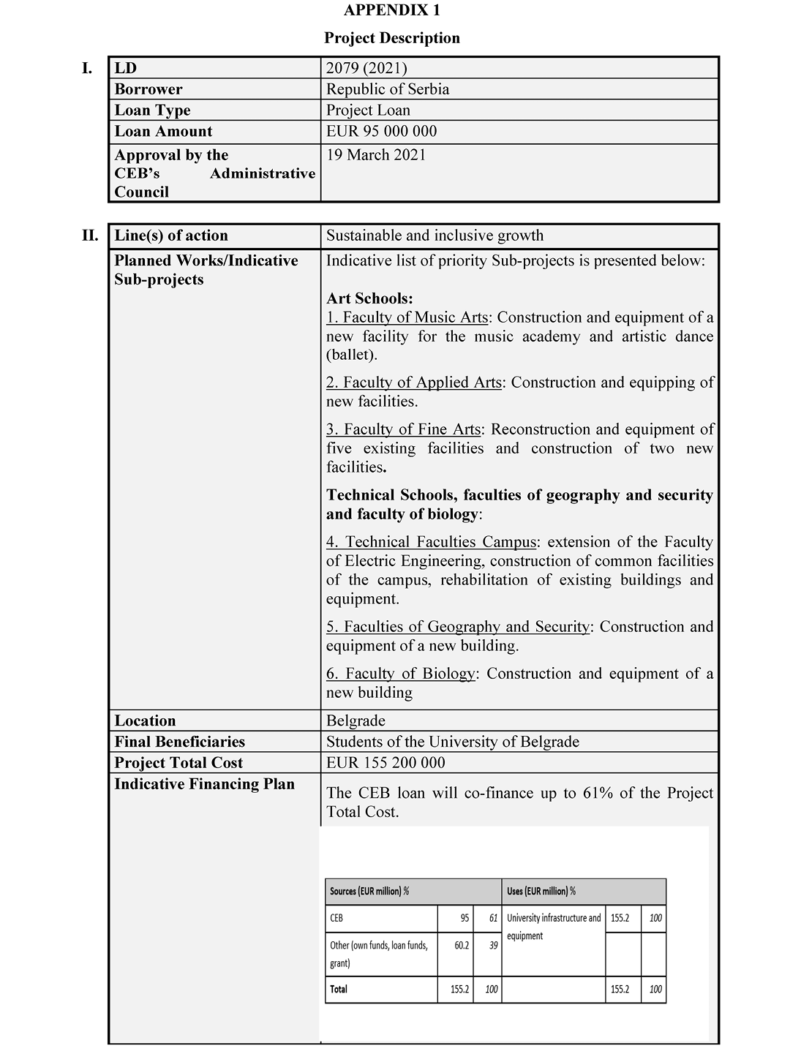

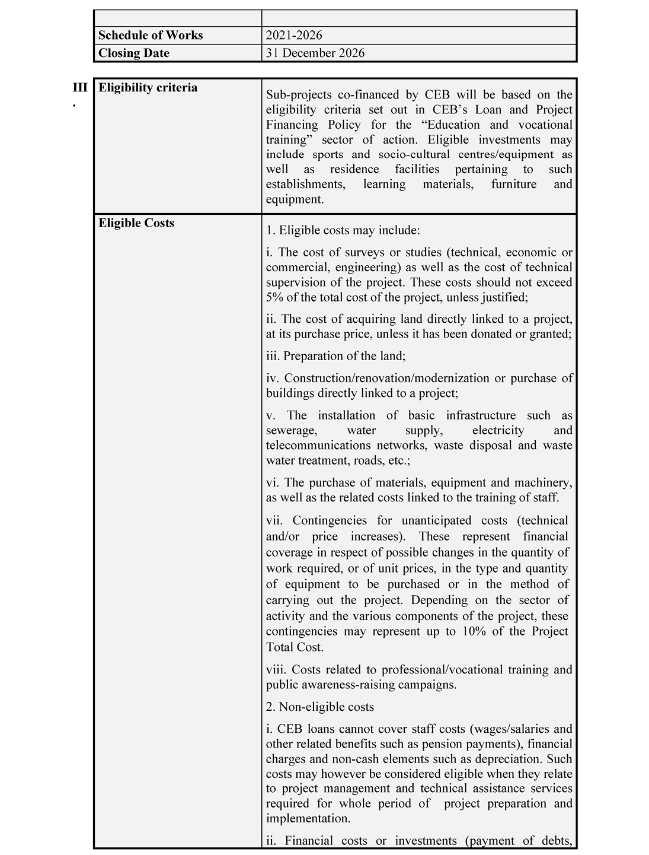

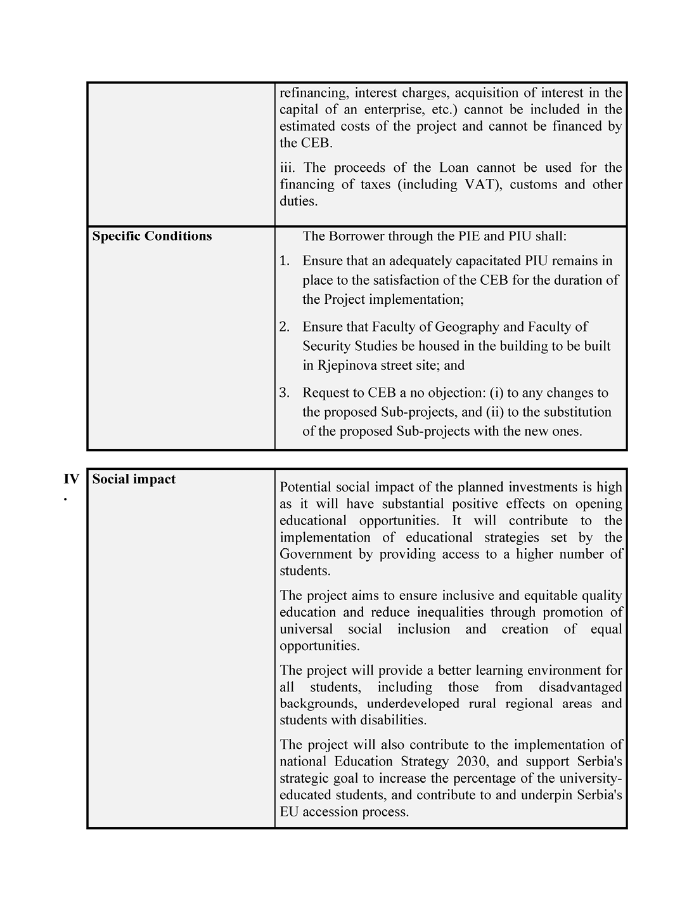

**APPENDIX 2**  
**Form of Legal Opinion**

Council of Europe Development Bank

55, avenue Kléber

75116 Paris (France)

Attn: Projects Department

Cc: Office of the General Counsel

[INSERT DATE]

**Re:** **Framework Loan Agreement between the Council of Europe Development Bank and the Republic of Serbia (Reference LD 2079 (2021))**

Dear Sir or Madam,

In my capacity as the Minister of Justice, I hereby submit this opinion in line with the provisions of Article 4.5(a)(i) of the Framework Loan Agreement LD 2079 (2021) between Council of Europe Development Bank and Republic of Serbia, for an amount of 95,000,000 EUR, signed on _____ and effective as of _____ (hereinafter referred to as the **”Loan Agreement”**). All the terms that are used here, if not otherwise defined, have the same meaning as in the Loan Agreement.

I have reviewed the original Loan Agreement and the provisions of the Constitution of the Republic of Serbia (”Official Gazette of the Republic of Serbia” No. 98/2006), as well as legal documents and other regulations, and I have undertaken other activities that I deemed necessary in order to submit this opinion.

According to the aforementioned, my opinion is as follows:

(a) Pursuant to the provision of Article 123, Item 1 of the Constitution of the Republic of Serbia, it is provided that the Government shall establish and pursue the policy, and pursuant to the provision of Article 2, Paragraph 1 and Article 43, Paragraph 3 of the Law on Government (”Official Gazette of the Republic of Serbia” No. 55/05, 71/05 – corrigendum, 101/07, 65/08, 16/11, 68/12 – Constitutional Court, 72/12, 7/14 – Constitutional Court, 44/14 and 30/18-other law) it is provided that the Government shall establish and pursue the policy of the Republic of Serbia, and when it does not pass other acts, the Government adopts conclusions. In line with the referred provisions, the Government at its session held on _______ adopted the Conclusion No: _______, whereby it adopted the Draft Loan Agreement and authorized ______________, to sign the Loan Agreement on behalf of the Government as the representative of the Republic of Serbia;

(b) Pursuant to the provision of Article 99, Paragraph 1, Item 4 of the Constitution of the Republic of Serbia,it is provided that the National Assembly of the Republic of Serbia ratifies the international treaties when their ratification is provided by law, and subject to the provision under Article 2, Paragraph 1 of the Law on Conclusion and Execution of International Treaties (”Official Gazette of the Republic of Serbia” No. 32/13) which provides that an international treaty shall be a treaty which the Republic of Serbia concludes in written form with one or more countries or one or more international organizations, which is governed by international law. Pursuant to the provision of Article 5, Paragraph 2 of the Law on Public Debt (”Official Gazette of the Republic of Serbia” No. 61/05, 107/09, 78/11, 68/15, 95/18, 91/19 and 149/20) it is provided that the National Assembly of the Republic of Serbia decides on borrowing of the Republic by taking long-term loans, borrowing for investment and program projects financing by taking long-term loans, issuing guarantees, and on direct taking over of the liabilities as a debtor under issued guarantee. In line with the stated provisions, the National Assembly of the Republic of Serbia rendered the Law on Ratification of Framework Loan Agreement LD 2079 (2021) between Council of Europe Development Bank and Republic of Serbia, University Infrastructure Project Loan (”Official Gazette of the Republic of Serbia - International Treaties”, No. ______);

(c) There are no other provisions according to which it would be necessary to submit, record or register the Loan Agreement with any court or state authority or organization in order to secure its legality, effectivenessand enforceability;

(d) The choice of the law set forth in Article 14 of the Loan Agreement, is legally valid and binding on the Borrower under the laws of the Republic of Serbia;

(е) Pursuant to Article 15 of the Loan Agreement, the arbitration provisions set forth in Chapter 4 of the CEB Loan Regulations shall apply for any claim or dispute between the Republic of Serbia and the Council of Europe Development Bank arising from the Loan Agreement, and any decision of the arbitration tribunal pertaining to the Loan Agreement can be executed in the Republic of Serbia without re-examination or re-litigation of the matters thereby adjudicated. In line with the aforementioned the waiver of immunity pursuant to Article 15 of the Loan Agreement is legally valid and binding;

(f) No taxes, customs duties, fees or other impositions, including without limitation taxes, fees or other levies for registration or transfers that are applicable in the Republic of Serbia, or any other unit of territorial autonomy or local government, shall be payable in connection with the conclusion or execution of the Loan Agreement, or in connection with the payments that the Republic of Serbia is to make to the Council of Europe Development Bank under the Loan Agreement;

(g) No exchange control restrictions are in place or consents are required in order to permit the receipt of all amounts to be disbursed under the Loan Agreement and to permit the repayment of the Loan and the payment of interest and all other amounts due under this Loan Agreement;

(h) The execution of the Loan Agreement did not, and its performance will not violate any norms of the Republic of Serbia or cause any material breach of any agreement or undertaking to which the Republic of Serbia is bound.

In view of everything stated above, I am of the opinion that all conditions that are stipulated by the Constitution, laws and other acts of the Republic of Serbia which could be applied to the Loan Agreement are met, that the provisions of the Loan Agreement are in full force and effect and that the Loan Agreement  
is legally valid, binding and enforceable in the Republic of Serbia in accordance with its terms.

Yours faithfully,

MINISTER

________

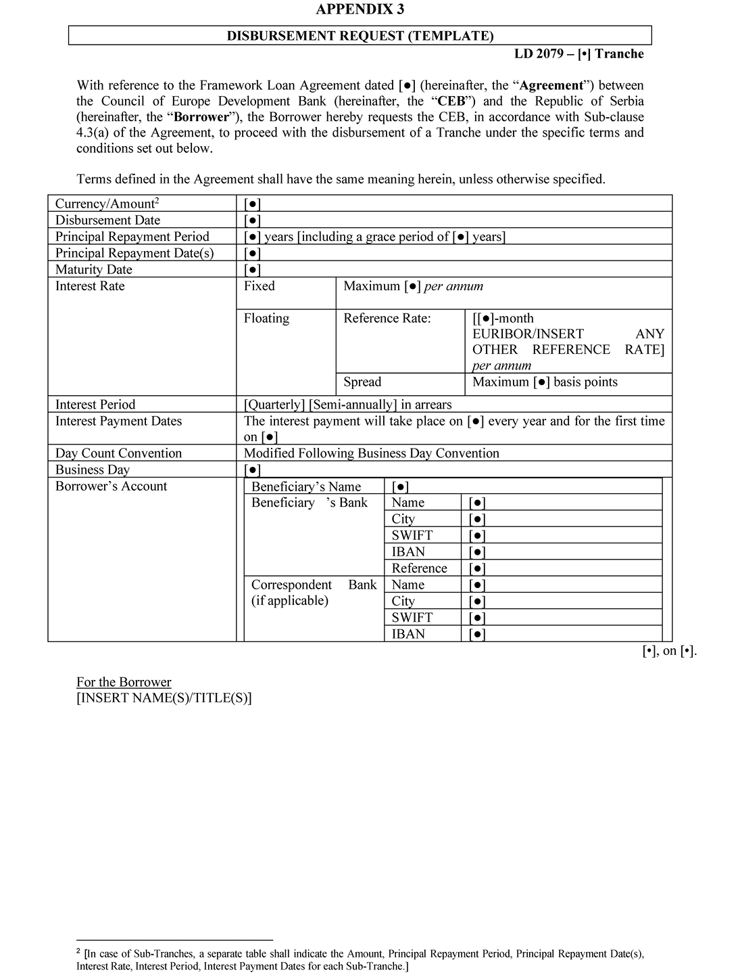

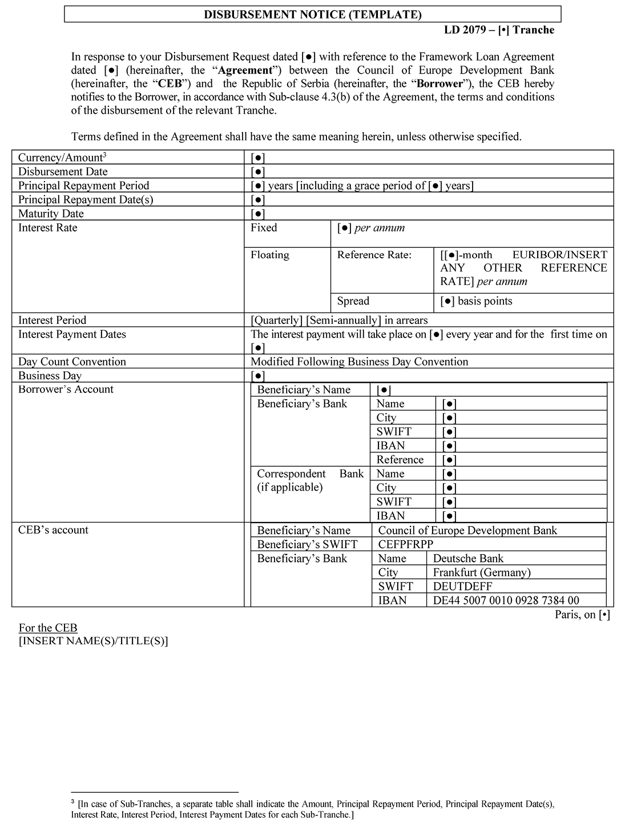

**APPENDIX 4**  
**Form of Certificate**

[INSERT LETTERHEAD]

To: Council of Europe Development Bank

From: [BORROWER]

Date: [NOT EARLIER THAN FIVE (5) BUSINESS DAYS BEFORE THE DISBURSEMENT REQUEST]

Subject: Framework Loan Agreement between Council of Europe Development Bank and [BORROWER] dated [●] (the “**Agreement**”).

Dear Sir or Madam,

Terms defined in the Agreement have the same meaning when used in this Certificate. For the purposes of Sub-clause 4.5 of the Agreement, we hereby certify to you as follows:

(a) No Material Adverse Change has occurred, as compared with the situation at the date of signature of the Agreement;

(b) No Cross-Default Event has occurred;

(c) None of the Borrower’s Debt Instruments includes loss-of-rating, financial ratios or *pari passu* provisions that are stricter than any equivalent provision of the Agreement;

(d) The representations and warranties to be made or repeated by us under Clause 8 of the Agreement are true in all respects; in particular, no Security has been granted to a third party in breach of Sub-clause 7.2 of the Agreement; and

(e) No event or circumstance which could give rise to the early reimbursement, suspension or cancellation of the Loan under the terms of Articles 3.3 (*Early reimbursement of disbursed loans*), 3.5 (*Suspension by the Bank of undisbursed loans*) and 3.6 (*Cancellation by the Bank of undisbursed loans*) of the Loan Regulations has occurred or may reasonably be expected to/is likely to occur.

For the [BORROWER]

**LD 2079 (2021)**

**APPENDIX 5:**  
 **Reporting Template (annual progress report/completion report)**

**PROJECT TITLE: _______________**

**ANNUAL PROGRESS REPORT/COMPLETION REPORT**

**REPORTING PERIOD: dd/mm/yyyy – dd/mm/yyyy**

Prepared by (name and signature) _______________  
Department______________  
Date_______________

**Table of Contents**

**1. Narrative Report**

1.1 Summary of the Project

1.2 Activities undertaken and Results achieved

1.3 Impact Prospects (to be presented in the completion report)

1.4 Communication and Visibility Activities

1.5 Deviations from the Plan and difficulties encountered, if any, and mitigation measures

1.6 Conditions precedent before disbursement, if applicable

**2. Monitoring tables**

Table 1: Project Costs and Financing Sources

Table 2A: Procurement Plan

Table 2B: List of Awarded Contracts

Table 3: Implementation Schedule

Table 4: Output/Outcome Indicators

**1. Narrative Report**

**1.1 Summary of the Project**

|  |  |  |
| --- | --- | --- |
| Title of the Project |  | |
| Objective |  | |
| Framework Loan Agreement (FLA) entry into force |  | |
| Implementing Agency |  | |
| Estimated project cost | Original: | Revised: |
| Approved CEB loan amount |  | |
| Maximum CEB financing of total eligible costs  (in percentage) |  | |
| Other sources of financing |  | |
| Implementation period | Original: mm/yy-mm/yy | Revised: |
| Closing date for CEB loan disbursement |  | |

**1.2 Activities undertaken and Results achieved**

Please describe the progress of activities in relation to the Project, including, but not limited to:

|  |  |
| --- | --- |
| Activity | Progress and results |
| Land acquisition and preparation |  |
| Studies and Design |  |
| Procurement related activities |  |
| Works, including photos showing the latest progress |  |
| Equipment |  |
| Management of environmental and health and safety issues (information on any incident, compliant and corrective action taken) |  |

**1.3 Impact Prospects (to be presented in the completion report)**

Provide information and comments as appropriate on the Project’s contribution to achieving the overall objective.

**1.4 Communication and Visibility Activities**

Please inform about the communication and visibility activities (public announcements, media/newspaper articles that mention CEB and/or other partners) including links of any media events and articles.

**1.5 Deviations from the Plan and difficulties encountered, if any, and mitigation measures**

Provide information on any major constraints/deviations from the plan, especially, but not limited to, problems that risk delaying the project. Explain the reasons for such deviations and propose corrective measures in the table below.

|  |  |  |  |
| --- | --- | --- | --- |
| Proposed Action Plan to solve issues (if any): | | | |
| Constraint/Deviation | Corrective Measure | Responsible | Completion Date |
|  |  |  |  |

**1.6 Conditions precedent before disbursement, if applicable**

Please detail conditions yet to be fulfilled in line with Framework Loan Agreement requirements and inform on the progress in addressing the conditions.

